

**SMT201 - Geographic Information Systems for Urban Planning**

AY2022/23 Term 1

GIS Project Report

Theme 2: Geography of Accessibility with GIS-based Network Analysis

Sub-theme 1: Impact of closures or mergers of education institutions on equity of access

Instructor: Professor Kam Tin Seong

G1 Team 2

Goh Tse Ting Claire, Lim Zhe Bin, Lu Quanfang

Table of Contents

**1. Introduction** **4**

1.1 Background 4

1.2 Motivation 4

1.3 Objectives 4

**2.0 Data Collection** **6**

2.1 Downloading Data 6

2.2 Managing the Imported Data 6

**3.0 Data Preparation, Data Cleaning and QGIS Project Setup** **6**

3.1 Creating a New Project and Assigning Project Coordinate System for New Project 6

3.1.1 Saving your project 7

3.2 Preparing base layer for study area 8

3.3 Storing your data sets in GeoPackage format 10

3.4 Preparation of Primary School Layer 11

3.4.1 Geocoding Prepared Data 12

Geocoding using MMQGIS Plugin 14

3.4.2 Adding Primary School Layer into QGIS Project 17

2.5 Preparation of Road Network Layer 18

3.5.1 Selecting all road networks within the study area 19

2.5.2 Extracting Motor Vehicle Road Network 21

3.5.3 Extracting Pedestrian Path Network 22

3.6.1 Extracting Youth Population 23

3.6.2 Creating Relational Join 24

3.6.3 Creating Choropleth Map to Display Youth Population Distribution 26

**4.0 Preparing Maps for Analysis** **28**

4.1 Creating the hexagon layer 28

4.1.1 Editing the hexagon layer 29

4.1.2 Saving the hexagon layer 30

4.1.3 Computing hexagon centroid 30

4.1.4 Saving the centroid layer 31

4.2.2 Network Accessibility Analysis 31

4.2.2.1 Install QNEAT Plugin 31

4.2.2.2 Working with OD Matrix Tool 31

3.2.2.3 Extracting shortest distance pairs 34

4.2.3 Mapping Accessibility Values 37

4.2.3.1 Creating a Duplicate Layer 37

4.2.3.2 Performing relational join 37

4.2.3.3 Preparing Choropleth Map 38

4.2.3.4 Preparing Bivariate Choropleth Map 40

**5.0 Data Preparation for Secondary School** **42**

5.1 Data Preparation 42

5.1.1 Data Cleaning 42

5.2 Geocode the prepared data (Before Merger) 43

5.3 Prepare data for Analysing Cccessibility (After Merger) 48

a. Use the SecondarySchool layer, open attribute table and press ctrl+F 48

5.4 Network Accessibility Analysis 49

**6.0 Accessibility Analysis for Junior Colleges** **49**

6.1 Data Preparation 49

6.2 Geocoding 50

6.3 MRT accessibility network 55

6.3.1 Data Preparation 55

6.3.2 Extracting Shortest Distance from Hexagon Centroid to School via MRT 58

6.3.2.1 OD Matrix for hex centroid to MRT stations 58

6.4 Network Accessibility Choropleth Maps (Driving, Walking and MRT) 60

**7.0 Results and Discussion** **61**

7.1 Main Mode of Transport for Students 61

7.2 Distribution of Youth Population 62

7.3 Accessibility Analysis to Primary Schools 64

7.3.1 Walking Accessibility Analysis 64

7.3.1.1 Before Merger 64

7.3.1.2 Walking Accessibility Analysis After Merger 65

7.3.1.3 Before and After Merger (Bivariate Map) 66

7.3.2 Driving Accessibility Before and After Merger (Bivariate Map) 67

, 67

7.3.3 Accessibility Analysis to Primary Schools from Tengah 69

7.4 Accessibility Analysis to Secondary Schools 72

7.4.1 Driving Accessibility 72

7.4.1.1 Before Merger 72

7.4.1.2 After Merger 73

7.4.2 Walking and MRT Accessibility 75

7.4.2.1 Before Merger 75

7.4.2.2 After Merger 76

7.5 Accessibility Analysis to Junior Colleges 77

7.5.1 Walking and MRT Accessibility 77

7.5.1.1 Before Merger 77

7.5.1.2 After Merger 78

7.4.2 Driving Accessibility Before and After Merger (Bivariate Map) 79

**8 Future Work** **82**

8.1 Extending Public Transport Accessibility Analysis to include Bus Networks 82

8.2 In-depth Accessibility Analysis on Lower and Middle Income Areas 82

8.3 Accessibility Analysis on New Public Housing Estates 82

**9 Lessons Learned** **83**

**10 References** **85**

# 

# 1. Introduction

## 1.1 Background

In 2019, due to falling birth rates and low enrolment numbers, the Ministry Of Education conducted a large-scale merger of schools, involving 14 primary schools, 6 secondary schools, and 8 JCs. By merging these schools, MOE aimed to ensure that each school had an adequate number of students for a meaningful educational experience (MOE, 2017). In naming merged schools, a variety of factors were considered, including the schools’ history and heritage, enrolments, as well as stakeholders’ interests and the sentiments of all schools involved.

## 1.2 Motivation

Our project “Singapore Education Institutions Analysis”, aims to investigate the impact of closures or mergers of schools on the equity of access to education in Singapore. The merger of schools resulted in lower accessibility for certain areas, making it more difficult for children to travel to school. This results in spatial inequalities across Singapore, especially due to the competitiveness in primary school admission, where children living within 1km of schools have priority admission. To achieve a meritocratic society, everyone should have similar levels of access to education. As such, we aim to identify which housing estates have been disproportionately affected by the merger, and provide recommendations to alleviate the issue and maintain equity of access to education across Singapore.

## 1.3 Objectives

Our project aims to identify and analyse the areas whose access to schools have been significantly impacted by the mergers. This would be in terms of walking, MRT and driving accessibility.

1. Primary Schools - Walking and Driving
2. Secondary Schools - Walking, MRT and Driving
3. Junior Colleges (JCs) - Walking, MRT and Driving

# 

# 2. Data Collection

## 2.1 Downloading Data

Firstly, you are required to download the following data from data.gov.sg:

1. [Master Plan 2019 Subzone Boundary (No Sea)](https://data.gov.sg/dataset/master-plan-2019-subzone-boundary-no-sea)
2. [General Information of Schools](https://data.gov.sg/dataset/school-directory-and-information)
3. [Singapore Residents by Planning Area / Subzone, Single Year of Age and Sex, June 2011-2020](https://www.singstat.gov.sg/find-data/search-by-theme/population/geographic-distribution/latest-data)

Next, you are required to download geospatial data from [geofabrik](https://download.geofabrik.de/asia/malaysia-singapore-brunei.html):

1. Roads data from OpenStreetMap (OSM) data sets

* Click on Asia → Malaysia, Singapore, and Brunei → Download malaysia-singapore-brunei-latest-free.shp.zip

Next, you are required to download MRT data (Train Station) from the [Land Transport Authority (LTA) Data Mall](https://datamall.lta.gov.sg/content/datamall/en/static-data.html). The data set provides the locations of MRT stations in Singapore.

## 2.2 Managing the Imported Data

Assuming the root directory of this project is called *GISProject,* create a sub-folder called *data*.

* Place the downloaded data from data.gov.sg and LTA Data Mall into the *data* sub-folder
  + Unzip the respective zipped files,
  + Extract the zipped files, and
  + Place them in *data* folder

# 3. Data Preparation, Data Cleaning and QGIS Project Setup

## 3.1 Creating a New Project and Assigning Project Coordinate System for New Project

1. From Windows Desktop, launch QGIS.
2. You will start a new QGIS project. From the menu bar, select **Project → New**.
3. Ensure that your projection system at the bottom right bar is using EPSG:3414, if not reassign the projection system by selecting SVY21 / Singapore TM.

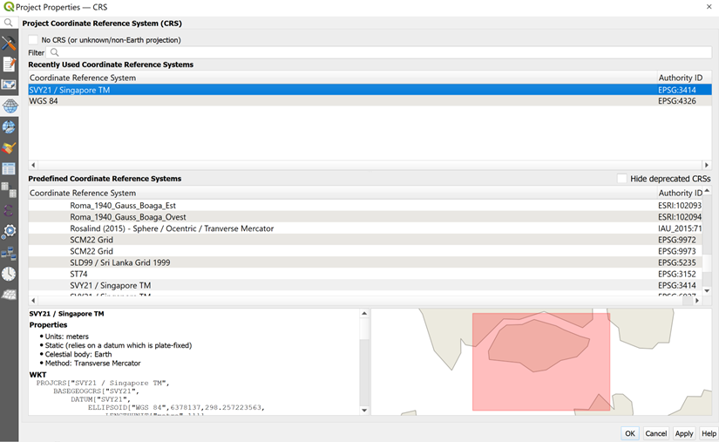

Notice that the projection system has been updated to EPSG:3414 now.



## 3.1.1 Saving your project

It is time to save the project.

1. From the menu bar, click **Project → Save**.
2. At the **Choose a QGIS project file** dialog window, navigate to the root project folder, then provide a proper project name such as GISProject in QGIS files (.qgs) format from the **Save as type**: dropdown list. Your screen should look similar to the screenshot below.

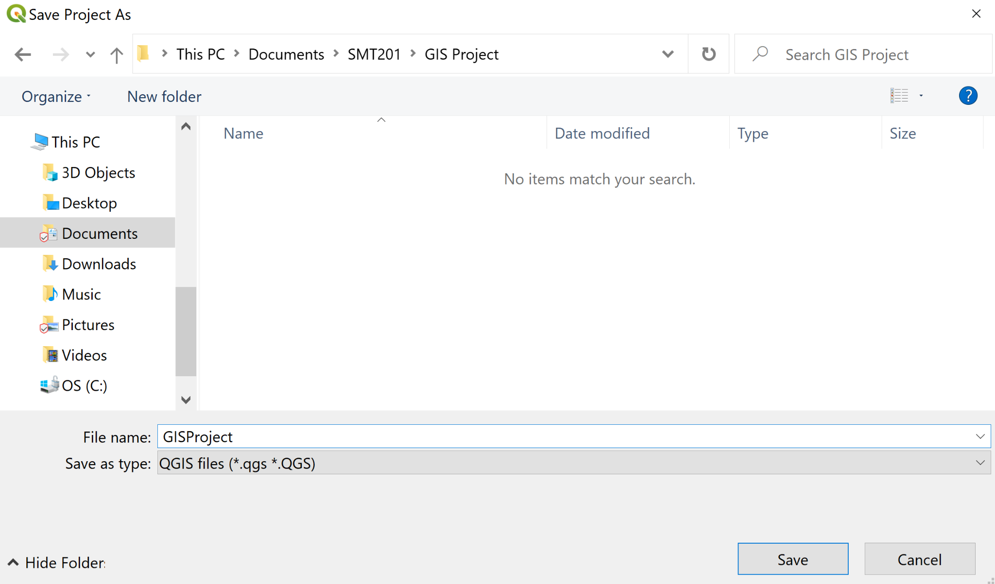

## 3.2 Preparing base layer for study area

Our study area would be the Singapore Planning Subzone excluding all the outer islands such as Pulau Ubin and Pulau Tekong.

1. From the **Browser** panel, navigate to the path of GISProject as shown in the screenshot below.

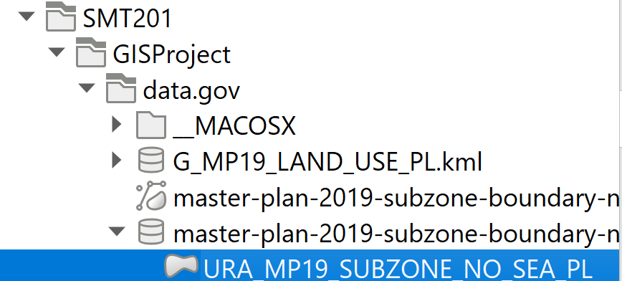

1. Double click on URA_MP19_SUBZONE_NO_SEA_PL.shp. Notice that URA_MP19_SUBZONE_NO_SEA_PL.shp is added in the **Layer** panel.
2. The View window should look like this.

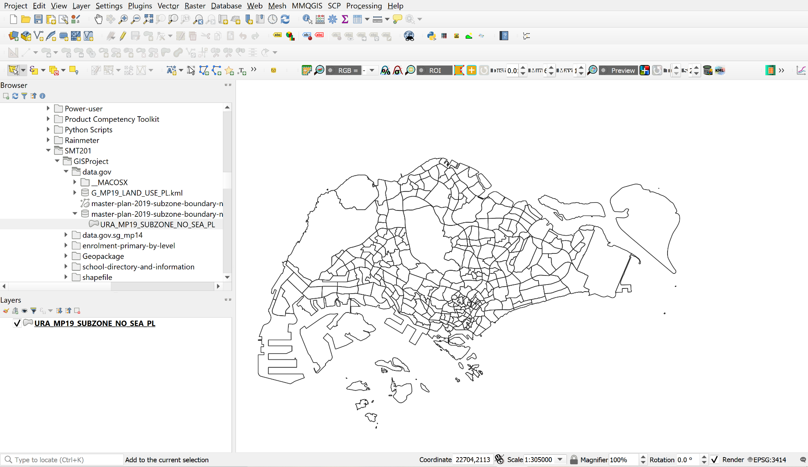

We will now select the main island of Singapore, excluding the outer islands.

1. From the toolbar, click **Select Features by Polygon**

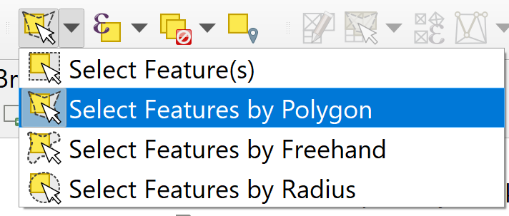

1. Select the main island of Singapore. Your screen should look similar to the screenshot below.

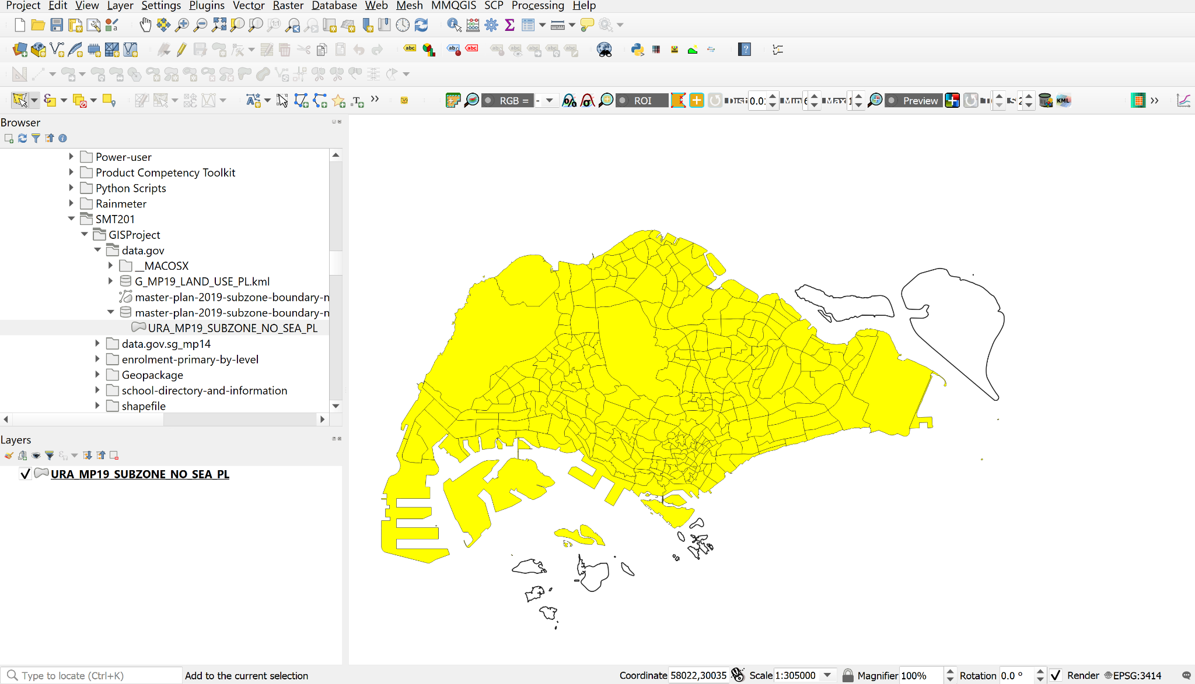

### 3.3 Storing your data sets in GeoPackage format

1. Save all your data sets into an integrated database called GISProject.
2. From the **Layers** panel, right-click on URA_MP19_SUBZONE_NO_SEA_PL layer.
3. Select **Export → Save Selected Features As** from the context menu.
   1. The **Save Vector Layer** dialog window appears. For **Format**, select GeoPackage from the drop-down list.
   2. For **Save as**, click on the *Browse* button. The **Save Layer As** dialog window appears
   3. Navigate to \GISProject\Geopackage\ sub-folder.
   4. For **File Name**, type GISProject.
   5. Rename your layer as MP19_SUBZONE.
   6. Check that the CRS is Project CRS: EPSG:3414 – SVY21

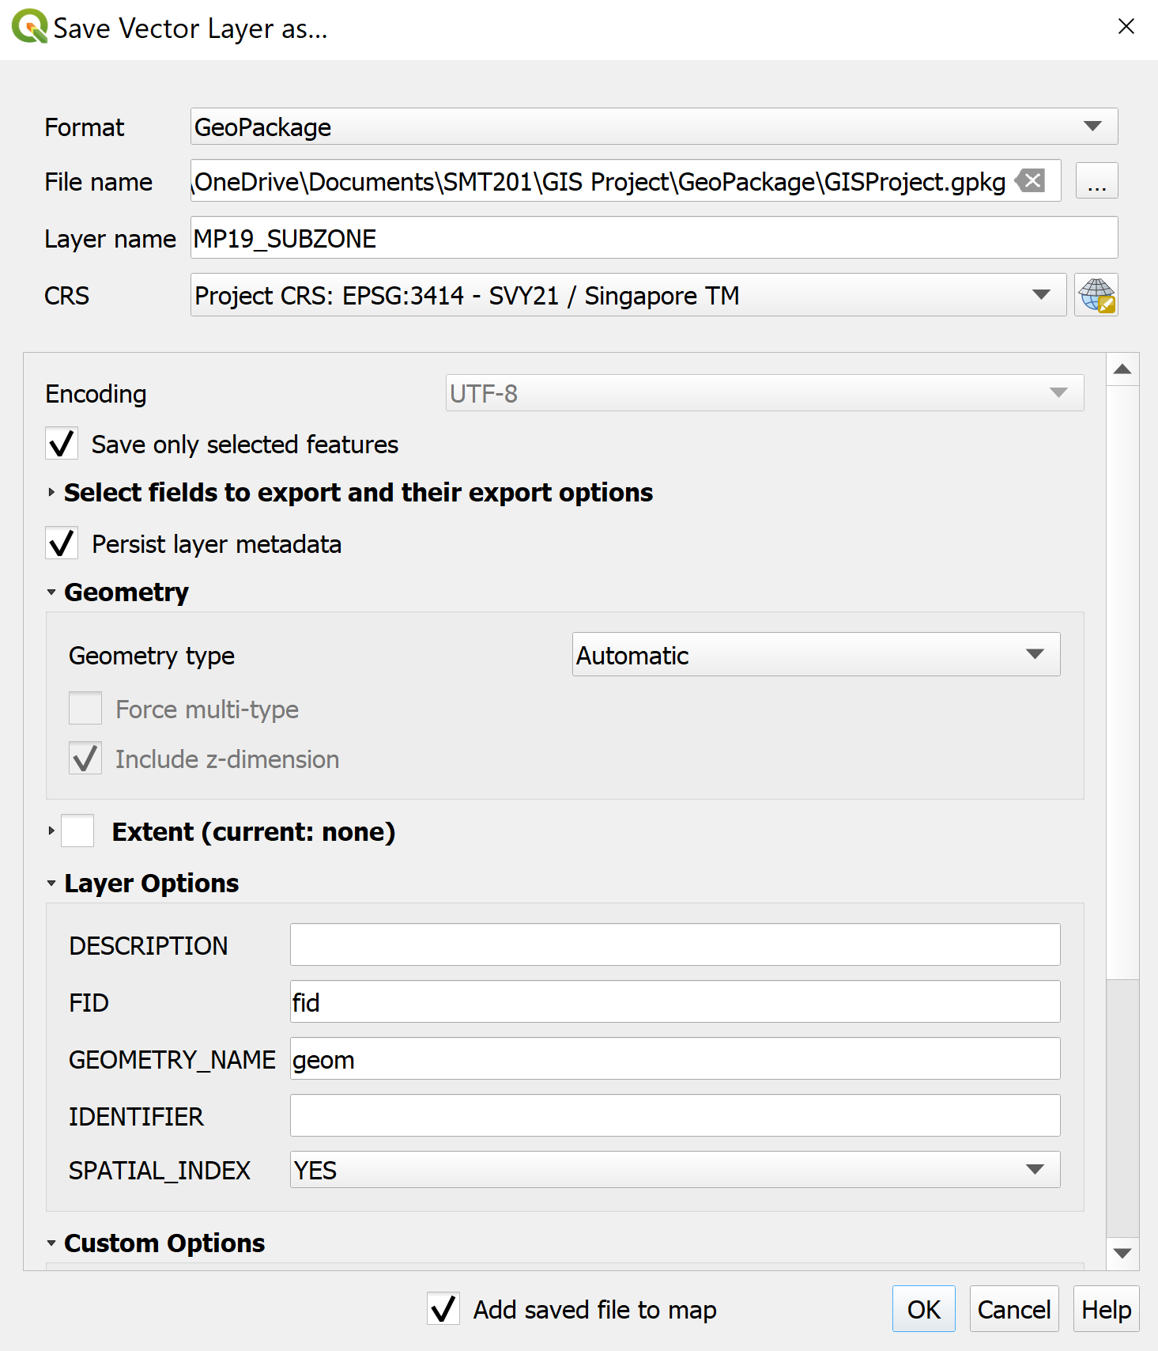

From the Layers panel, right click the URA_MP19_SUBZONE_NO_SEA_PL layer and click **Remove Layer.**

## 3.4 Preparation of Primary School Layer

Review the content of general-information-of-schools.csv file. Locate and open the file with **Excel.**

Your screen should look like the figure below.

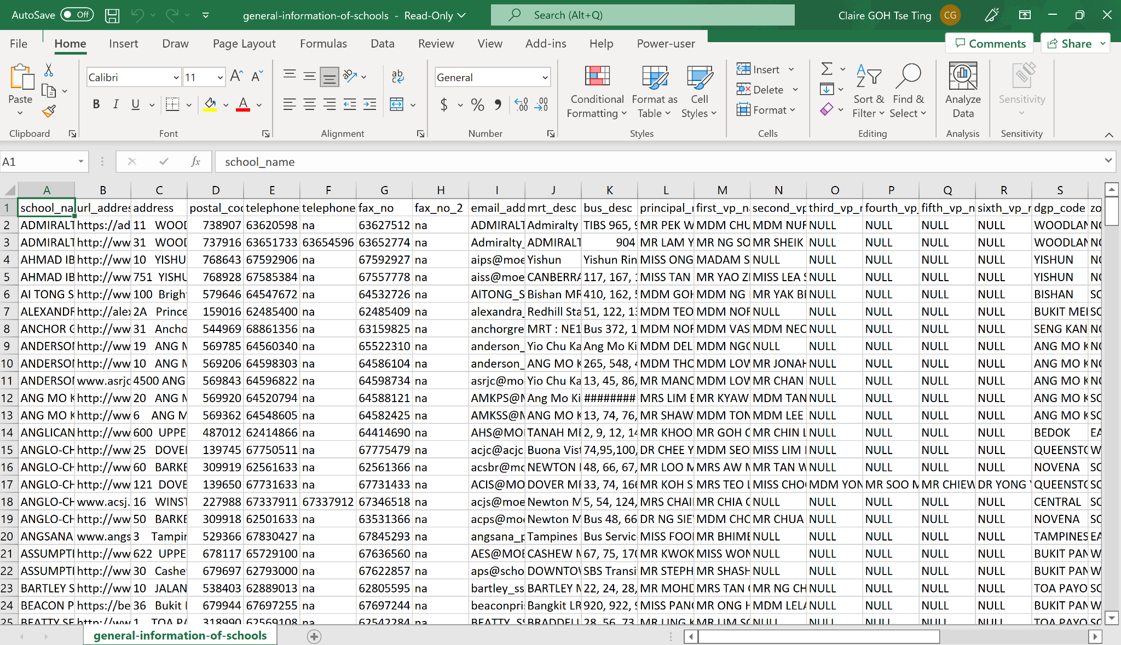

1. Using appropriate Excel functions to sort the schools according to the mainlevel_code field, retain only the schools categorized as *Primary*.

Take note that there are 3 Primary Schools: Catholic High School, CHIJ St. Nicholas Girls’ School and Maris Stella High School categorized as Mixed Levels under the mainlevel_code.

1. Using appropriate Excel function, retain the school_name, address, postal_code, and mainlevel_code field and delete the unwanted fields.
2. Create two new fields: country and city fields
3. Fill the two fields with *Singapore*
4. The final general-information-of-schools.csv should look like this. Save the file.

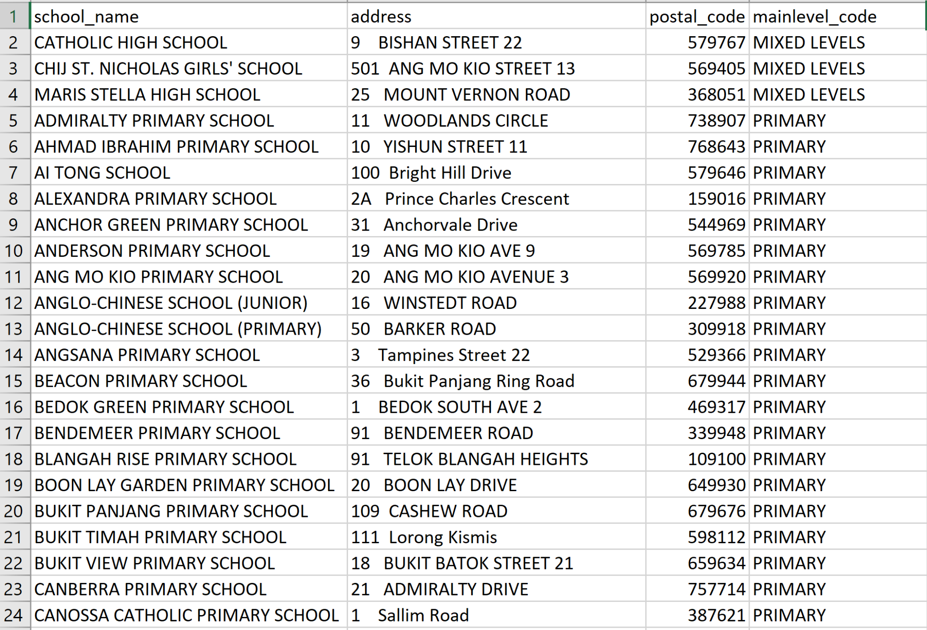

### 3.4.1 Geocoding Prepared Data

1. Geocode the general-information-of-schools data set by using SLA OneMap API. Save the geocoded data set in geocoded_school.csv. The geocoded data set should have the new fields Latitude and Longitude.

The geocoded_school.csv should look similar to this.

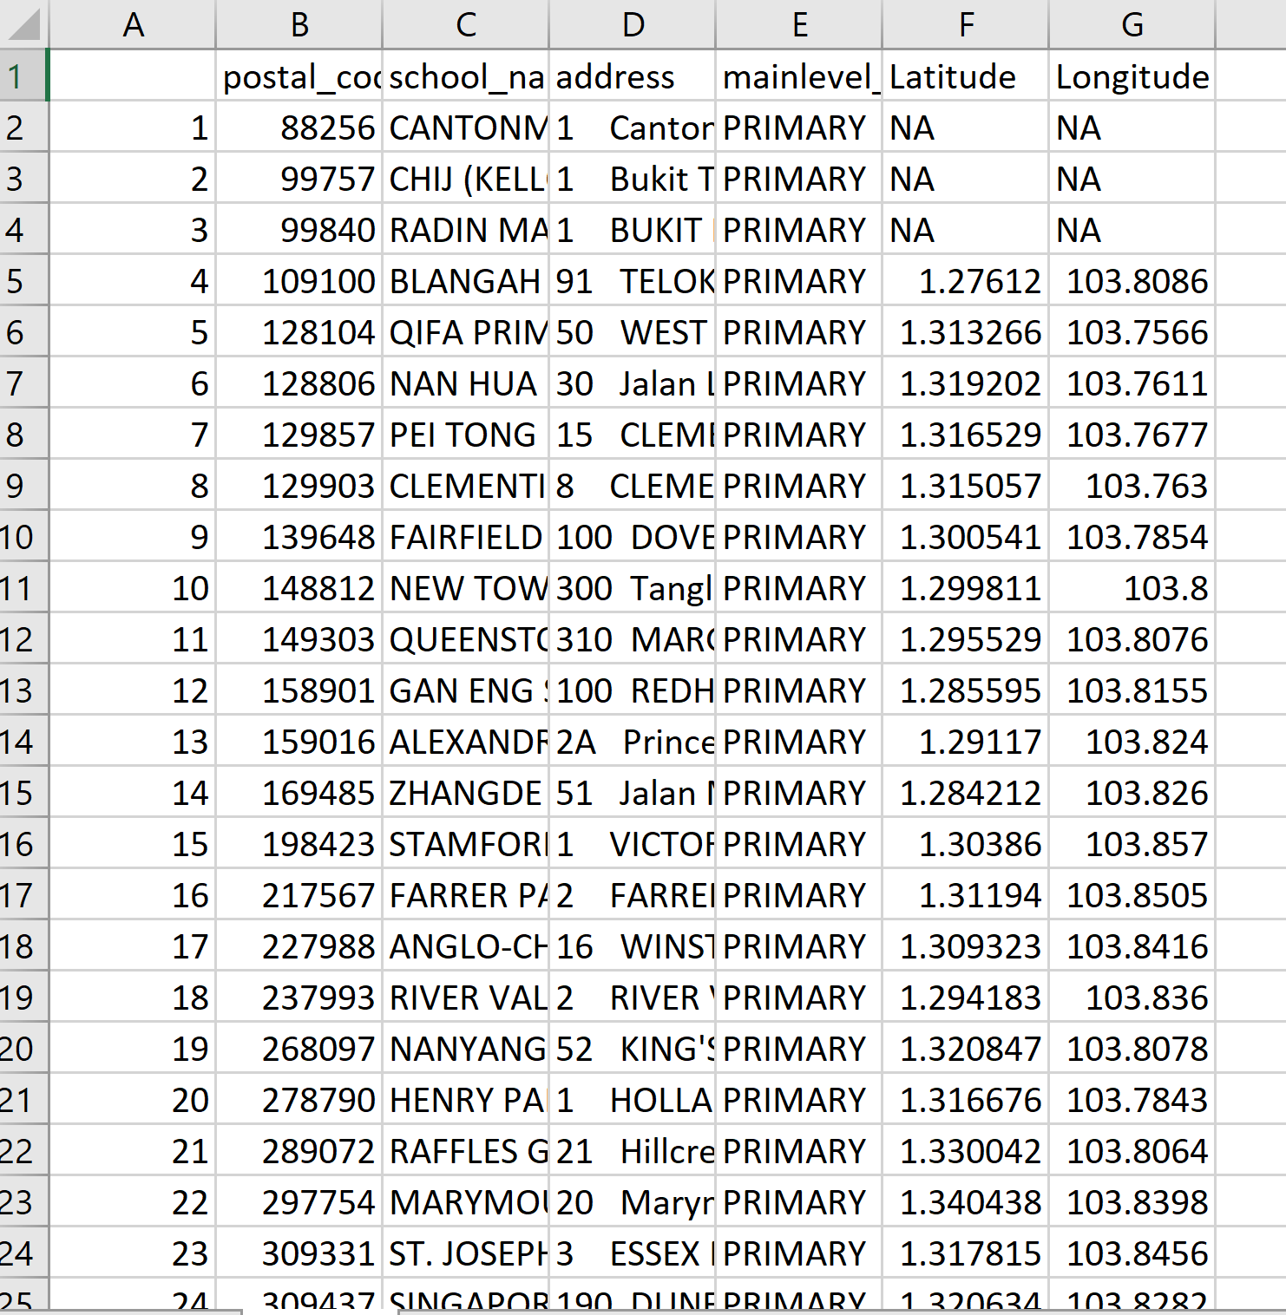

Notice the first 4 entries do not have values under Latitude and Longitude.

1. Collate the 4 primary schools without any values in the Latitude and Longitude fields and save them in not-foundschools.csv.
   1. Create two new fields: country and city
   2. Fill the cell below country and city fields with Singapore.

The final not-foundschools.csv should look similar to this.

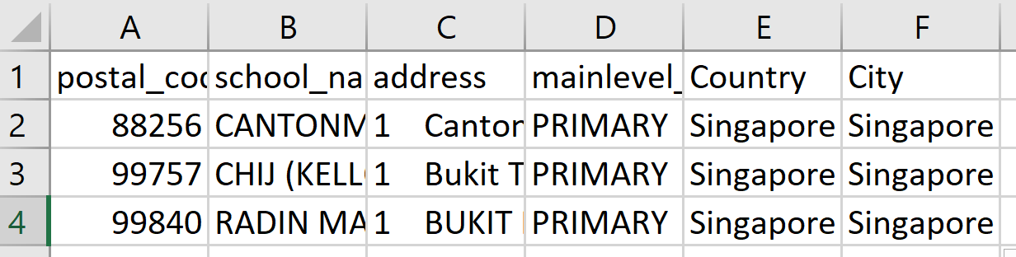

**Installing the MMQGIS Plugin**

To install the MMQGIS plugin, you will need to load the QGIS plugin repository by following the steps below.

* From the menu bar, select **Plugins → Manage and Install Plugins.**

**Plugins** dialog window appears as shown below.

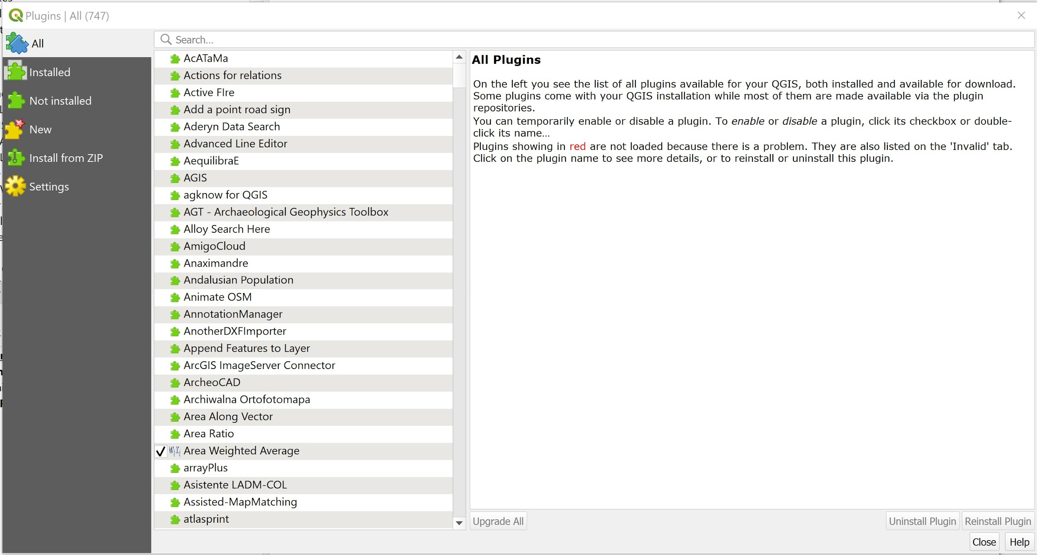

Notice that there is a long list of plugins available. We can use the Search function to locate mmqgis plugin easily.

* At Search, type *mmqgis*.

Your screen should look similar to the figure below.

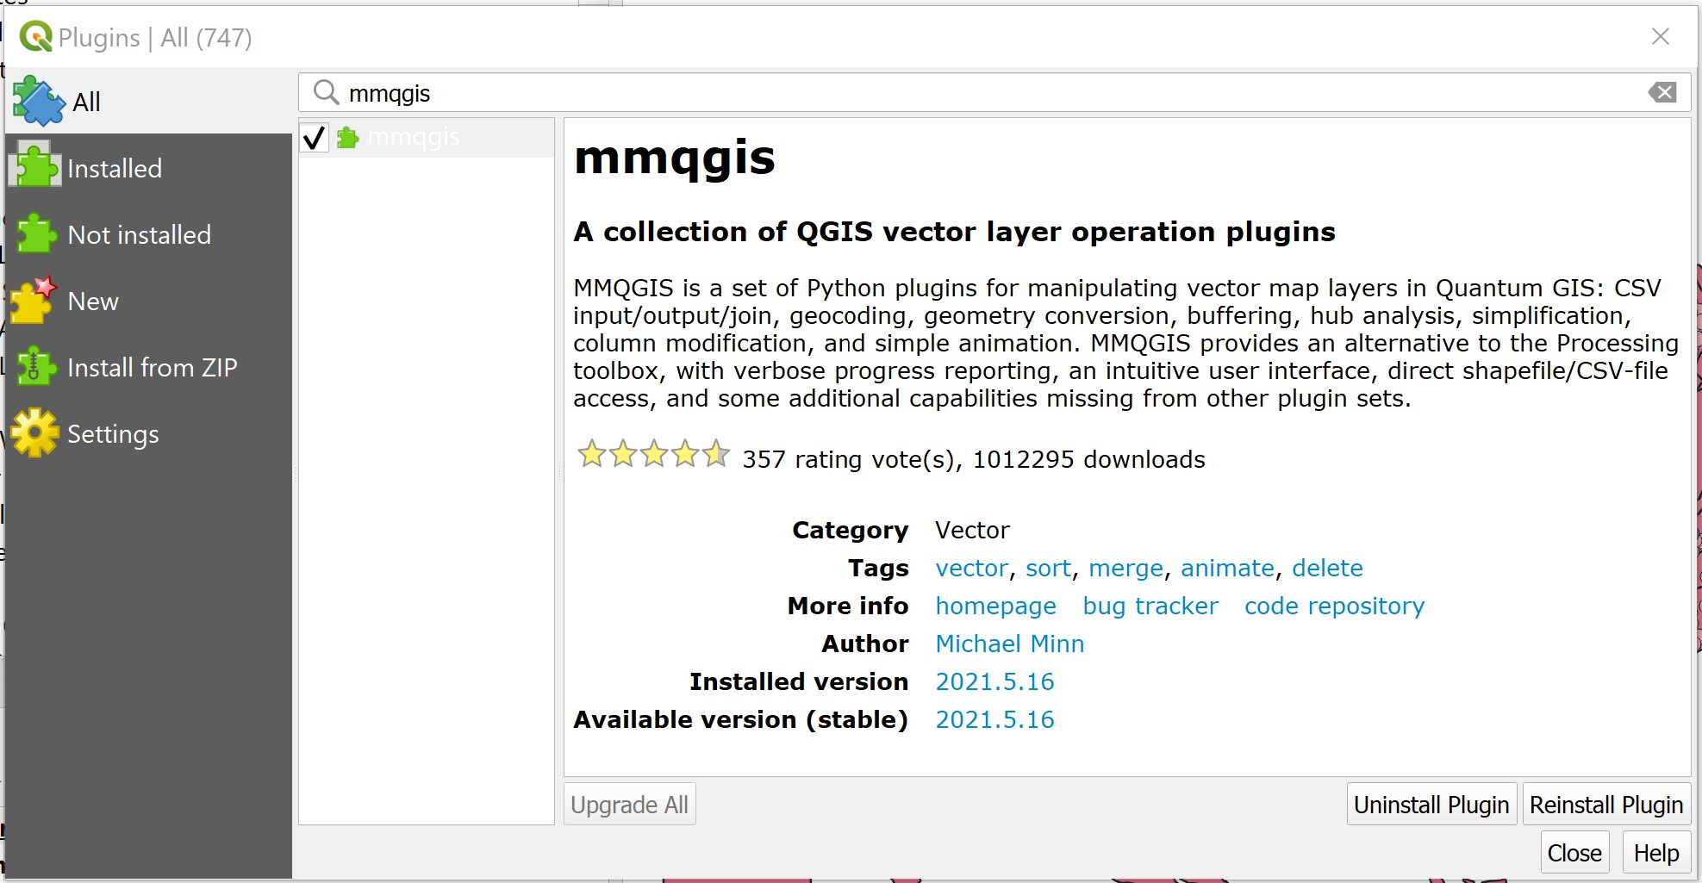

* Click on **Install Plugin** button to run the installer.

After installing mmqgis plugin, remember to close the **Plugin** dialog window.

* Click on **Close** button.

### Geocoding using MMQGIS Plugin

Now, you are ready geocode not-foundschools dataset.

* From the menu bar, select **MMQGIS → Geocode → Geocode CSV with Web Service.**

Web Service Geocode dialog window appears.

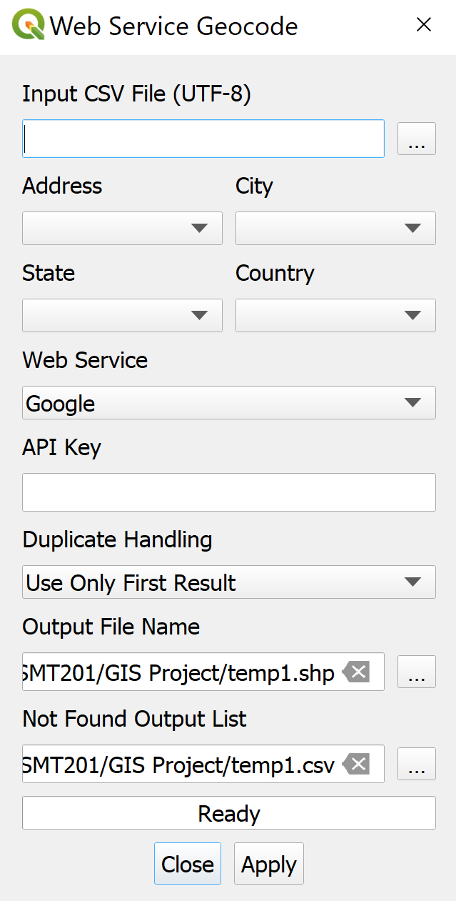

* From Input CSV File (UTF-8), click on **Browse** button.

Select a file dialog window appears.

* Navigate to the path where not-foundschools.csv reside.
* Click on not-foundschools.csv.
* Click on **Open** button.

Your screen should similar to the screenshot below.

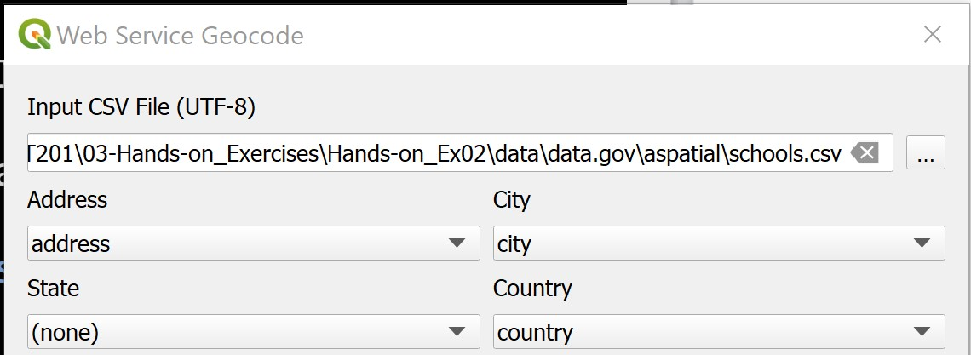

* For *Web Service*, select OpenStreetMap/Nominatim from the drop-down list.

Geocode Tool will generate two output files. They are a point feature GIS data set along with a *Not Found CSV* file containing all rows that could not be geocoded (for whatever reason). We need to tell Geocode Tool where to keep these two output files.

* Use File Explorer to create a new sub-folder called *geocoding* in GISProject directory.
* For Output File Name, click on Browse button.

Create or select a file dialog window appears.

* Navigate to the newly create *geocoding* sub-folder.
* For File name, type geocoded_sch.shp
* Click on Save button.

You also need to provide the Not Found List Output list a place holder.

* For Not Found Output list, click on Browse button.

Create or select a file dialog window appears.

* Navigate to the newly create *geocoding* sub-folder.
* For File name, type not_found_sch.csv
* Click on Save button.

The completed dialog window should look similar to the screenshot below.

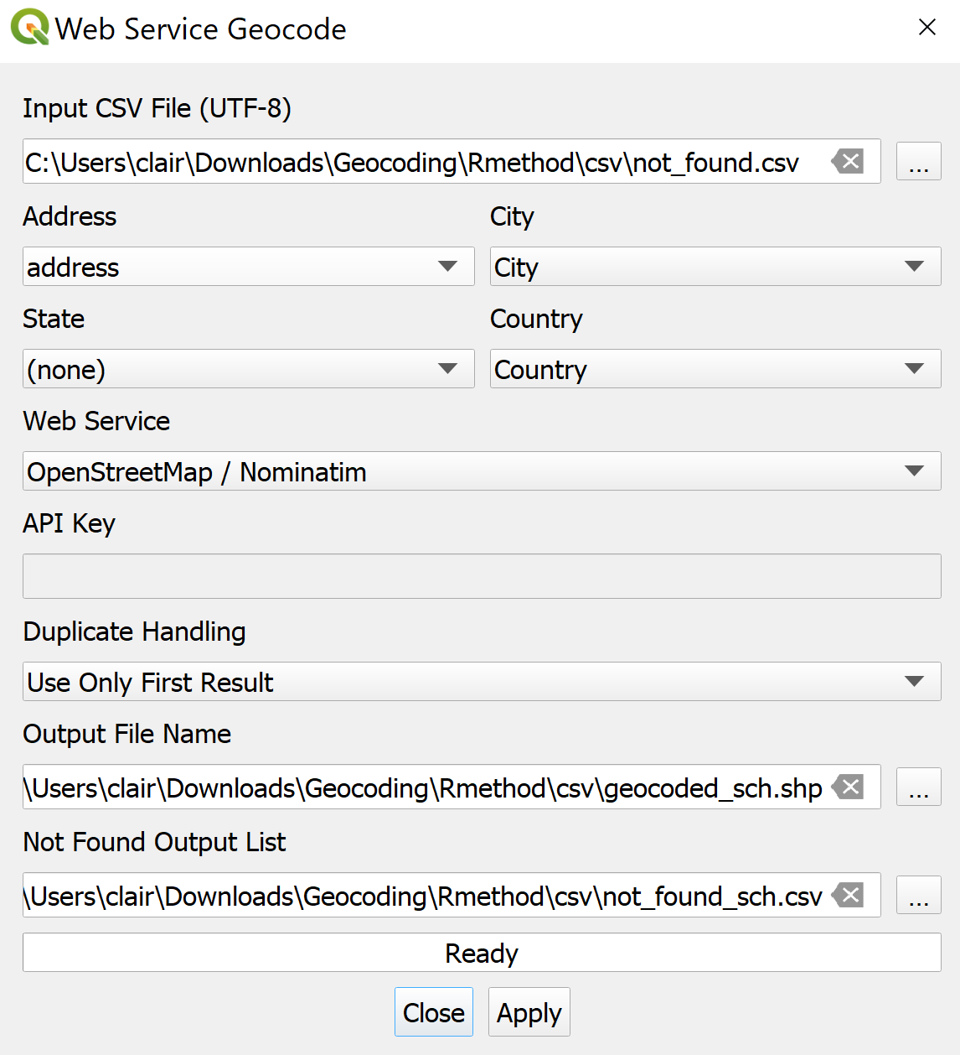

Now, you are ready to perform the geocoding function.

* At the Web Service Geocode dialog window, click on **Apply** button.

When the geocoding function is completed, notice that a new shapefile layer will be added on QGIS map window. At the same time, the progress bar will indicate numbers of records that have been geocoded successfully.

* Click on the **Close** button to close the dialog window.

At the **Layers** panel, right-click on geocoded_schs layer → **Open Attribute Table**

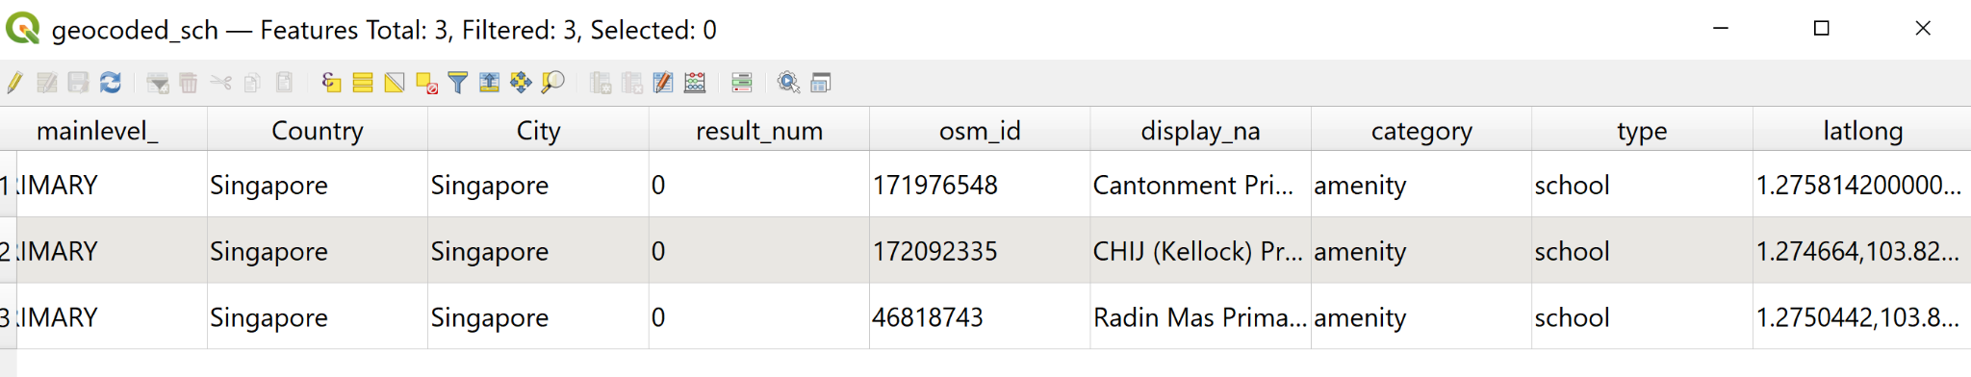

* Extract the values from the latlong field and fill in the missing Latitude and Longitude of the 3 primary schools in the geocoded_school.csv.
* The final geocoded_school.csv should look similar to the screenshot below. Save the file as primary_schools.csv.

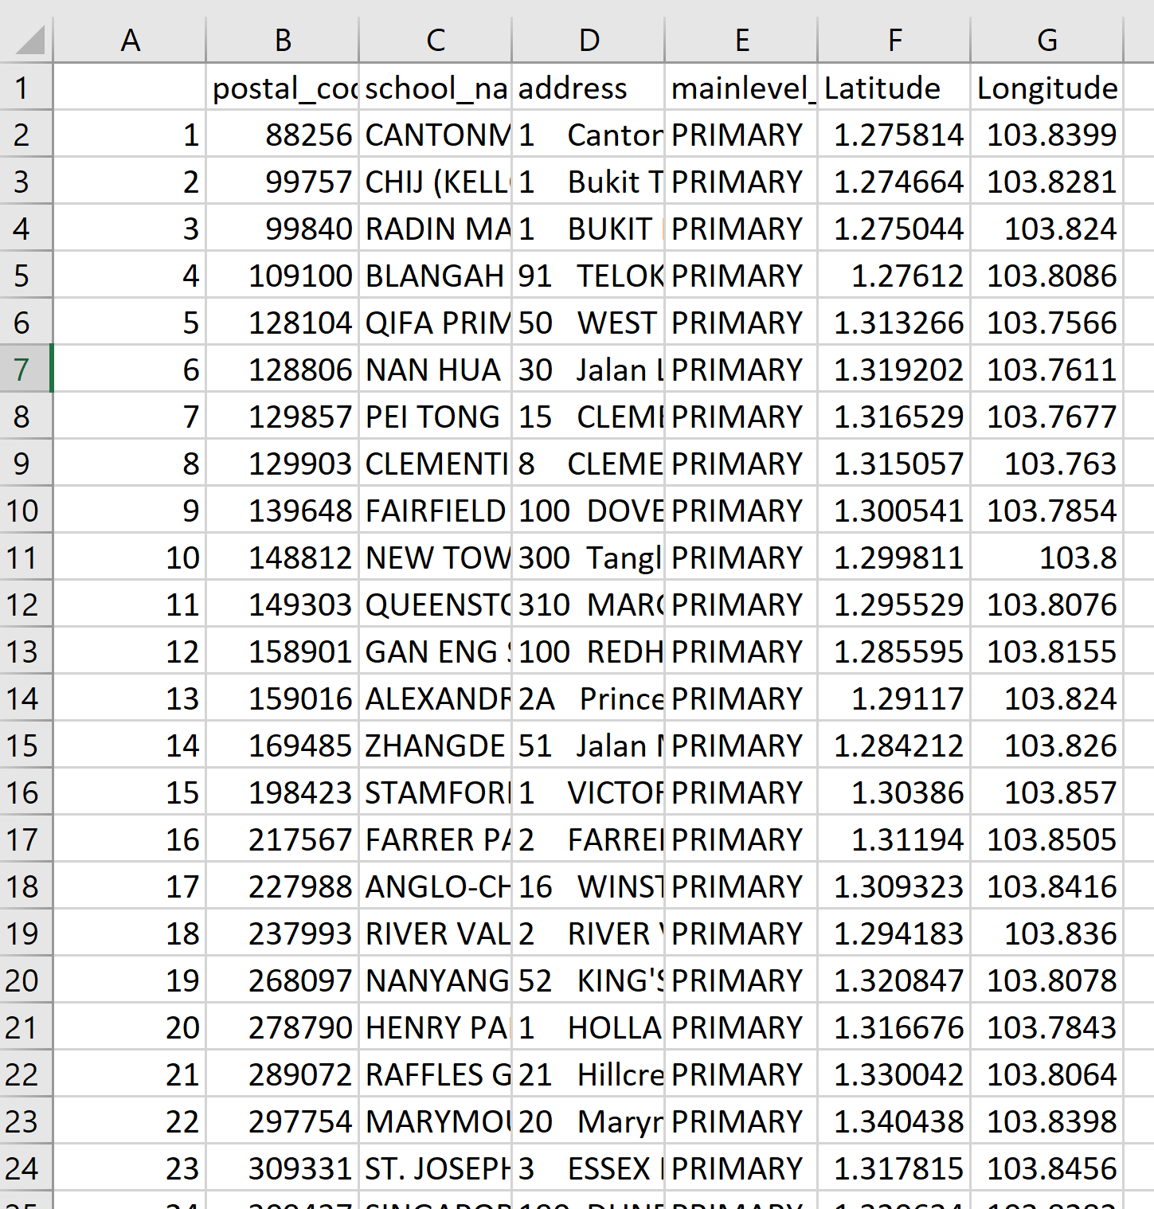

### 3.4.2 Adding Primary School Layer into QGIS Project

We will now import the primary school csv into the project.

* Click **Layer → Add Layer → Add Raster Layer.**

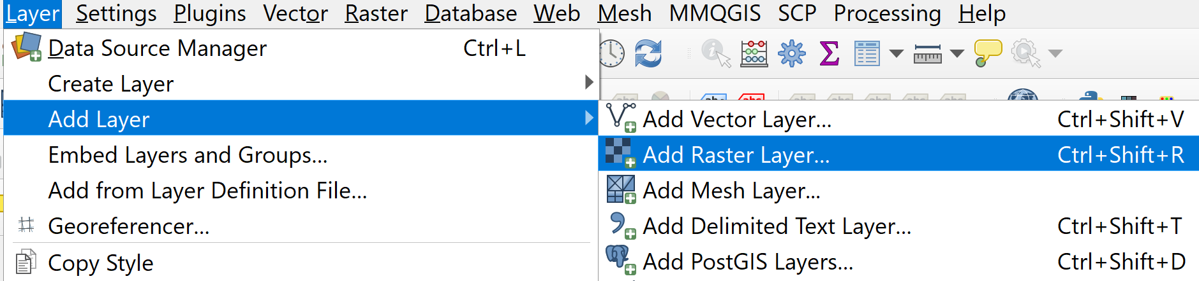

**Data Source Manager | Delimited Text** dialog window appears.

* For **File name,** navigate to the folder where the primary school csv resides
* For **Geometry Definition**, click *Point coordinates* and ensure **X field** is set as *Longitude* and **Y field** is set as *Latitude*
* Click **Add** button.
* Click **Close** button.

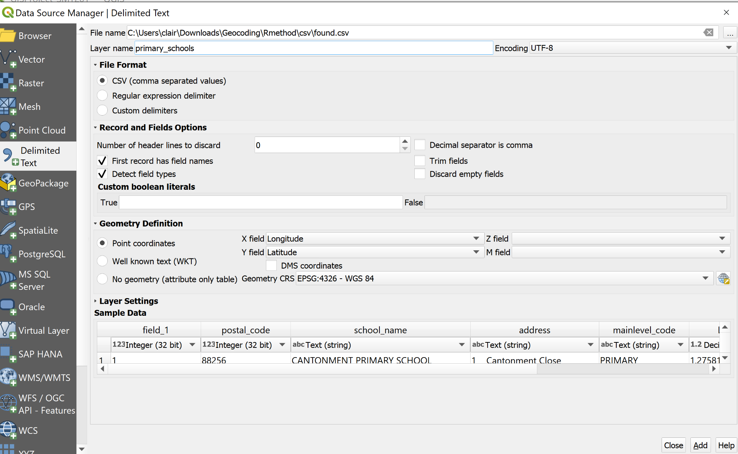

In the **Layers** panel, notice that the primary_schools layer has been added.

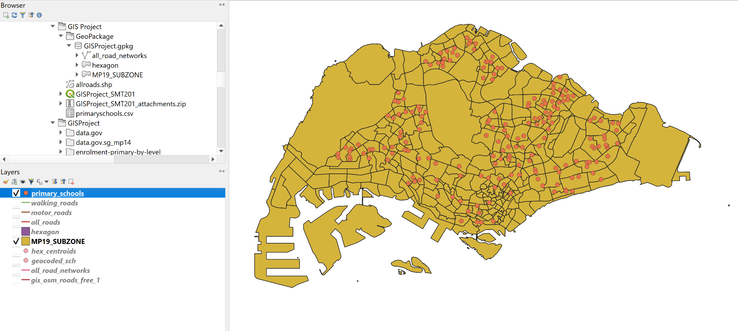

## 3.5 Preparation of Road Network Layer

Using the steps learned from the previous section, import the Road Network Data (gis_osm_roads_free_1.shp) into QGIS. The Road Network data contains road networks from Malaysia, Brunei and Singapore.

### 3.5.1 Selecting all road networks within the study area

Using spatial query function of QGIS, extract the road network features that fall within Singapore mainland study area.

1. From the icon bar, click on the drop-down list next to **Selection** icon
   1. Select **Select Features by Polygon** from the drop-down list

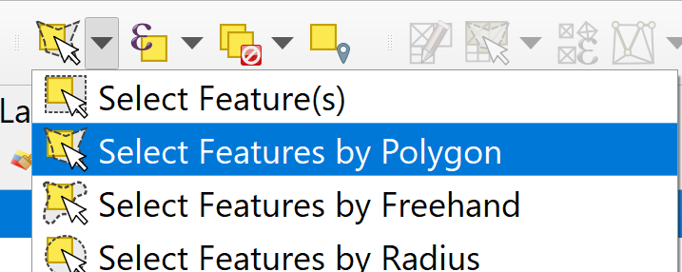

1. At **Browser** panel, click on gis_osm_roads_free_1 to make sure that it is the active layer.
2. Click and drape to form a freehand coloured shape to cover all the road network features that fall within Singapore mainland.
3. Next, release the mouse and notice that all the selected features are highlighted.

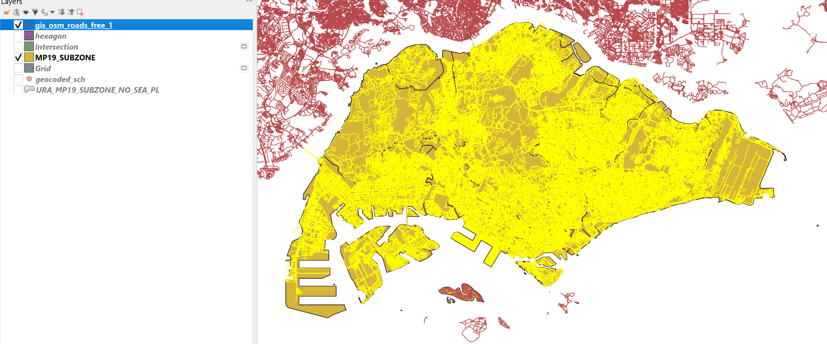

1. Using the steps learned from previous sections, save the selected features in GeoPackage format. Name the layer all_road_networks.Your screen should look similar to the screenshot below.

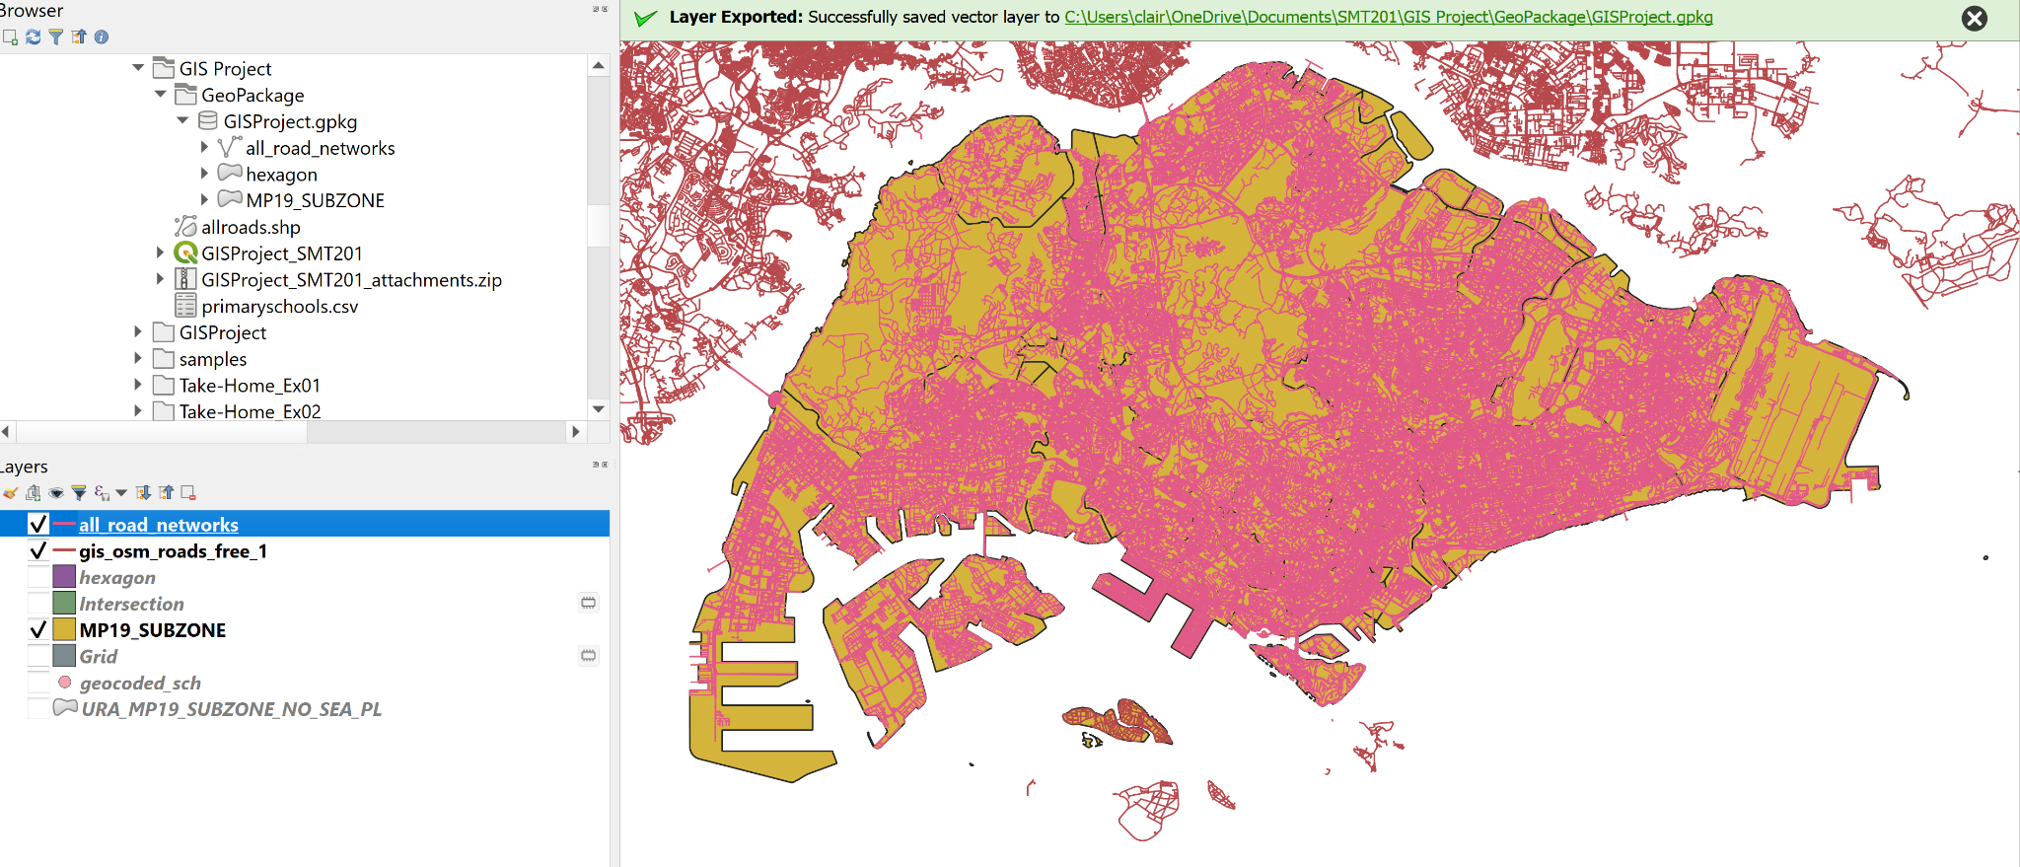

To further filter the road network layer, we will exclude roads that are not walking or motor roads.

1. Under the **Layers** panel, right click on all_road_networks → **Open Attribute Table**
2. Click on the **Select features using an expression** icon. The **Select features by expression** dialog window will appear.
3. At the upper left corner of the window, click on the **Expression** tab.
   1. Under the expression pane, key in the following:

**"fclass" not in (‘bridleway’, ‘track’, ‘track_grade1’, ‘track_grade2’, ‘track_grade3’, ‘track_grade4’, ‘track_grade5’, ‘unclassified’, ‘unknown’)**

The query statement in the Expression pane should look similar to this:

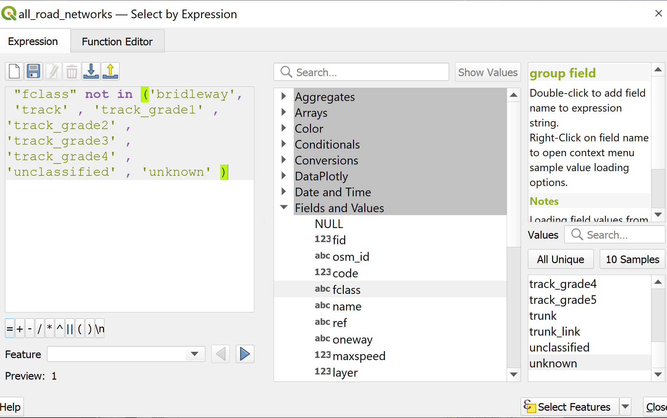

1. Click on **Select Features** button and close the window.
2. Using the steps learned from previous sections, save the selected features in GeoPackage format. Name the layer all_roads.

### 3.5.2 Extracting Motor Vehicle Road Network

1. Under the **Layers** panel, right click on all_roads → **Open Attribute Table**
2. Click on the **Select features using an expression** icon. The **Select features by expression** dialog window will appear.
3. At the upper left corner of the window, click on the **Expression** tab.
   1. Under the expression pane, key in the following:

**"fclass" = 'motorway' or "fclass" = 'motorway_link' or "fclass" = 'primary' or "fclass" = 'primary_link' or "fclass" = 'secondary' or "fclass" = 'secondary_link' or "fclass" = 'tertiary' or "fclass" = 'tertiary_link' or "fclass" = 'residential' or "fclass" = 'trunk' or "fclass" = 'trunk_link'**

The query statement in the Expression pane should look similar to this:

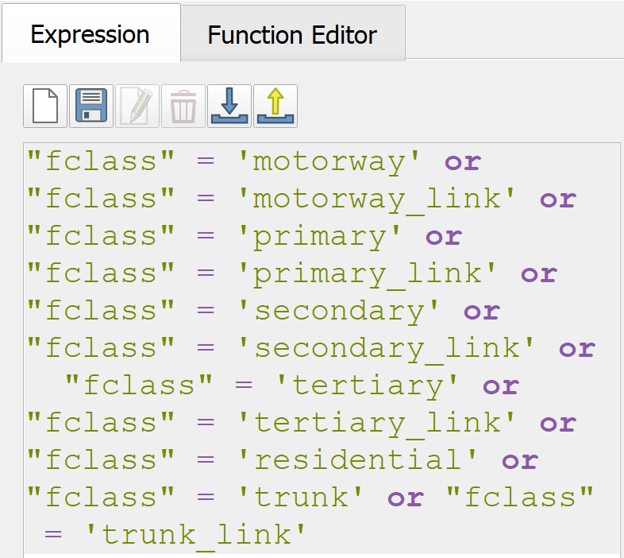

1. Click on **Select Features** button and close the window.
2. Using the steps learned from previous sections, save the selected features in GeoPackage format. Name the layer motor_roads.The motor_roads layer should look similar to the screenshot below.

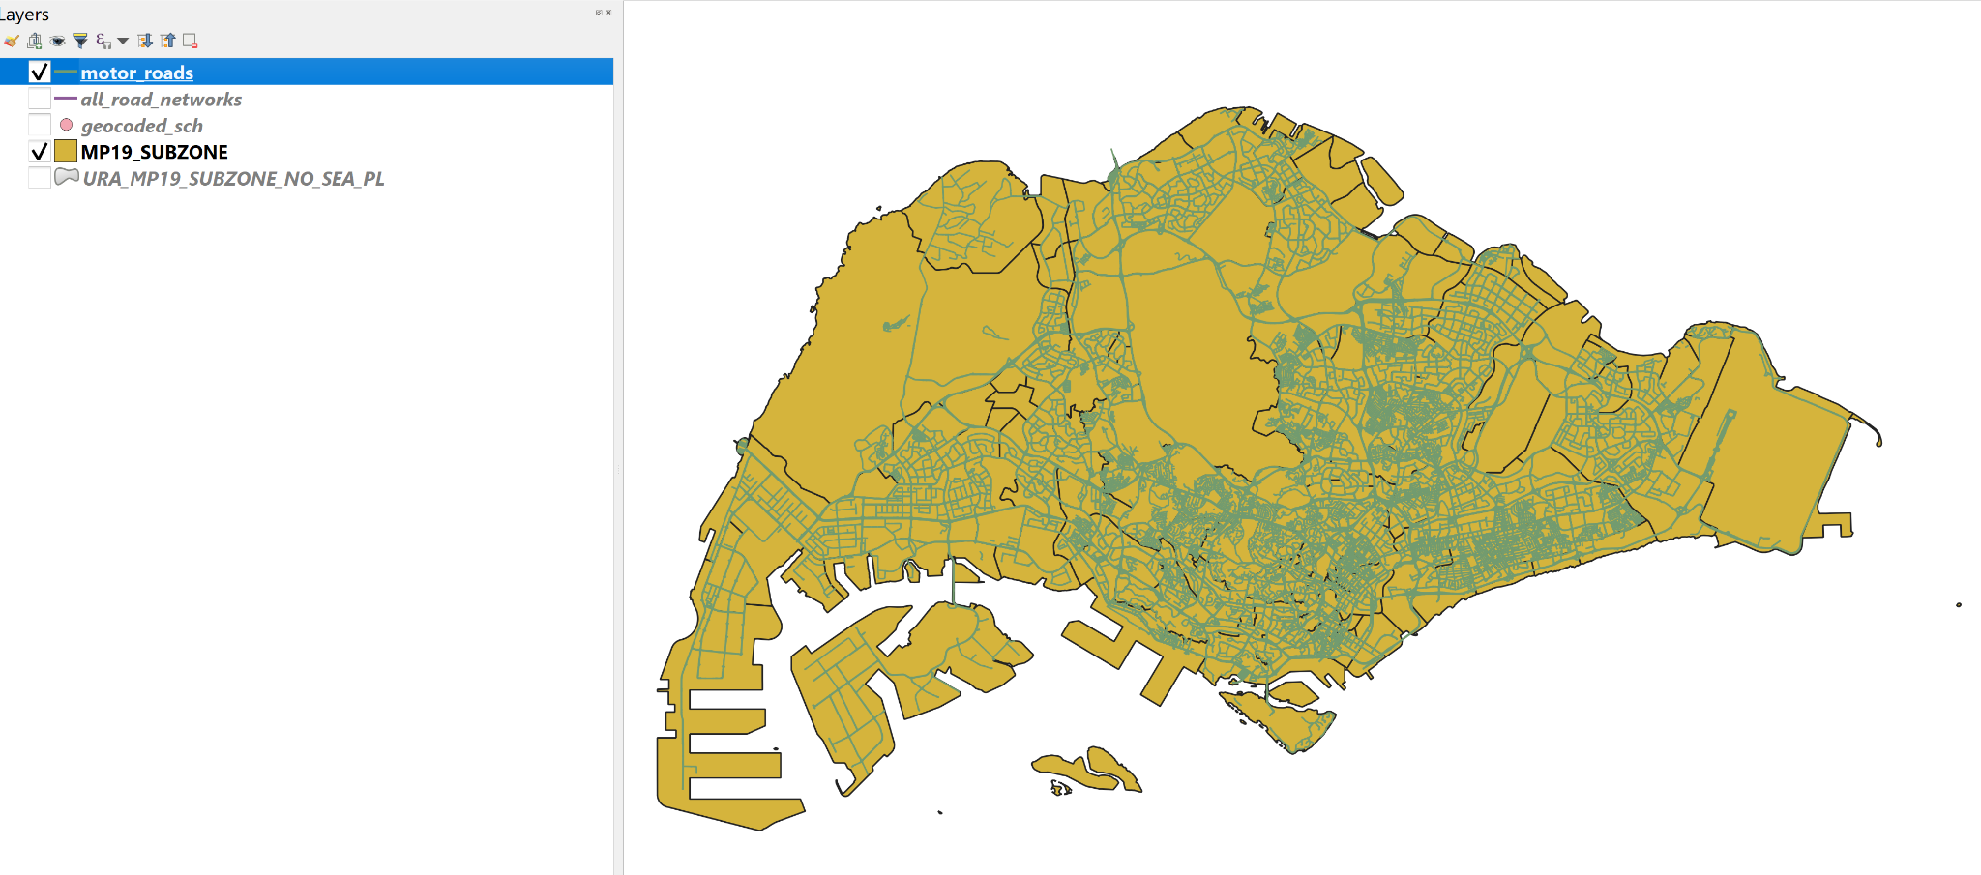

### 3.5.3 Extracting Pedestrian Path Network

Using appropriate QGIS functions learnt from previous sections, extract the pedestrian path network from the all_road_networks layer.

1. Under the expression pane, key in the following:

**"fclass" = 'residential' or "fclass" = 'living_street' or "fclass" = 'pedestrian' or "fclass" = 'service' or "fclass" = 'cycleway' or "fclass" = 'footway' or "fclass" = 'path' or "fclass" = 'steps'**

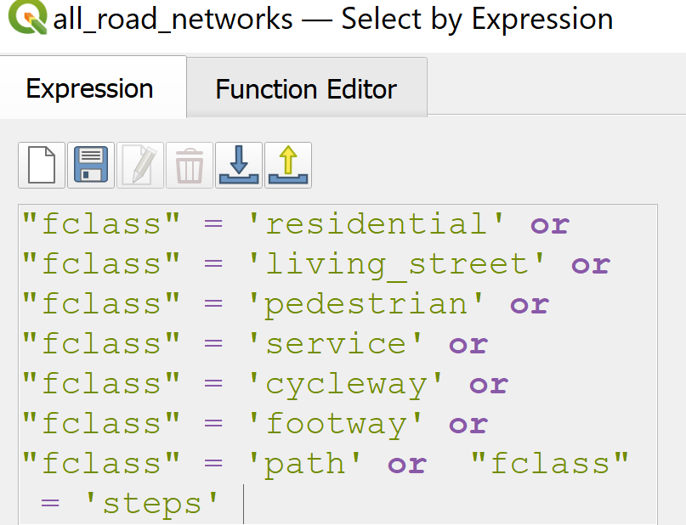

1. Using the steps learned from previous sections, save the selected features in GeoPackage format. Name the layer walking_roads.The walking_roads layer should look similar to the screenshot below.

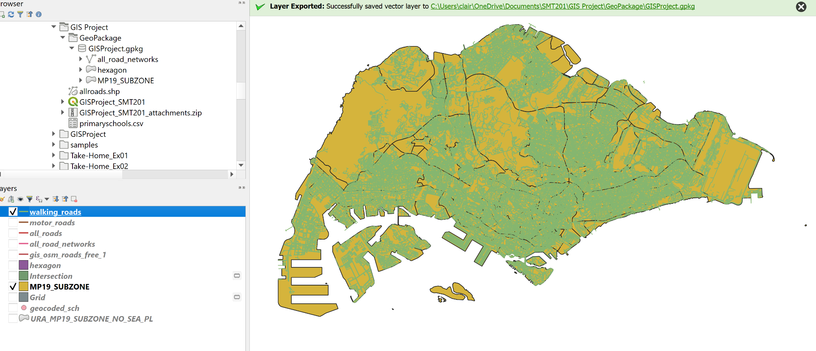

3.6 Preparation of Young People Distribution Layer

Using the steps learned previously, import Singapore Residents by Planning Area / Subzone, Single Year of Age and Sex, June 2011-2020 layer (*respopagesex2011to2020*) into the project.

## 3.6.1 Extracting Youth Population

We will now use SQL to extract the distribution of the youth population from *respopagesex2011to2020*.

1. Click **Processing → Toolbox**
2. Type *Execute SQL*into the search bar.
3. **Execute SQL** toolbox appears.
   1. For *Additional input datasources,* select *respopagesex2011to2020*
   2. For SQL query, type

Select "PA", "SZ", sum("Pop") as "Young People"

from respopagesex2011to2020

where "Time" = "2019" and "Age" in (‘0’,’1’,’2’,’3’,’4’,’5’,’6’,’7’,’8’,’9’,’10’,'11','12','13','14','15','16','17','18',')

group by "PA","SZ"

* 1. For *Geometry type*, select **No geometry**

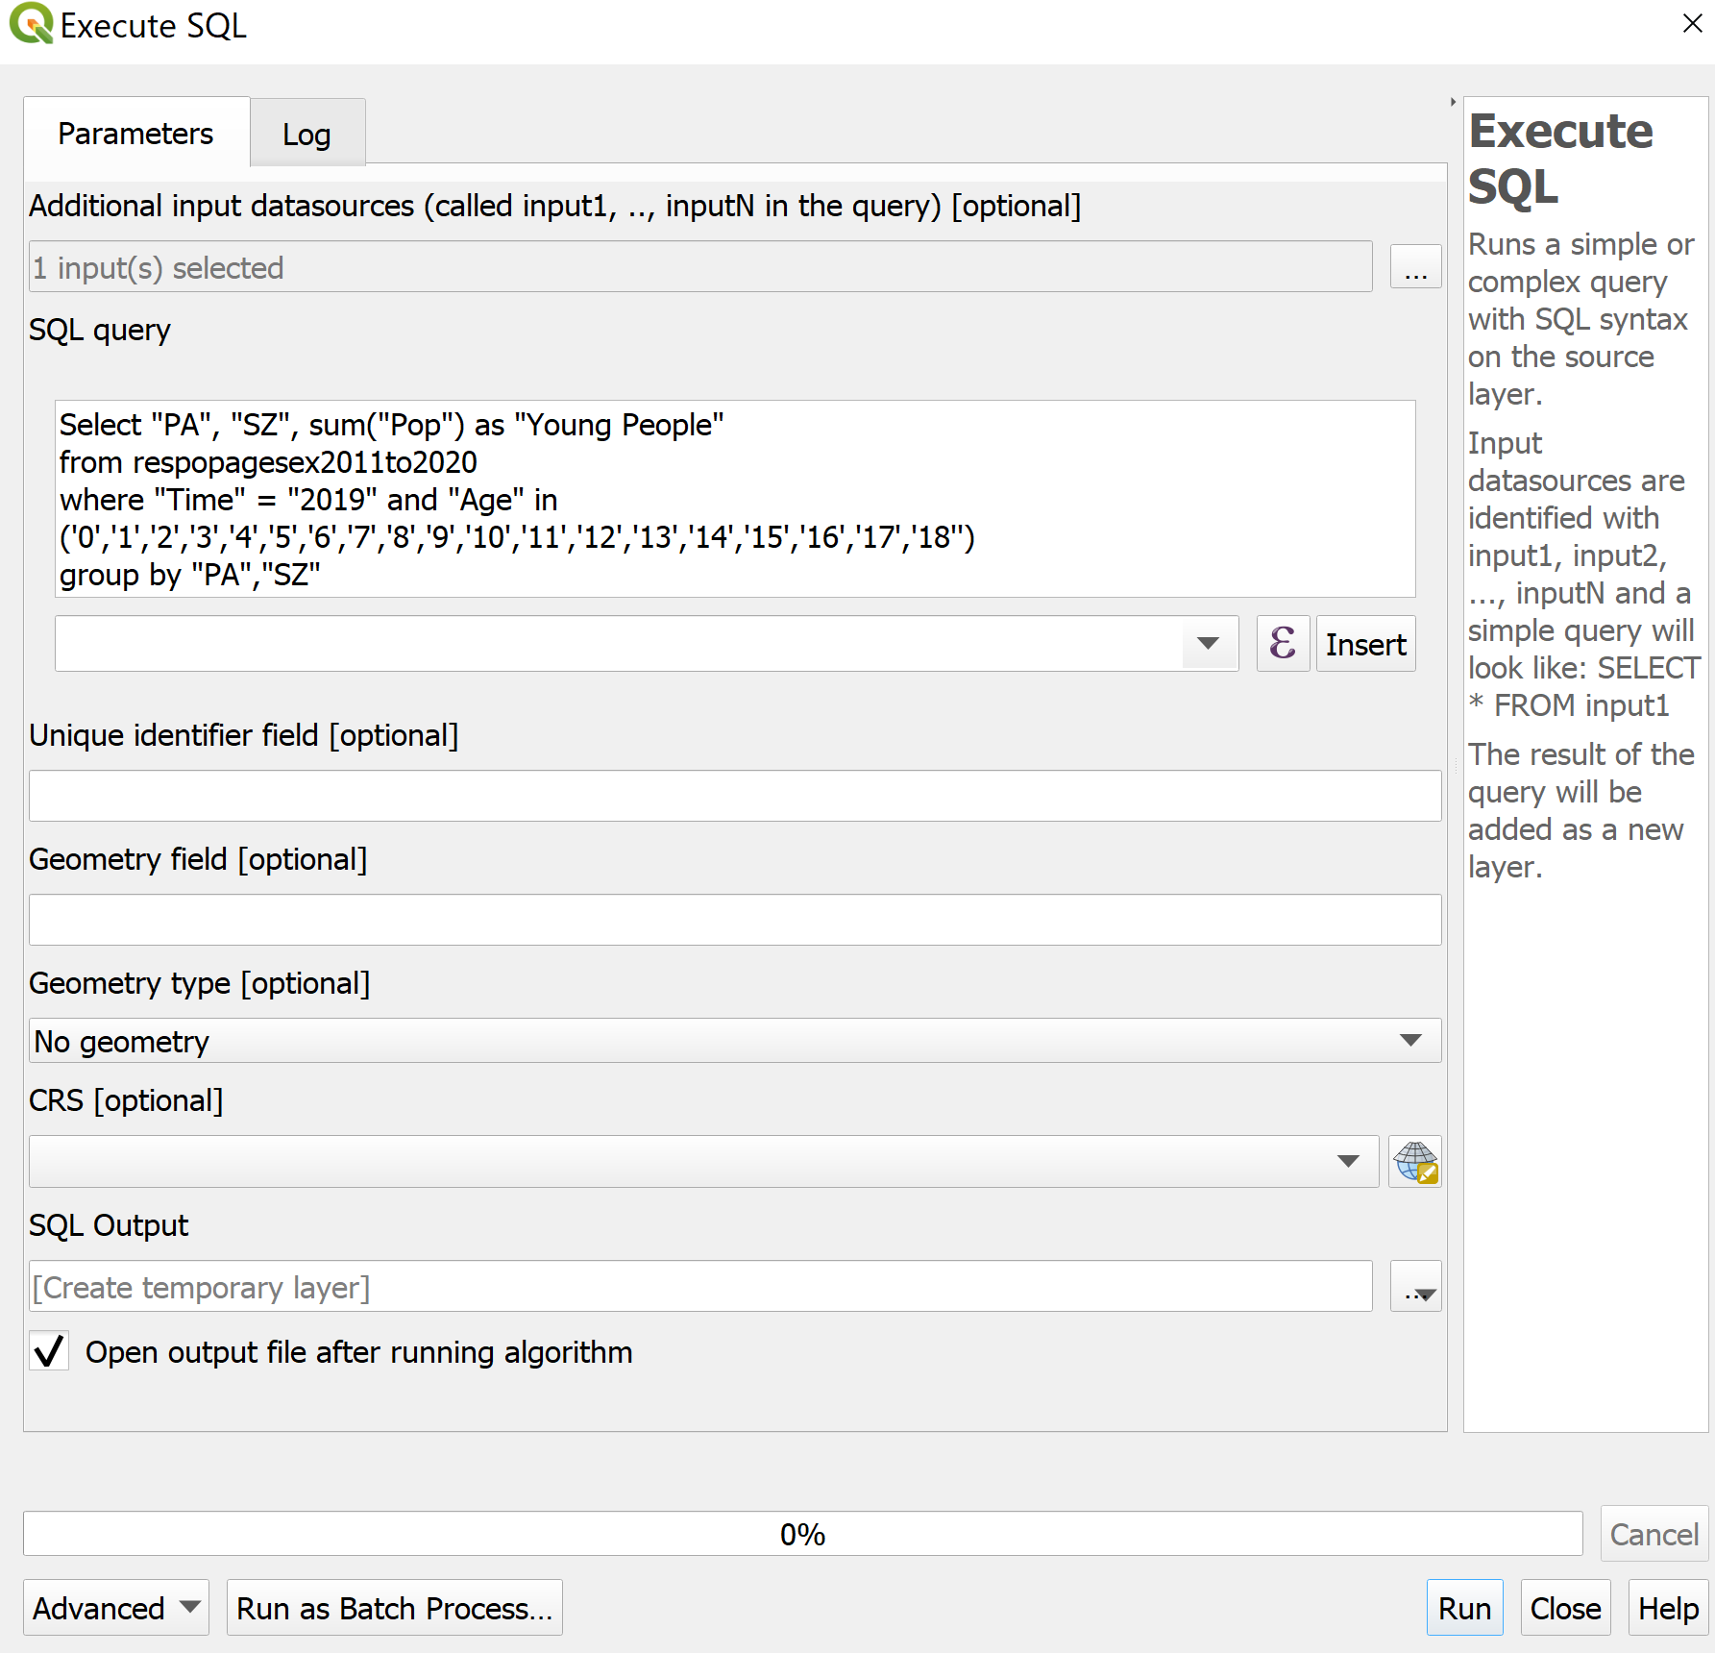

* 1. Click **Run** button.
  2. A new layer called SQL Output will appear in the **Layers** panel.

## 3.6.2 Creating Relational Join

We will now perform relational join between the SQL Output layer and the MP19_SUBZONE layer.We will use the subzone name as the unique identifier to join these two layers.

1. Right-click on SQL Output → select **Open Attribute Table.** Observe that the **SZ** column values are currently in lower case. We will change the values to upper case.
2. Click **Open field calculator ** icon
3. Click **Update existing field**
4. For *Value*, select **SZ**
5. Under **Expression** panel, type **upper(“SZ”)**
6. Click **OK** button

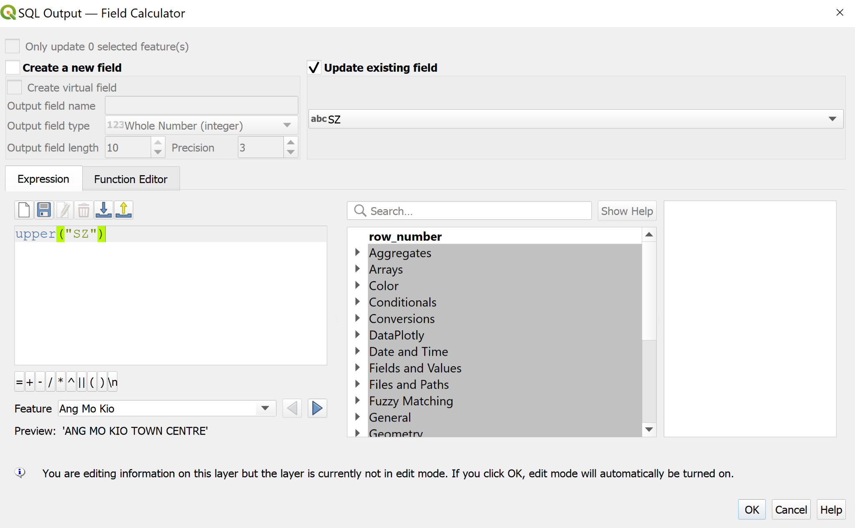

Notice that the **SZ** column values are now in upper case.

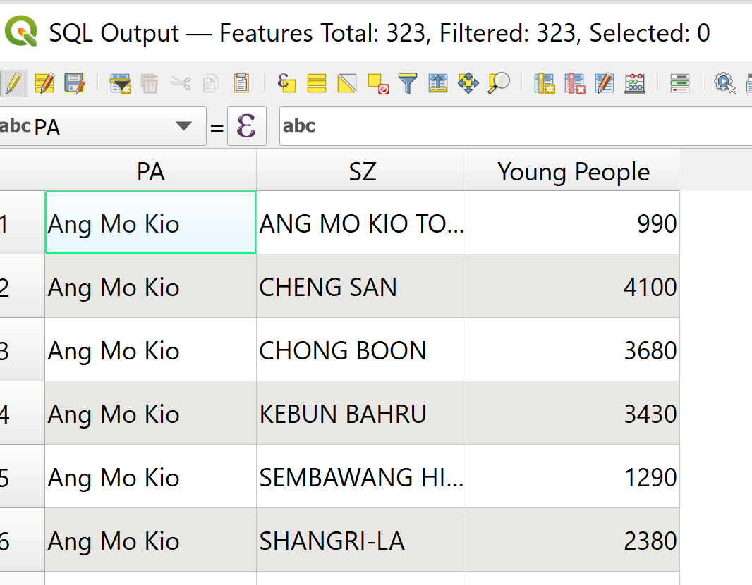

Using the steps learned previously, save SQL Output into Geopackage format. Name the layer Young People Distribution.

We will now join the Young People Distribution layer and the MP19_SUBZONE layer.

1. Right click on MP19_SUBZONE layer → click **Properties** → click **Joins**
2. Click on the **+** icon at the bottom of the screen.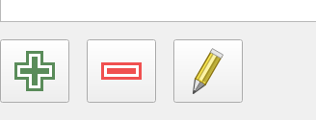
3. The **Add Vector Join** dialog window appears.
   1. For *Join layer*, select **Young People**
   2. For *Join field*, select **SZ**
   3. For *Target field*, select **SUBZONE_N**

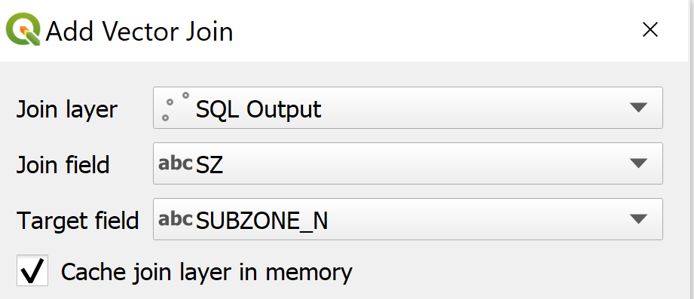

1. Click **OK** button.

Notice that a relational join between Young People and MP19_SUBZONE has been created.

## 3.6.3 Creating Choropleth Map to Display Youth Population Distribution

We will now prepare the choropleth map to analyse the distribution of the youth population.

1. From the **Layers** panel, right-click on MP19_SUBZONE layer → click **Properties.**
2. The **Layer Properties** dialog window appears. Click on **Symbology** tab
   1. At *Symbol* selection drop-down list, select **Graduated** from the drop-down list
   2. For *Value*, select **Young_People_Distribution_Young_People**
   3. For *Classes*, keep it as 5
   4. For *Color* ramp, choose **Blues**
   5. For *Mode*, select **Natural Breaks (Jenks)** from the drop-down list
   6. Click **Classify** button

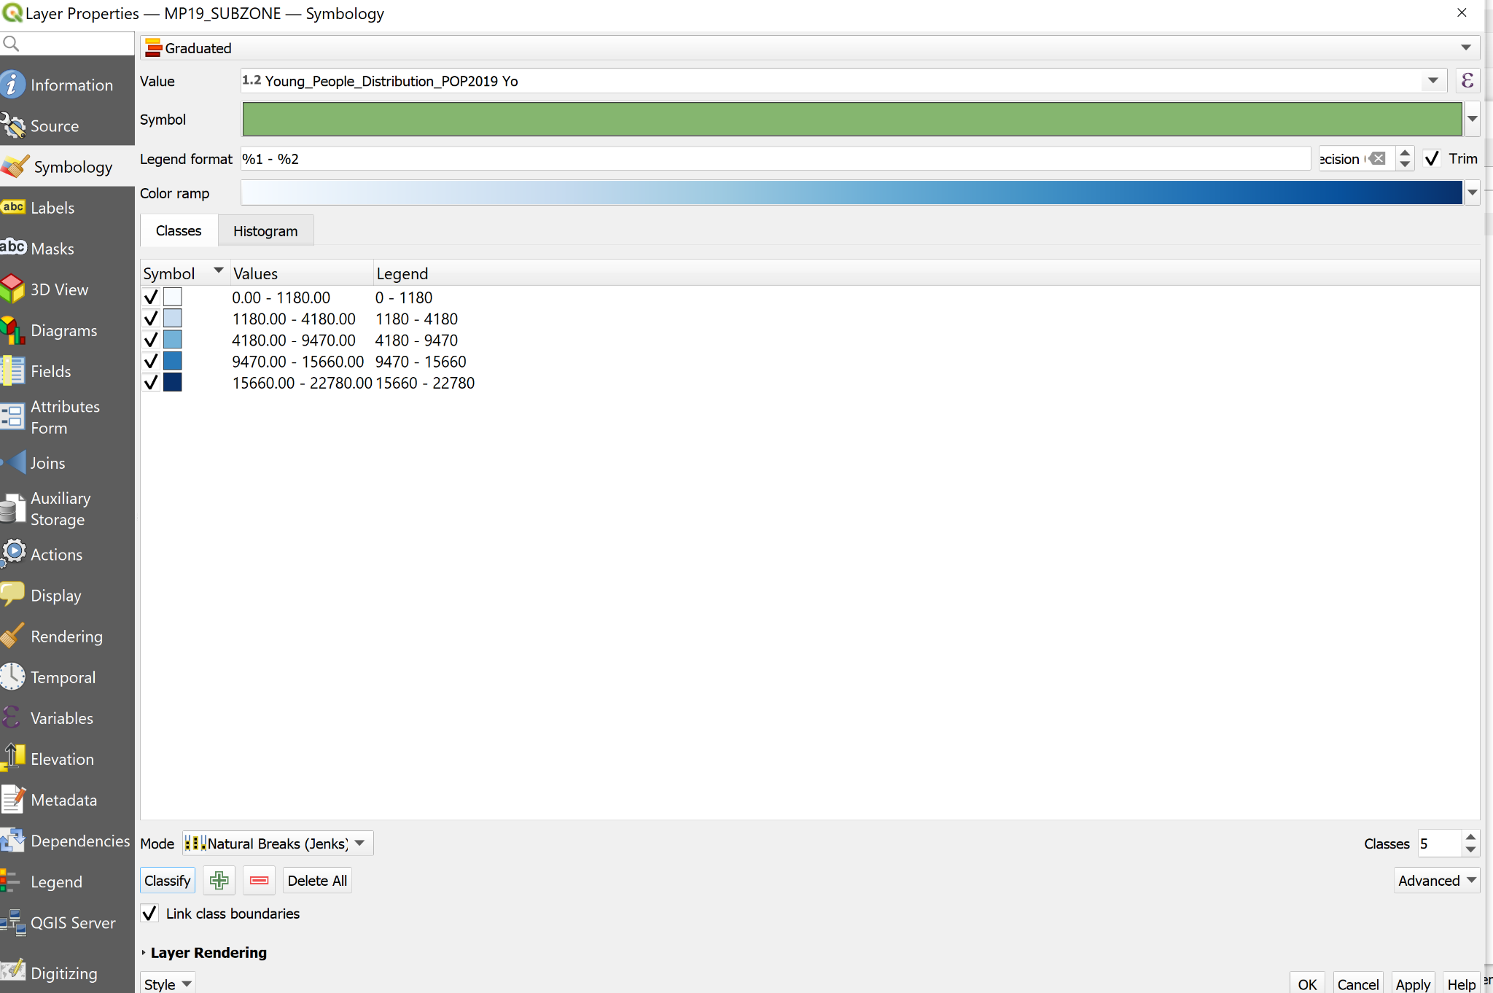

1. Click the OK button.Notice that a choropleth map is now formed.

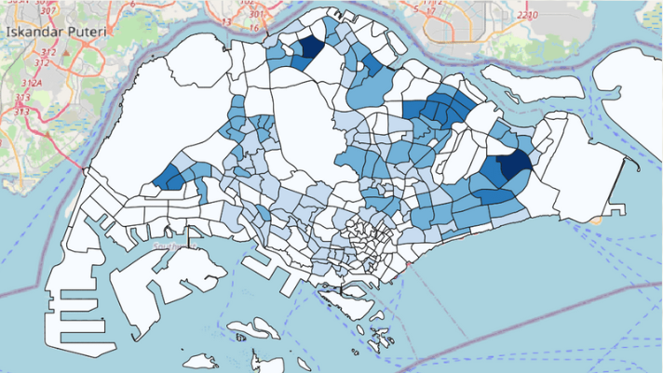

# 4. Preparing Maps for Analysis

## 4.1 Creating the hexagon layer

Now, we are going to create a hexagon layer by using the MP19_SUBZONE layer as the base. The hexagon distance is 250m.

* From the menu bar, select **Vector → Research Tools → Create Grids**.

**Create Grids** dialog window appears.

* For Grid type: select *Hexagon (Polygon)* from the drop down list.

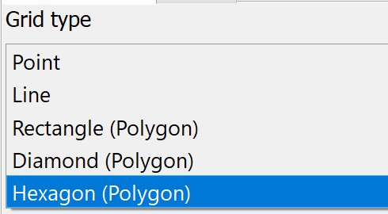

* For Grid extend:, select *Calculate from Layer* → MP19_SUBZONE

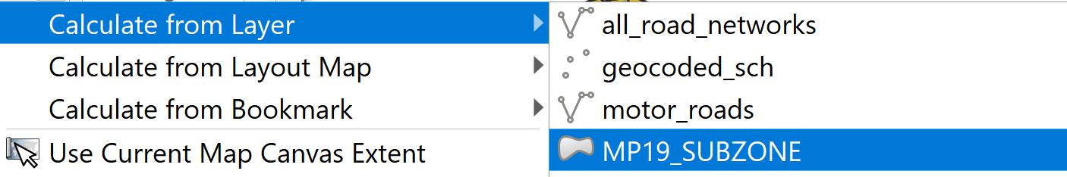

* For Horizontal spacing, type *500*.
* For Vertical spacing, type *500*.
* For Grid CRS, make sure that *EPSG 3414* is used.

When you are ready to run the process,

* Click on **Run** button.

Read the Log before closing the dialog window.

* Click on **Close** button.

Notice that a new temporary layer called Grid is added on the Layer pane and display on **Map** window.

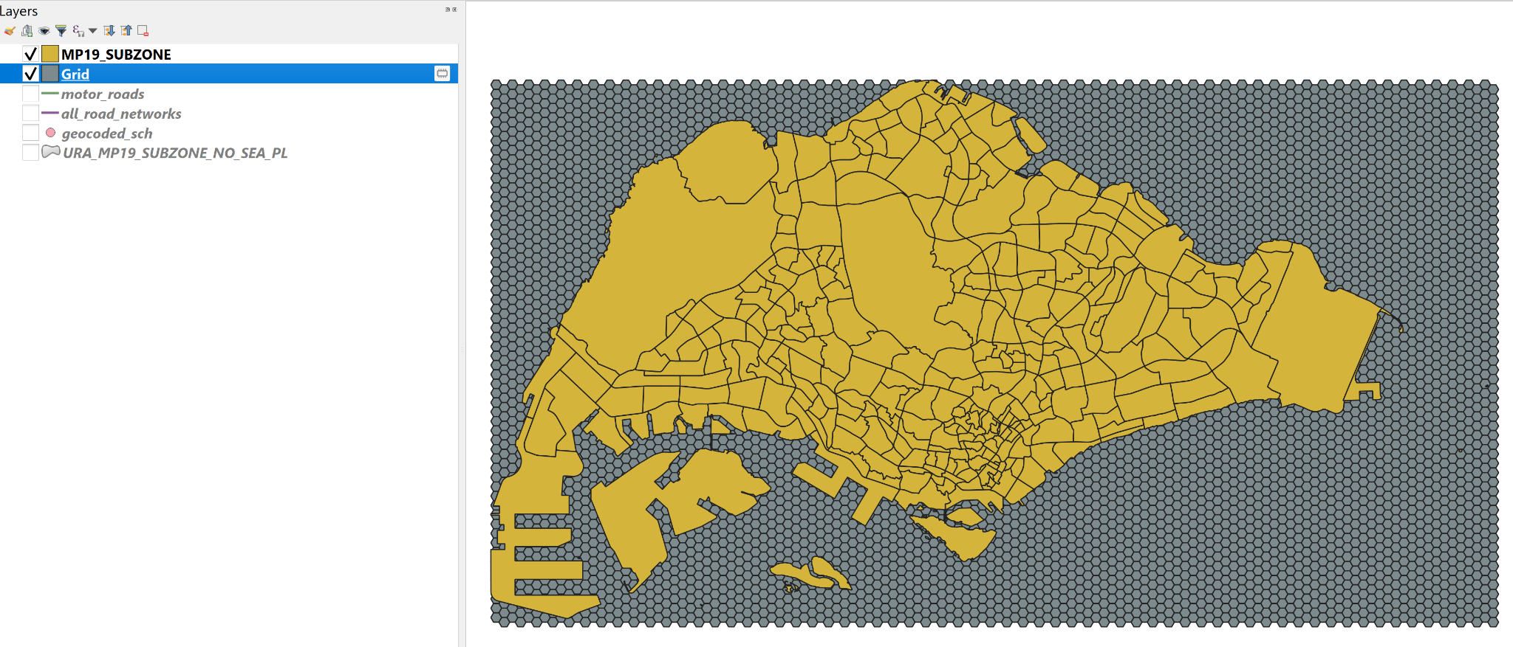

### 4.1.1 Editing the hexagon layer

Using the **Clipped** function, intersect the Grid layer and MP19_SUBZONE layer.

Using **Select features by polygon** function as learnt in the previous section, select the area that falls under Singapore mainland.

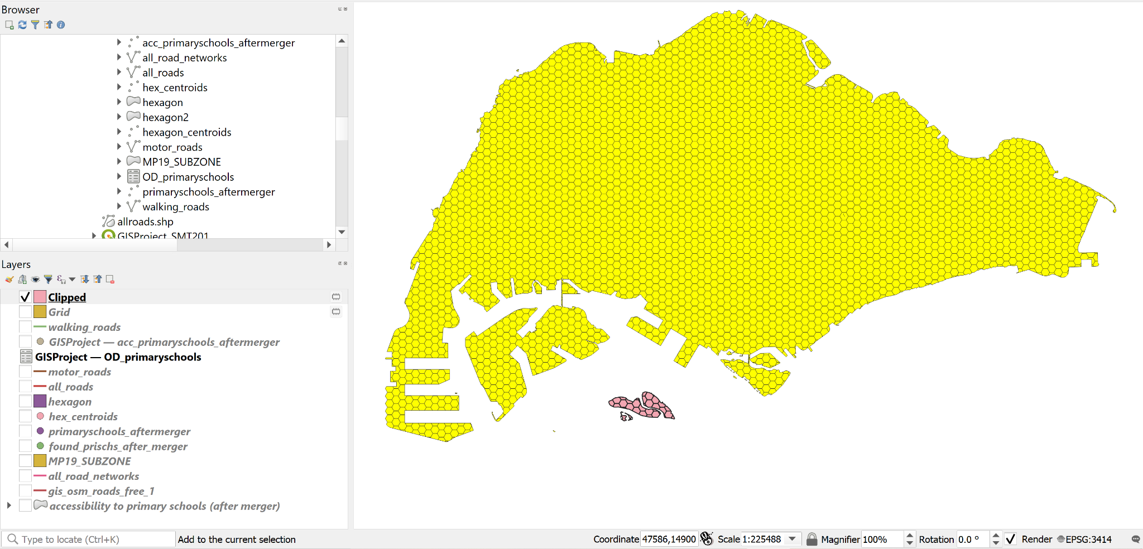

Your screen should look similar to the screenshot below.

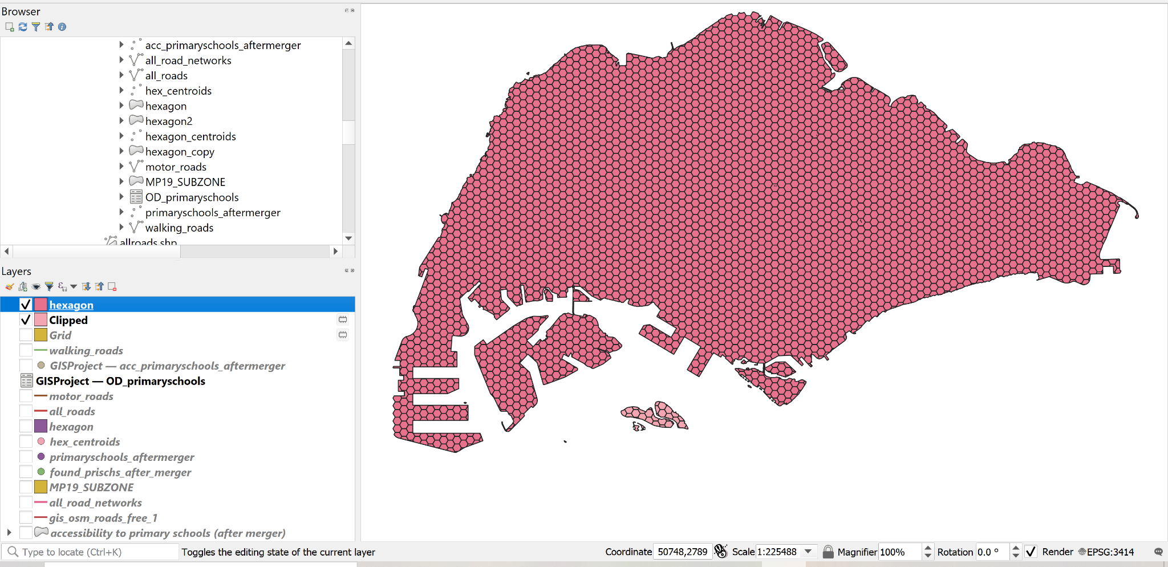

### 4.1.2 Saving the hexagon layer

Using the steps you had learned in previous sections, save the edited Grid layer into GeoPackage format. Name the layer hexagon.

Before you move on to the next section, remember to remove the temporary Grid layer.

### 4.1.3 Computing hexagon centroid

In general, network analysis required the demand in a point feature. Hexagon, on the other hand, is a polygon feature. In order to meet the analysis need, we will compute the centroids of the hexagons.

* From the menu bar, select **Vector → Geometry Tools → Centroids.**

Centroids dialog window appears.

* For **Input layer**, select *hexagon* from the drop-down list.

When you are ready to run the process,

* Click on **Run** button.

Reminder: Read the log before closing.

* Click on **Close** button.

Notice that a new temporary layer called Centroids is added onto the **Layers** panel and display on Map view.

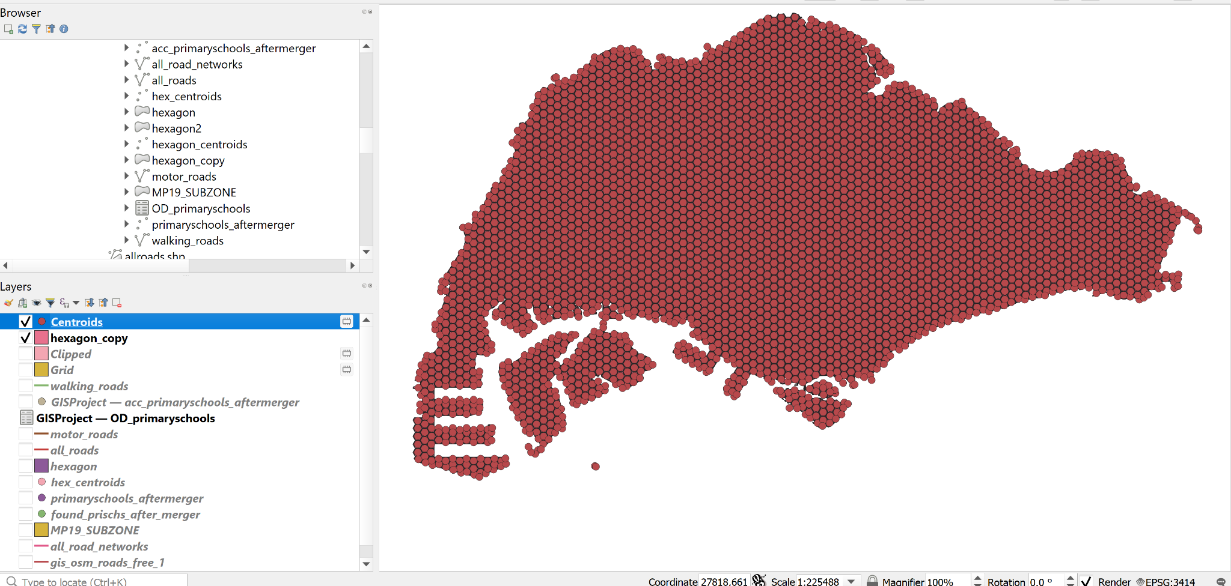

### 4.1.4 Saving the centroid layer

Using the steps you had learned in previous hands-on exercise, save the temporary Centroids layer into GeoPackage format. Name the newly created layer hex_centroids .

Before you move on to the next section, remember to remove the temporary Centroids layer.

## 4.2.2 Network Accessibility Analysis

### 4.2.2.1 Install QNEAT Plugin

1. From the menu bar, select **Plugins → Manage and Install plugins**. **Plugins** dialog window appears.
2. At the query, type QNEAT3. Notice that QNEAT3 appears on the search output list.
3. Click on QNEAT3.
   1. Click on **Install Plugin** button.

When the installation is completed, click on the **Close** button.

### 4.2.2.2 Working with OD Matrix Tool

Next, we will use the Origin-Destination Matrix (OD Matrix) tool of QNEAT3 plugin to calculate the distances between hexagon centrois (as the demand points) and primary schools (as the supply points).

* From the menu bar, click on **Processing → Toolbox**
* At the Search pane, type OD Matrix.

Your screen should look similar to the screenshot below.

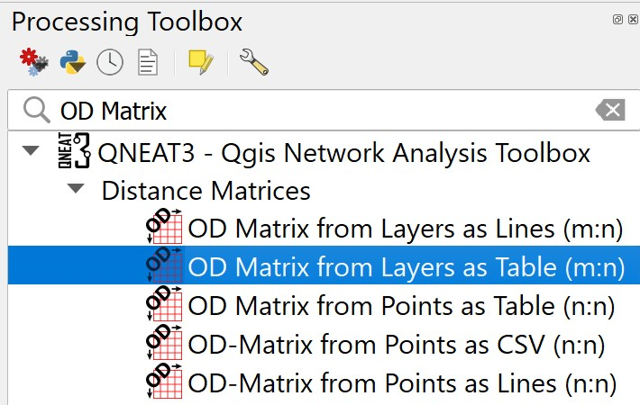

* Click on OD Matrix Layers as Table (m:n).

OD Matrix Layers as Table (m:n) dialog window appears.

* For Network Layer, select motor_roads from the drop-down list.
* For From-Point Layer, select hex_centroids from the drop-down list.
* For Unique Point ID Field, select fid from the drop-down list.
* For To-Point Layer, select primary_schools from the drop-down list.
* For Unique Point ID Field, select fid from the drop-down list.
* For Optimization Criterion, select Shortest Path (distance optimization) from the drop-down list.
* For Entry Cost calculation method, select Ellipsoidal from the drop-down list.
* For Direction field, select oneway from the drop-down list.
* For Value for forward direction, type F.
* For Value for backward direction, type T.
* For Value for both direction, type B.
* For Topology tolerance, type *0.5* (i.e. 0.5 m).

The completed dialog window should look similar to the screenshot below.

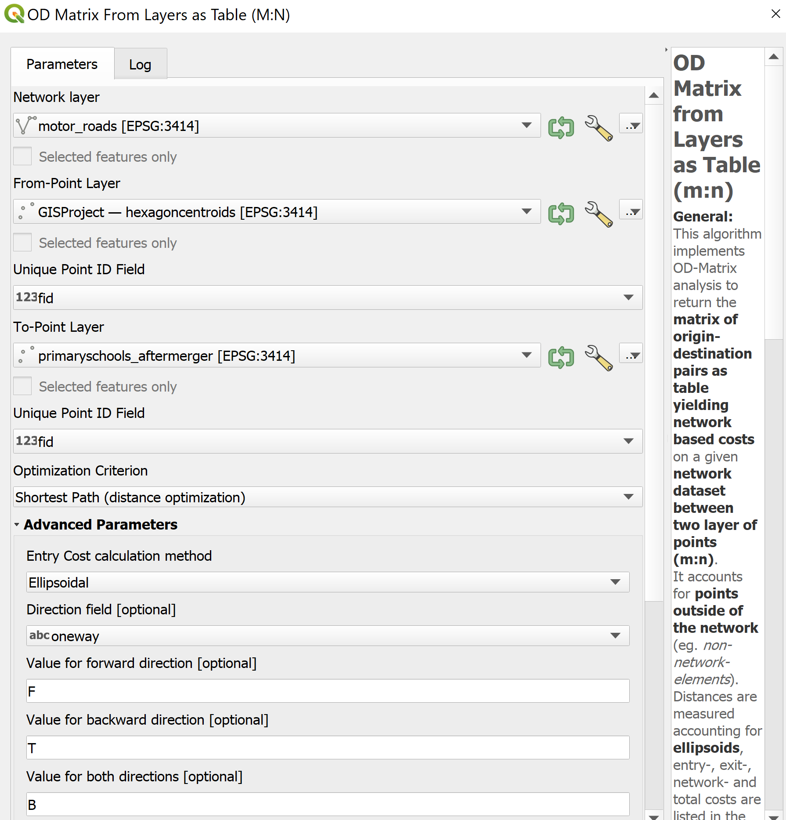

When you are ready to run the process.

* At the OD Matrix dialog window, click on **Run** button.

.

When you are ready to close the dialog window, click on the **Close** button.

Notice that a new temporary table called Output OD Matrix is added onto **Layers** panel.

* At the **Layers** panel, right-click on Output OD Matrix and select **Open Attribute Table** from the context menu.

A data table that looks similar to the screenshot below appears.

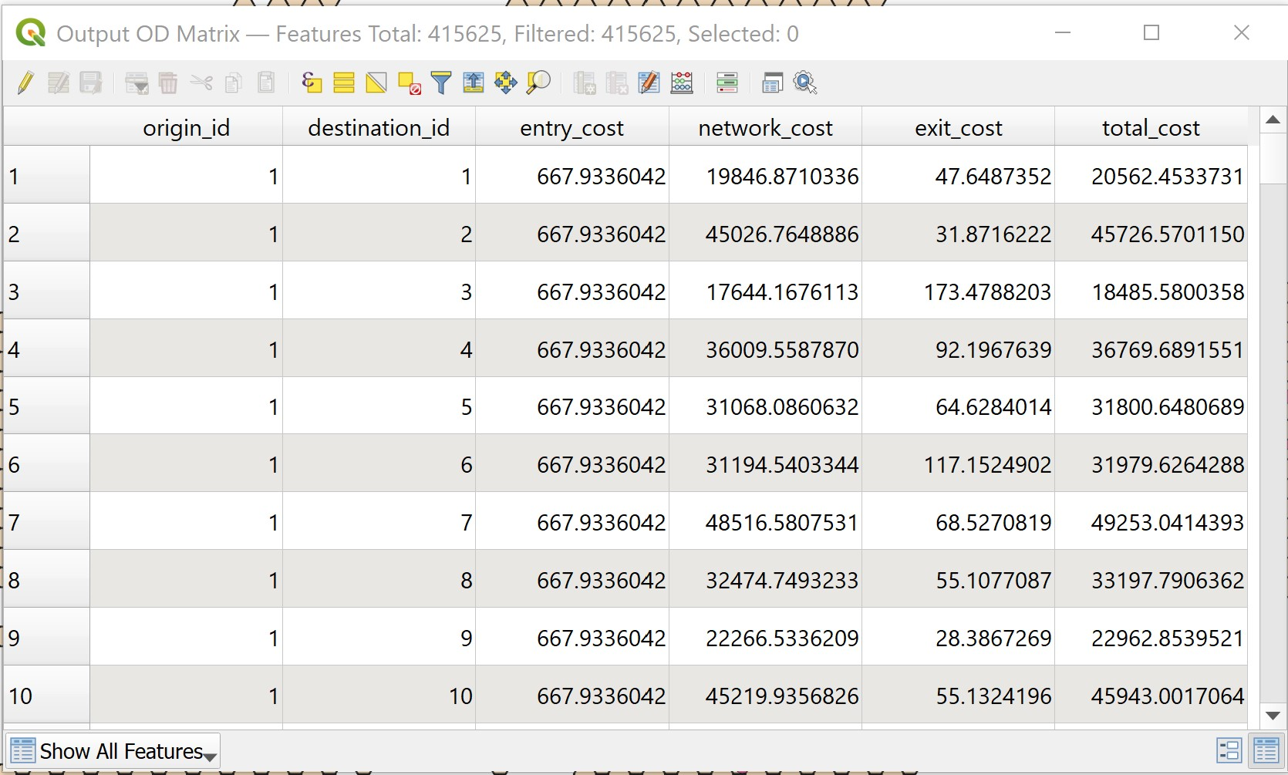

Using the steps learnt in previous sections, save the temporary Output OD Matrix table as GeoPackage format. Name the layer OD_primaryschools.

### 4.2.2.3 Extracting shortest distance pairs

Next, we will use the SQL tool of QGIS to select destination points with the shortest distance.

* At the **Search** pane of **Processing Toolbox**, type SQL.

**SQL** function appears on the list.

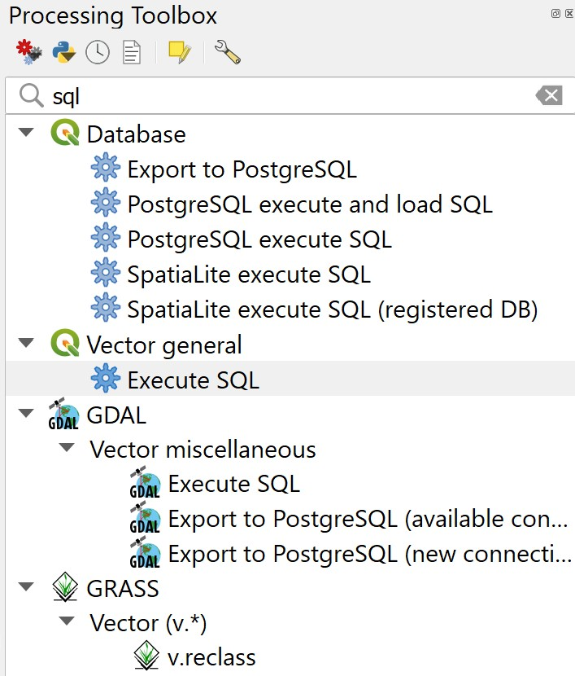

* Double-click on **Execute SQL** of **Vector general.**

**Execute SQL** dialog window appears.

* For **Additional input datasources**, select on the button at the right end.
* Click on the checkbox Output OD Matrix.

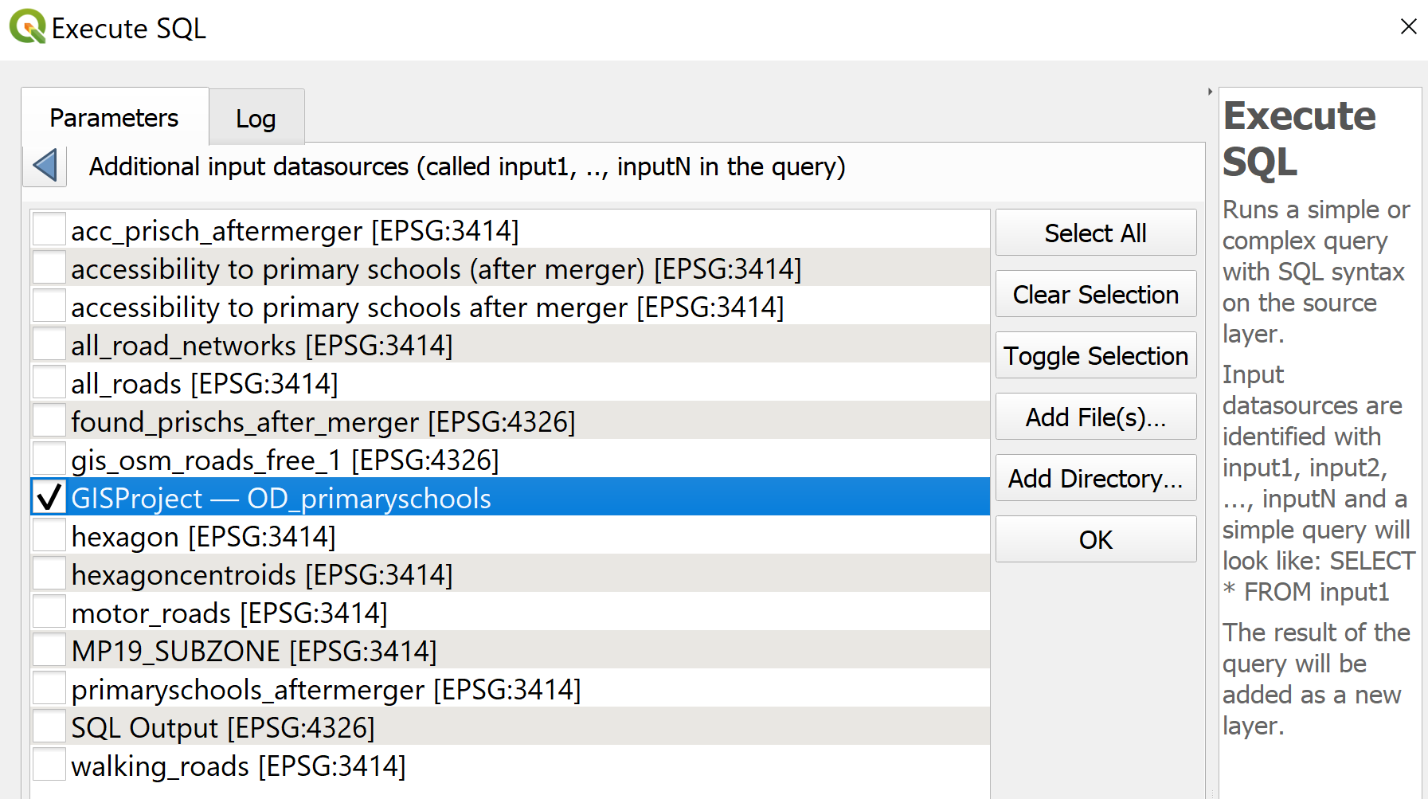

* Click on **OK** button.
* At SQL query panel, type the following SQL

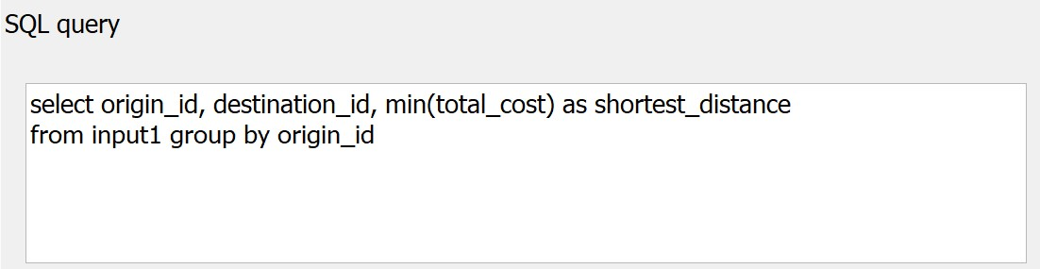

* For *Geometry type*, select No Geometry from the drop-down list.

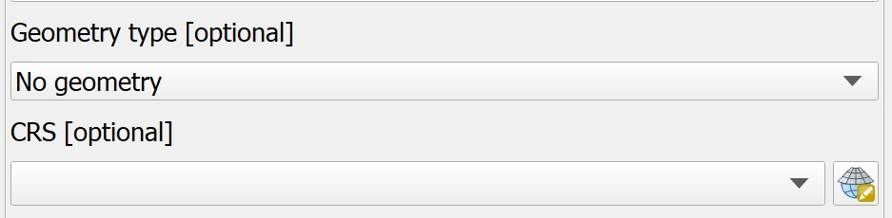

Notice that a temporary table called SQL Output is added onto **Layers** panel. It consists of four fields. The values in shortest_distance field are the shortest distance between demand points and its nearest primary school.

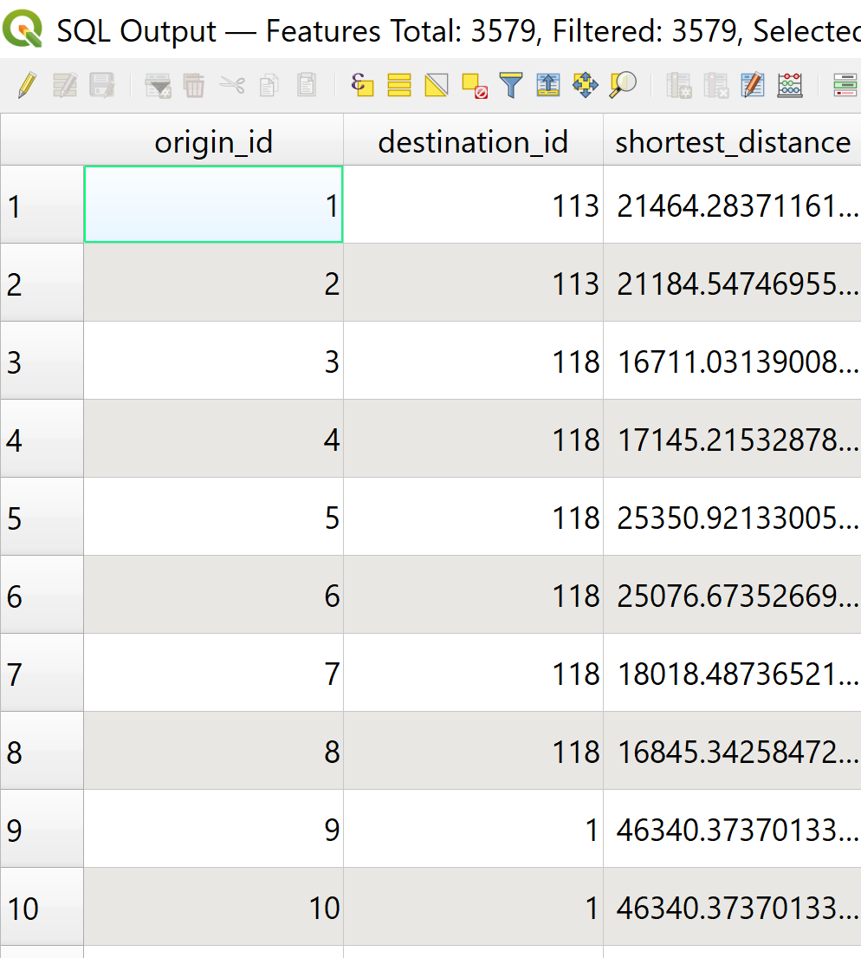

Using the steps you learnt in previous sections save the temporary SQL Output table as GeoPackage format. Name the layer acc_primaryschools_beforemerger.

For the SQL Output created from walking_roads, there will be several null values in the *shortest_distance* column that prevents us from joining this layer to the hexagon layer

in the next step. To circumvent this, we will create a new column for *shortest_distance* that is type integer.

* Right-click on acc_primaryschools_walking_beforemerger → **Open Attribute Table**.
* Click on **Create new field** icon 
  + For **Output field name**, type *shortest_distance_new*
  + For **Output field type,** select *Decimal number (real)*
  + In **Expression** panel, type *shortest_distance*

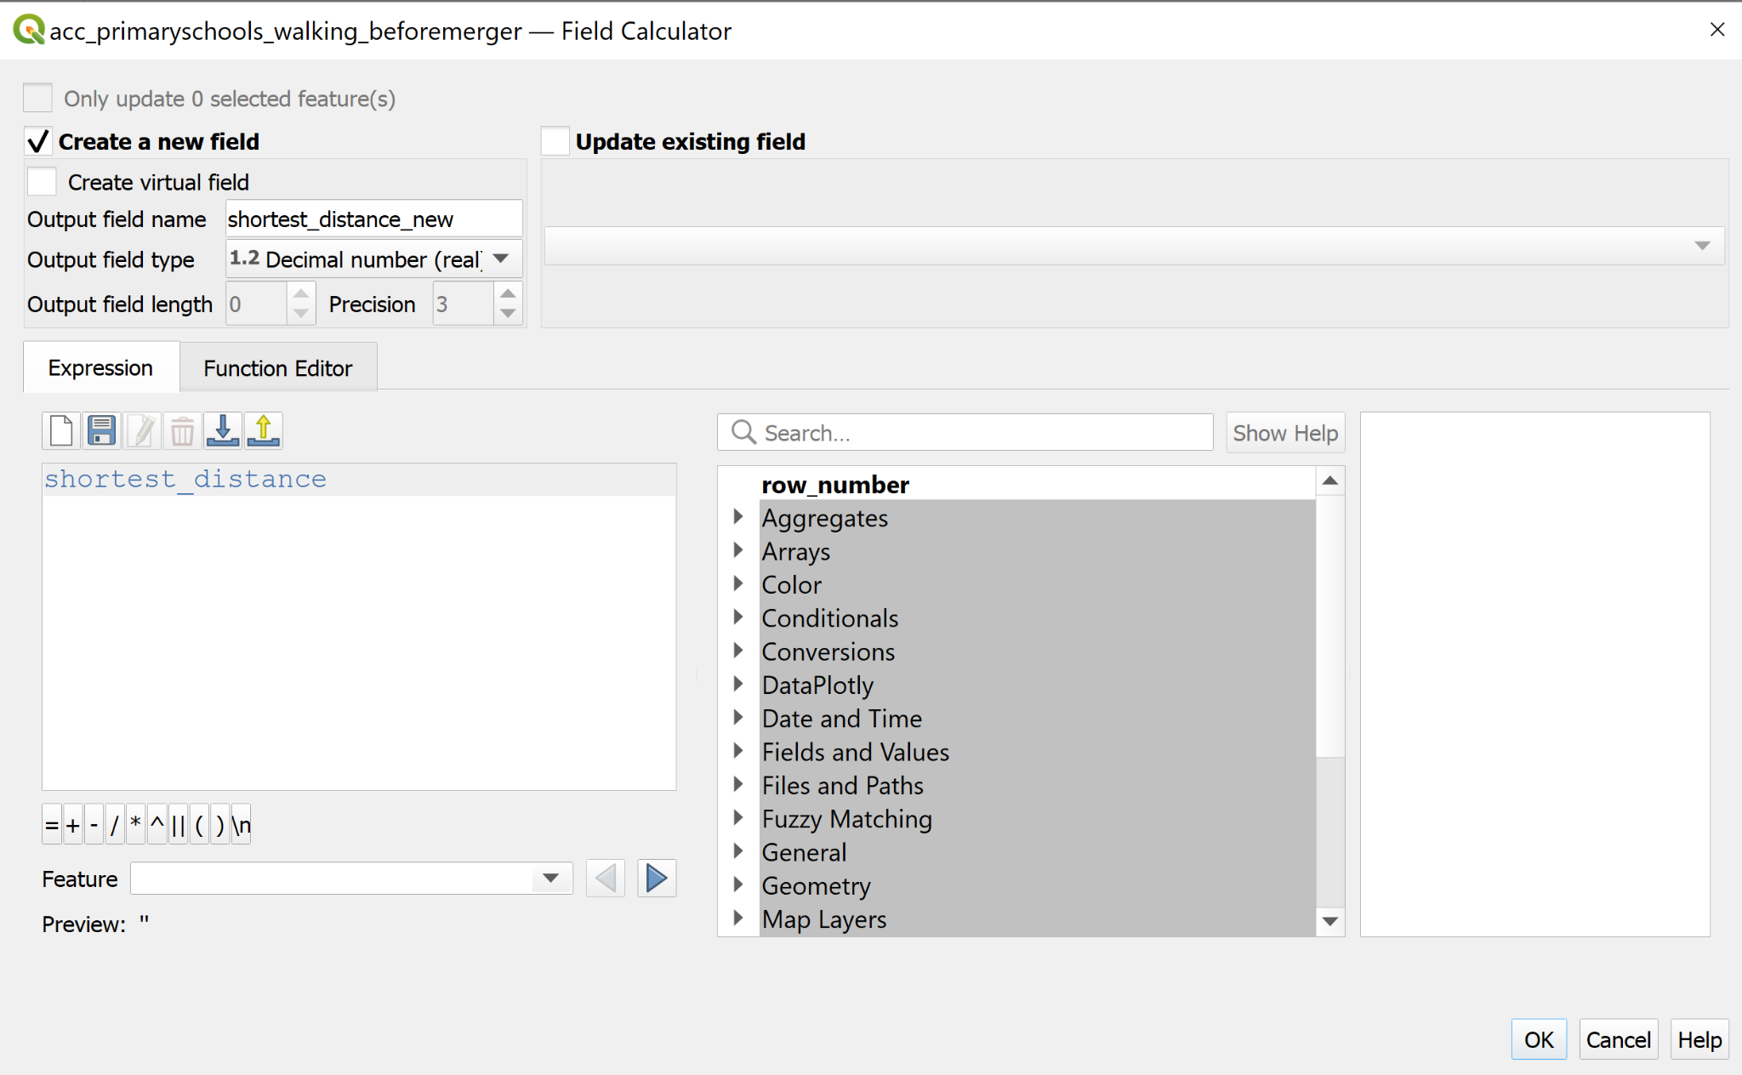

* Click **OK** button. A new column called *shortest_distance_new* is created.

Repeat the above steps for acc_primaryschools_aftermerger.

### 4.2.3 Mapping Accessibility Values

### 4.2.3.1 Creating a Duplicate Layer

Before we getting started, let us create a duplicate copy of hexagon layer

* At the **Layers** panel, right-click on hexagon layer and select Duplicate Layer from the context menu.

A new layer called hexagon copy is added onto **Layers** panel.

* Rename the layer to Accessibility to primary schools.

### 4.2.3.2 Performing relational join

Before we can prepare the choropleth map, we need to join acc_primaryschools data table to the newly created Accessibility to primary schools by using *fid* of acc_primaryschools data table and *fid* of Accessibility to primary schools attribute table as unique join fields.

* At the **Layer** panel, right-click on Accessibility to primary schools layer and select **Properties** from the context menu.

The **Properties** dialog window appears.

* At the option panel, click on **Joins**.
* Click on **+** button to add a join.

The **Add Vector Join** dialog window appears.

* For **Join layer**, select acc_primaryschools from the drop-down list.
* For **Join field**, select fid from the drop-down list.
* For **Target field,** select fid from the drop-down lsit.
* Keep the checkbox in front of Cache join layer in memory checked.

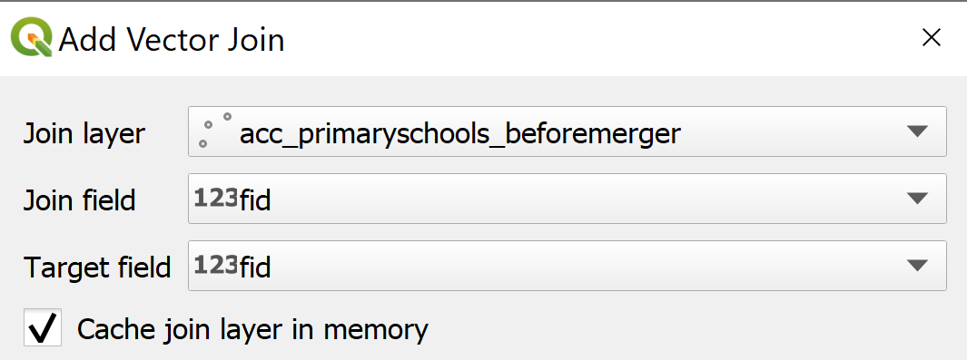

* When you are ready, click on **OK** button.

### 4.2.3.3 Preparing Choropleth Map

Prepare a choropleth map to show the distribution of accessibility to primary schools.

1. From the **Layers** panel, double-click on the Accessibility to primary schools layer. The **Layer Properties** dialog window appears.
2. Click on the **Symbology** tab.
3. At **Symbol** selection drop-down list, select **Graduated** from the drop-down list.
4. For **Value**, select *acc_primaryschools_beforemerger_shortest_distance* from the drop down list.
5. For **Classes**, keep it as 5.
6. For **Color** ramp, choose *Blues* or any colour of your choice from the drop-down list.
   1. Select **Invert Color Ramp**
7. For **Mode**, choose *Equal Count (Quantile)* from the drop-down list.
8. Click on the **Classify** button.

Your screen should look similar to the screenshot below.

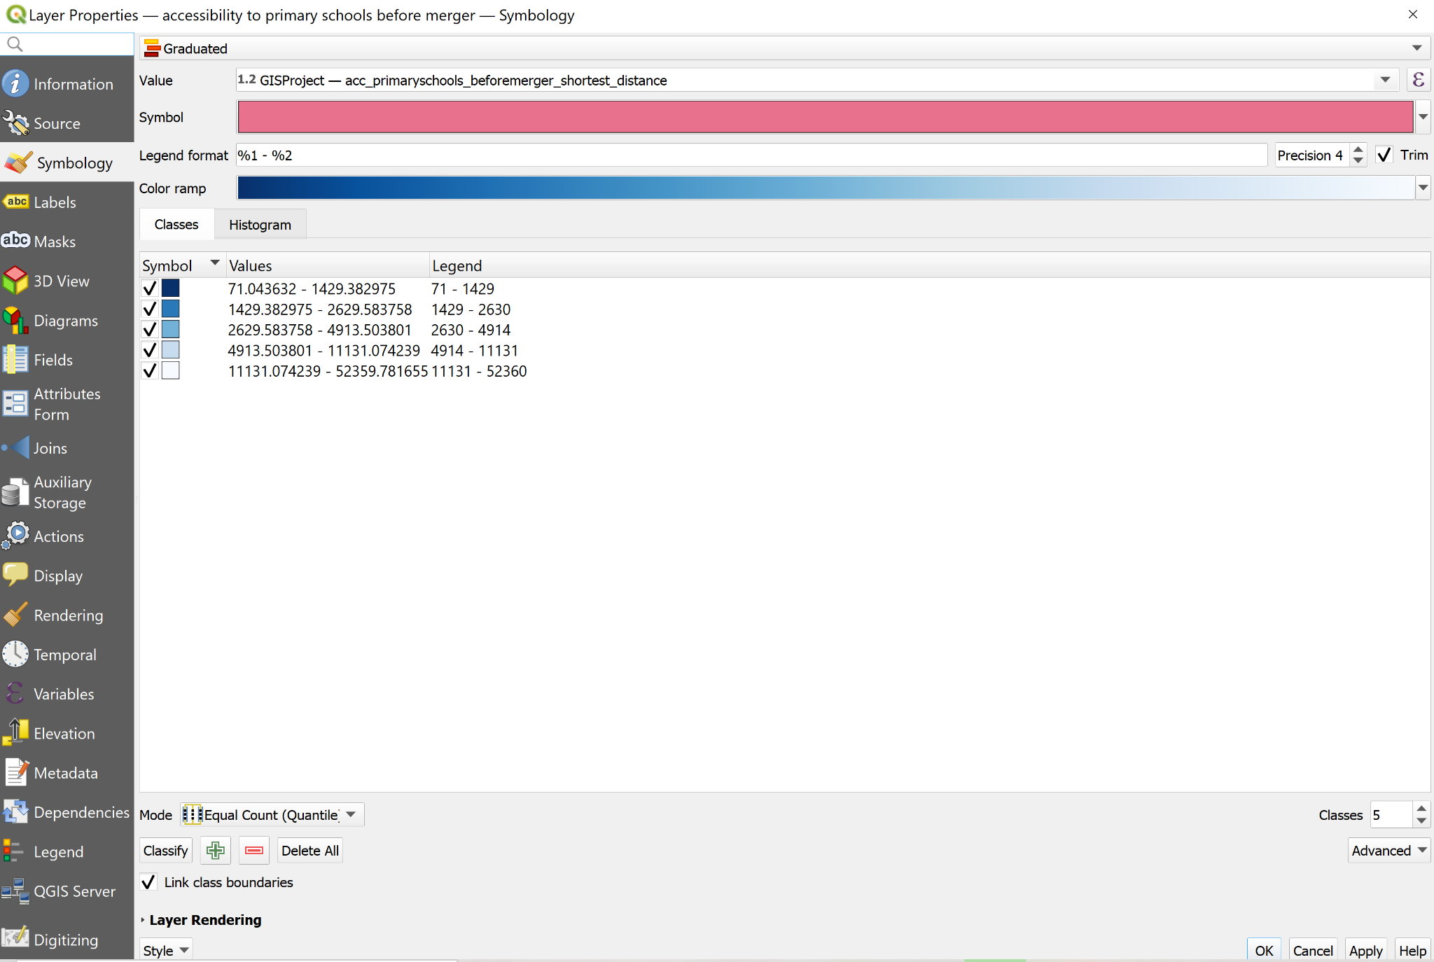

Your choropleth map should look similar to the screenshot below.

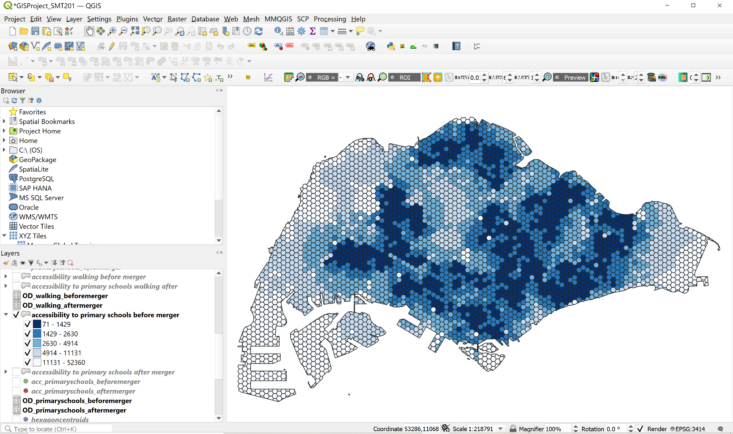

Repeat the above steps to obtain choropleth maps for

1. Accessibility to Primary Schools After Merger (Driving)
2. Accessibility to Primary Schools Before Merger (Walking)
3. Accessibility to Primary Schools After Merger (Walking)

To obtain b and c, under section 3.2.2.2, for Network Layer, select walking_roads from the drop-down list.

### 4.2.3.4 Preparing Bivariate Choropleth Map

We will now create a bivariate choropleth map to compare the driving and walking accessibility to primary schools, both before and after the merger of schools. To do this,

1. Create a copy of the Accessibility to Primary Schools Before Merger (Driving) and Accessibility to Primary Schools Before Merger (Walking). Right-click on the layer and select **Duplicate layer**
2. For Accessibility to Primary Schools Before Merger (Driving) layer, right-click → **Properties → Symbology**
   1. Select **Graduated**
   2. For **Value,** select *acc_primaryschools_beforemerger_shortest_distance*
   3. For **Classes**
      1. <2km
         1. Color: #be64ac
         2. Values: 0-2000
      2. 2-5km
         1. Color: #dfb0d6
         2. Values: 2000-5000
      3. >5km
         1. Color: #e8e8e8
         2. Values: 5000-52359.78

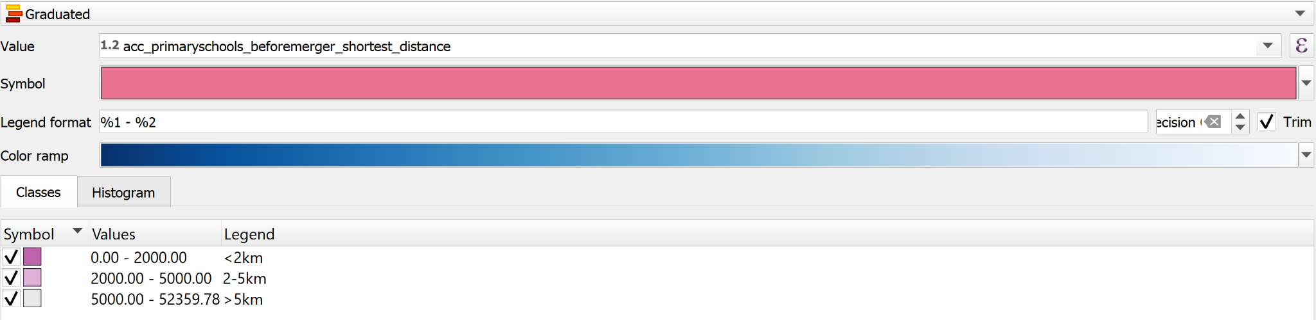

1. For Accessibility to Primary Schools BeforeMerger (Driving) layer, right-click → **Properties → Symbology**
   1. Select **Graduated**
   2. For **Value,** select *acc_primaryschools_walking_beforemerger_shortest_distance_new*
   3. For **Classes**
      1. <1km
         1. Color: #5ac8c8
         2. Values: 0-1000
      2. 2-5km
         1. Color: #ace4e4
         2. Values: 1000-2000
      3. >2km
         1. Color: #e8e8e8
         2. Values: 2000-53051

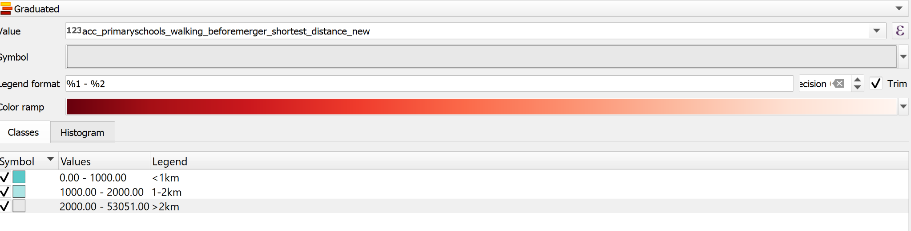

1. For Accessibility to Primary Schools Before Merger (Driving) layer, on **Symbology** page, click **Layer Rendering**
   1. For **Blending mode**, select *Multiply*

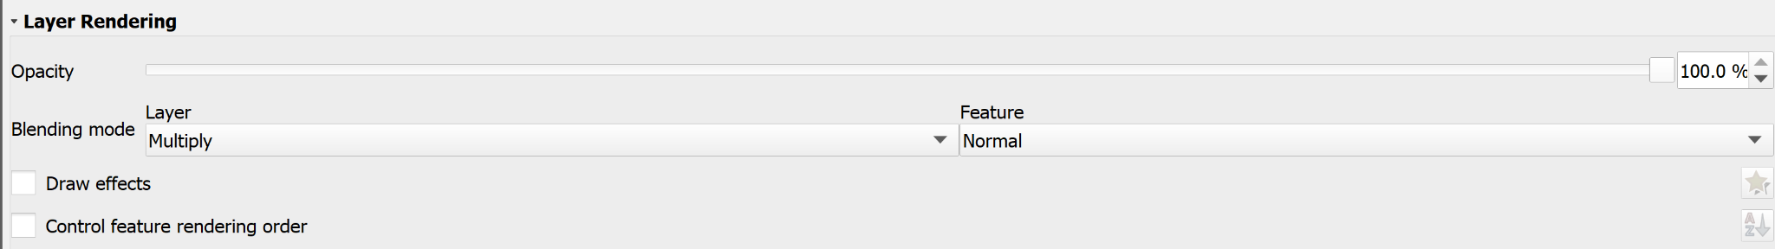

* 1. Click the **OK** button and close the window.

1. A bivariate choropleth map will appear.

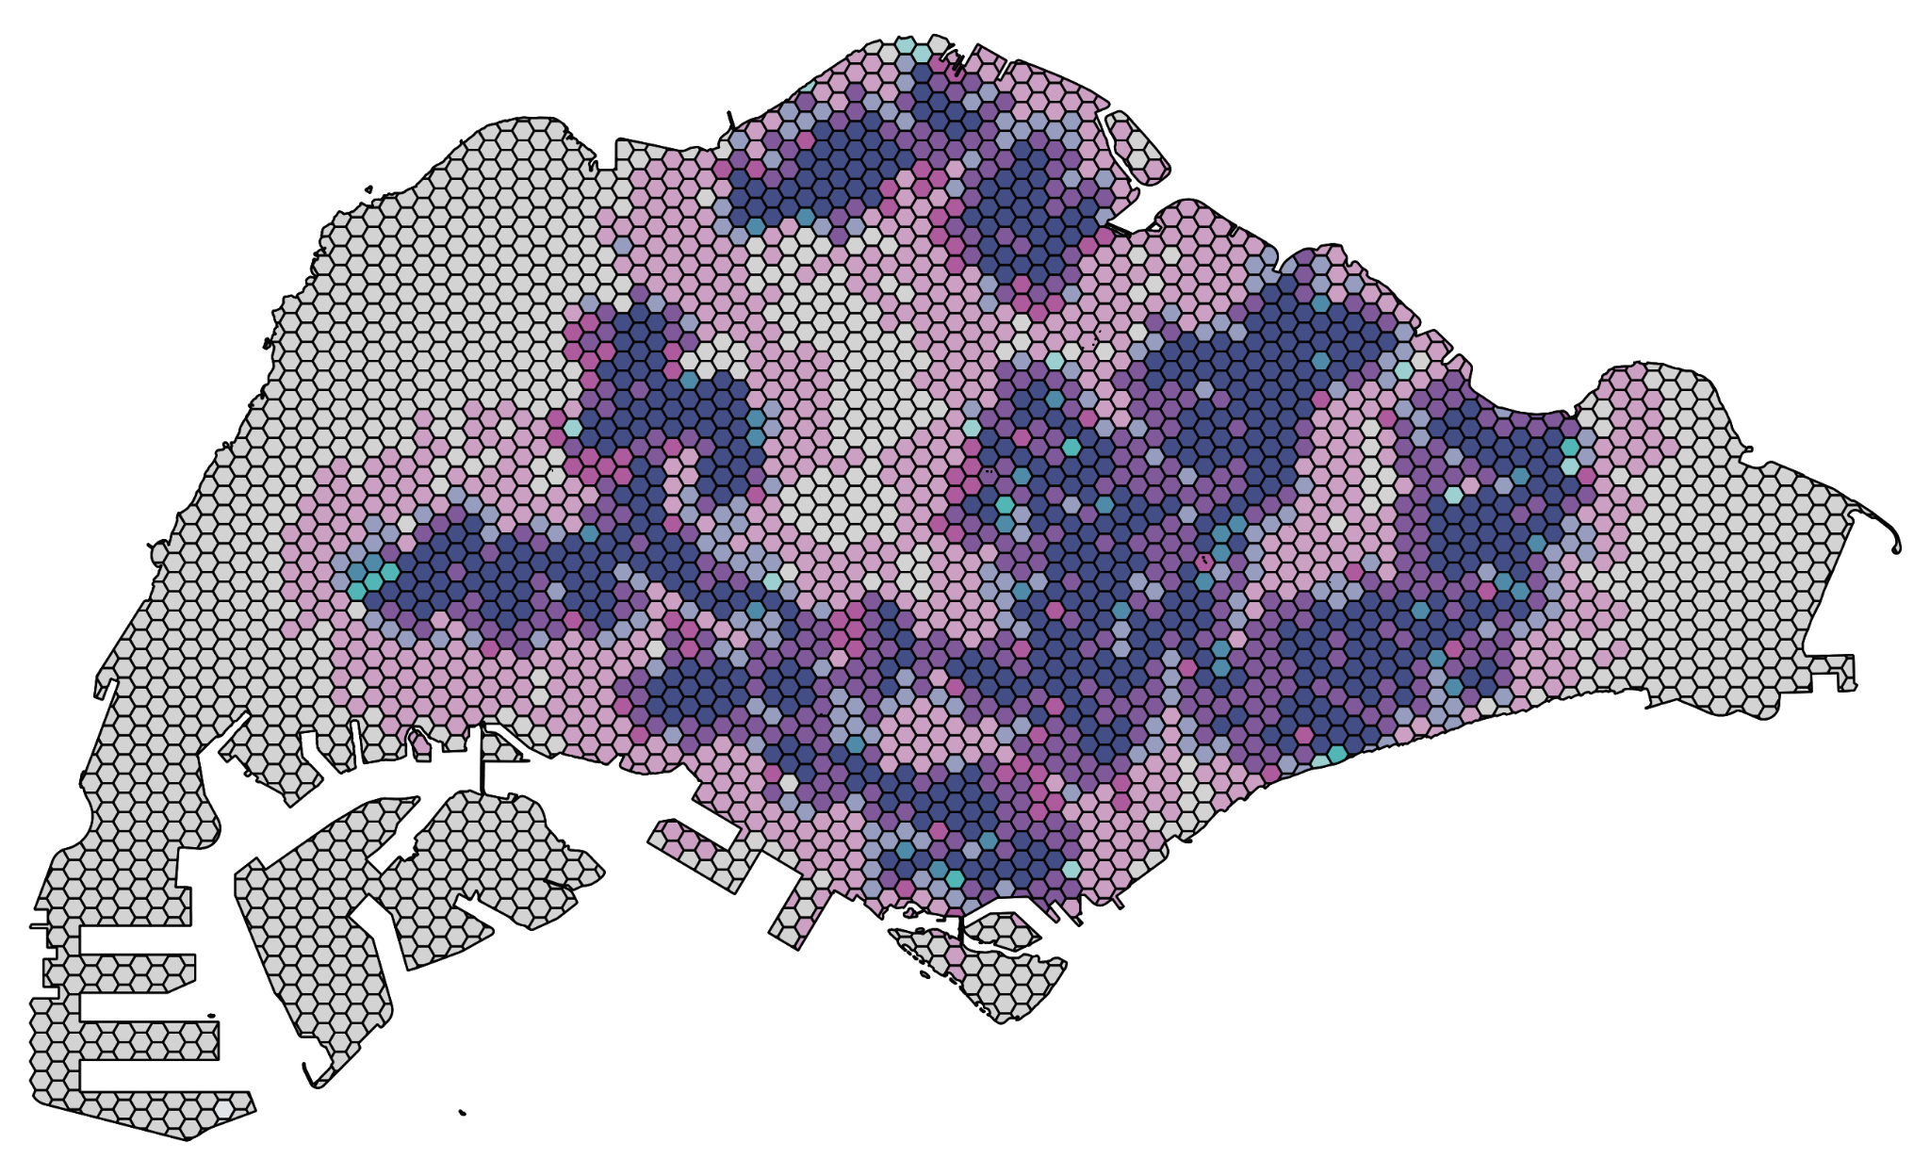

1. To create the bivariate legend, install the plugin called **Bivariate Legend.** Using the Bivariate legend, the parameters will be:
   1. **Top layer:** Accessibility to Primary Schools Before Merger (Driving)
   2. **Bottom layer**: Accessibility to Primary Schools Before Merger (Walking)
   3. **Square width**: 48
   4. Multiply

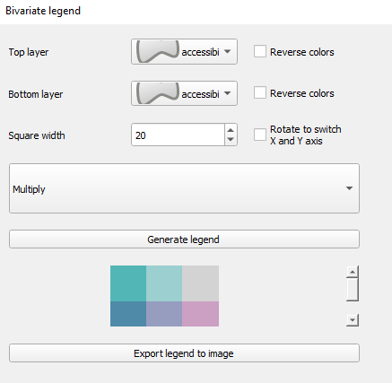

1. Click **Generate legend** and **Export legend to image**, and save it as a .png file
2. To create the report, go to **Project** → **New Print Layout**. Create the print layout.

# 5. Data Preparation for Secondary School

## 5.1 Data Preparation

## 5.1.1 Data Cleaning

a. Clean *School Directory and Information* file downloaded from [General Information of Schools](https://data.gov.sg/dataset/school-directory-and-information) by keeping the column like shown below, filtering the mainlevel_code with the value of SECONDARY and MIXED_LEVEL.

b. Carefully check each school labelled with mixed_level, and remove schools that do not include secondary school, for example Singapore Sports School and School of the Arts, save it into the Data folder and name it ***Singapore_Secondary_Schools***.

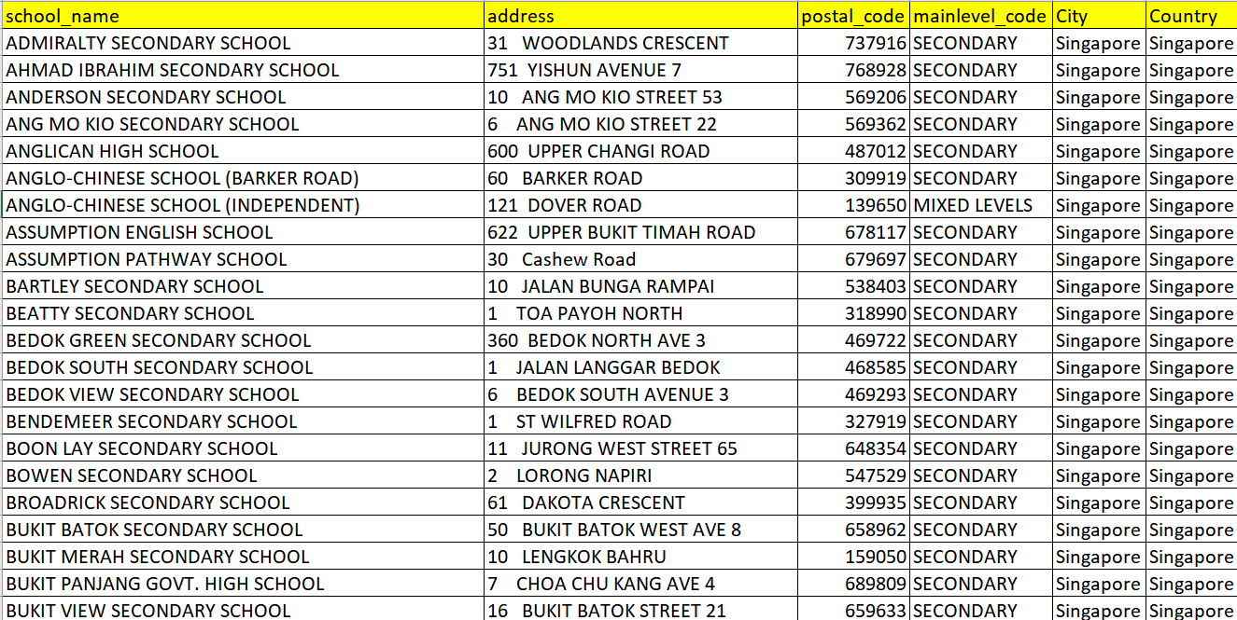

## 5.2 Geocode the prepared data (Before Merger)

1. Open **MMQGIS → Geocode → Geocode CSV with Web Service**

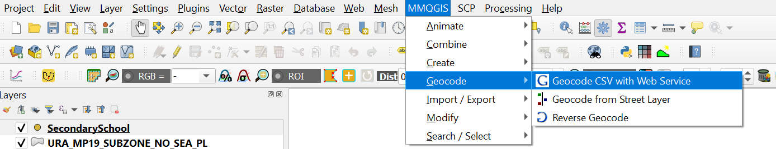

1. Navigate to the *singapore_secondary_schools.csv* by clicking the button at the end of the bar under **Input CSV File (UTF-8 )**

* For **Address**, select address from the dropdown list
* For **City**, select City
* For **Country**, select Country
* For **Web Service**, select OpenStreetMap / Nominatim
* Save it in your geocoded file

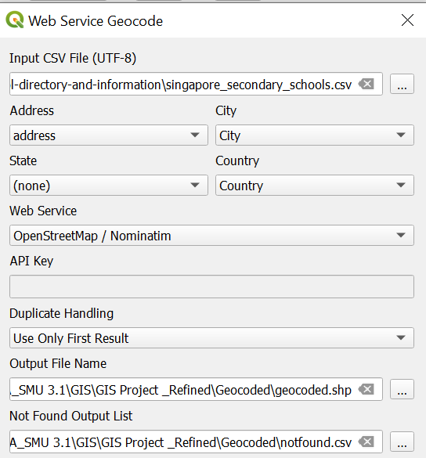

1. Now you may notice a layer called *geocoded* appears. Let us rename it to ‘SecondarySchool’
2. Navigate to the *notfound* file in your geocode folder. There are some schools that are not geocoded properly, and we need to manually find them on the map.

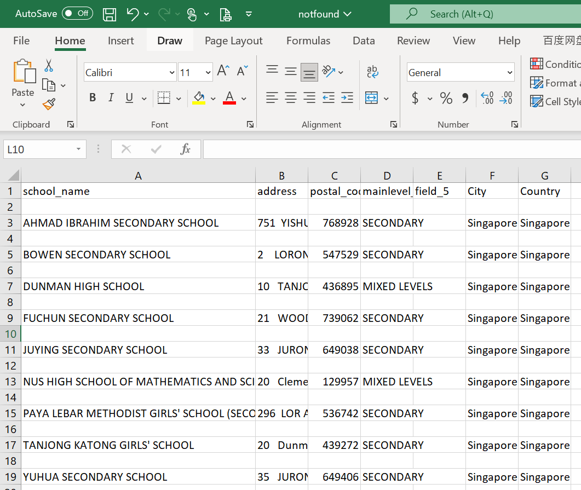

1. Now click Browser **→** double click OpenStreetMap

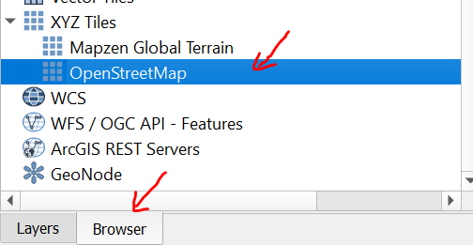

1. For example, Bowen Secondary school is not geocoded properly, we can manually find it by using the OpenStreetMap by using its address.

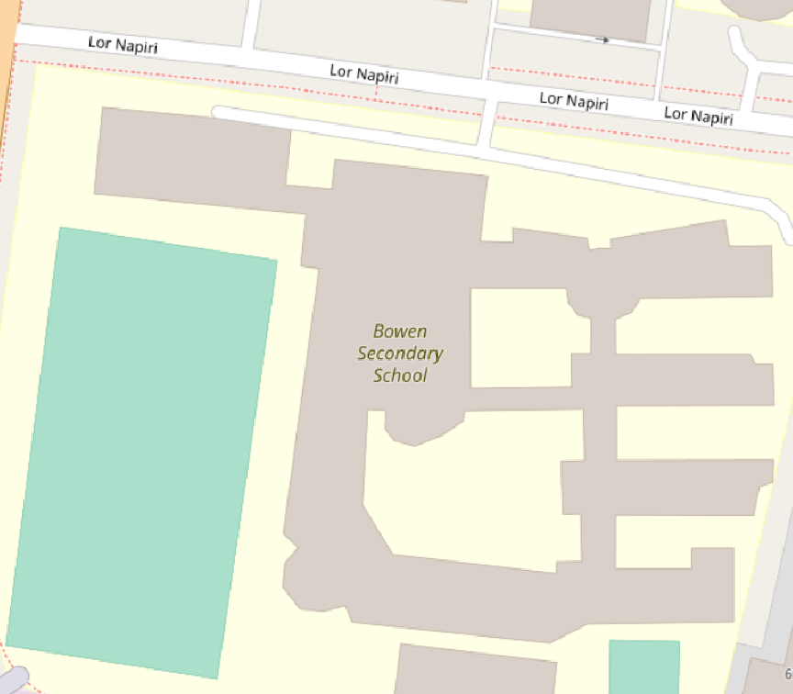

1. After you find Bowen Secondary School on Open Map, active and tick the SecondarySchool layer → right click and select **Toggle Editing**

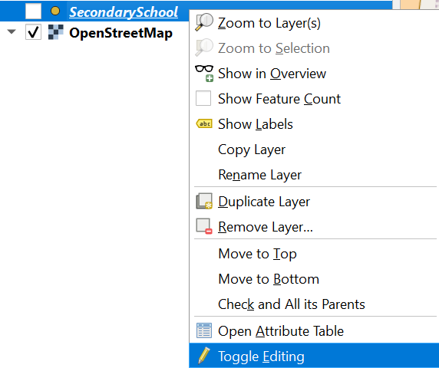

1. Click the **Add Point Feature** icon that is circled in red.

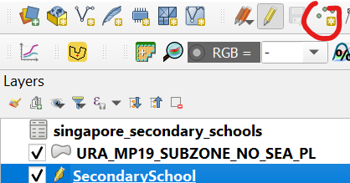

1. Fill in the necessary information according to your *notfound.csv* file

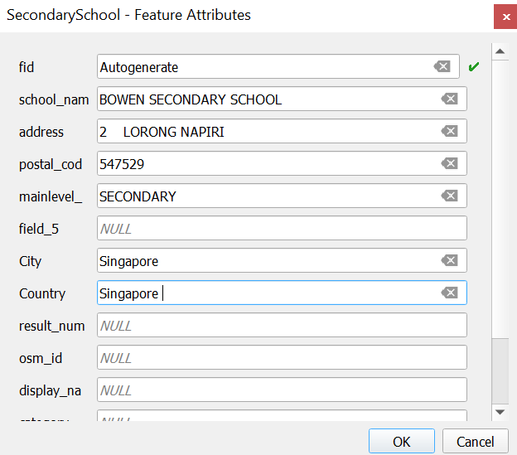

1. Repeat the steps for the other school in the *notfound.csv* file, and open the attribute table. There should be 153 features. Save it into the Geopackage database. The data will be used to analyse the accessibility of the secondary school before 2019, so we name it SecondarySchool

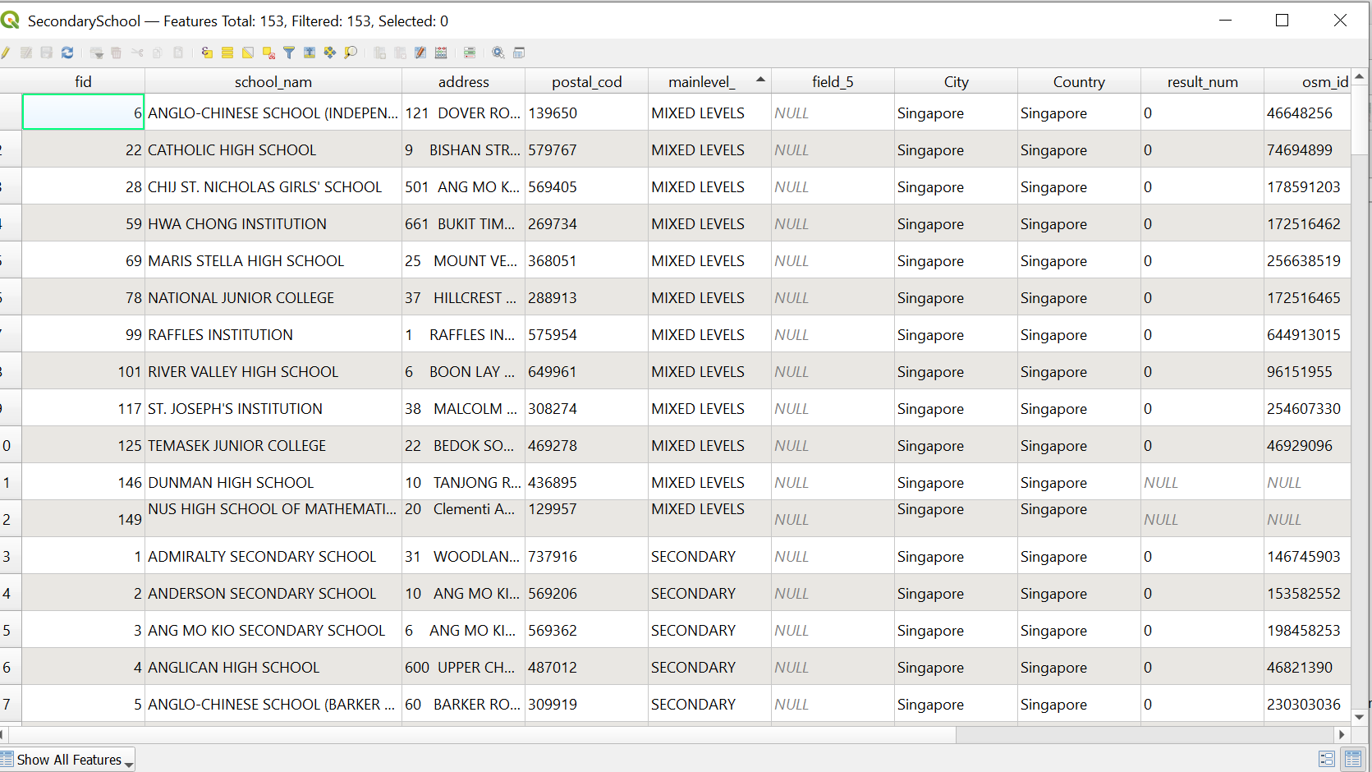

## 5.3 Prepare data for Analysing Cccessibility (After Merger)

In 2019, there were 3 pairs of secondary school merged:

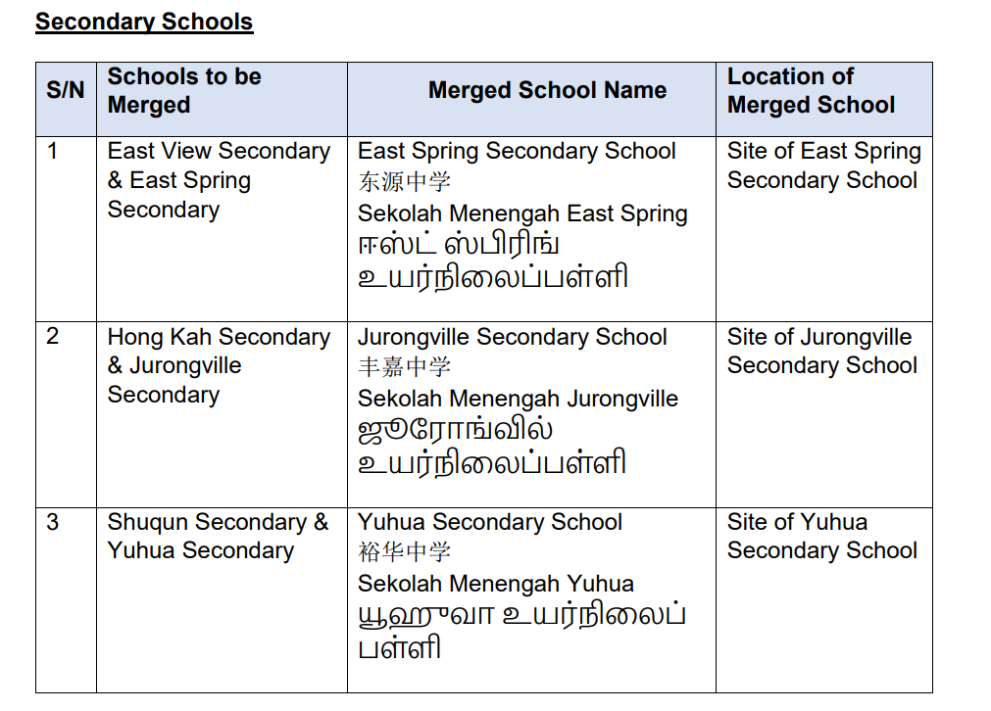

Source: [Ministry of Education](https://www.moe.gov.sg/-/media/files/news/press/2017/annex-a---named-of-pri-and-sec-schools-merging-in-2019.pdf)

## Use the SecondarySchool layer, open attribute table and press ctrl+F

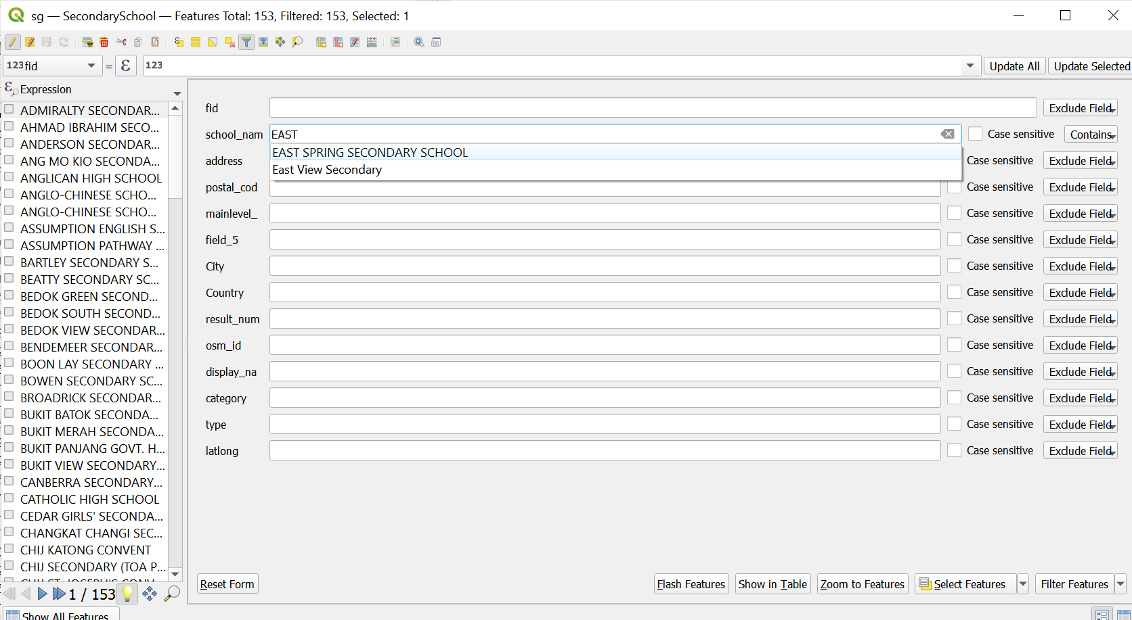

1. In the field of school_name, type ‘East View Secondary’ and click **Select Feature**.
2. Click **Toggle Editing**
3. Select the highlighted point which is East View Secondary Achool
4. Click the Delete Selected icon:  to remove the East View Secondary School

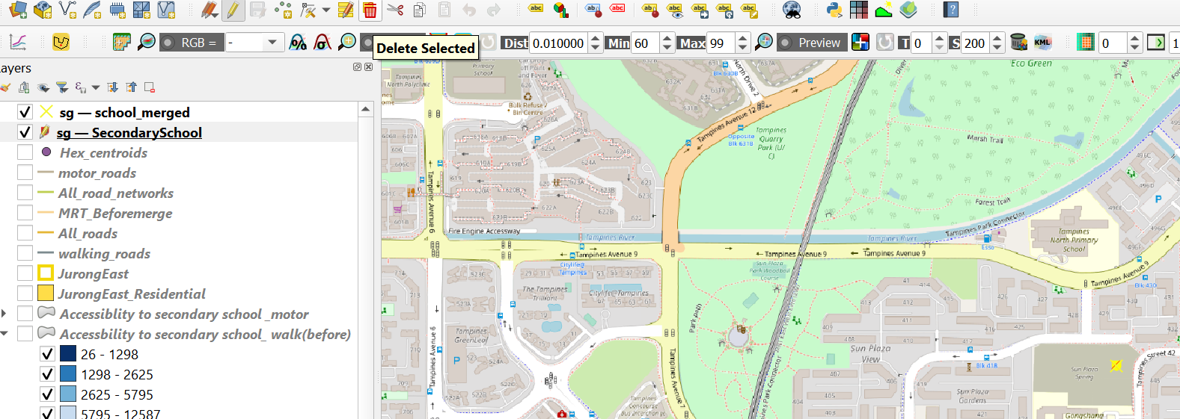

1. Repeat the same step to remove the other merged schools
2. Save the rest of the school in the database and name it Secondary School_After merged

## 5.4 Network Accessibility Analysis

The logic for preparing walking accessibility, driving accessibility and choropleth maps are the same and demonstrated in the previous section. The choropleth thresholds used for walking and driving maps are the same as in Primary School, while MRT uses the same thresholds for driving.

# 6. Accessibility Analysis for Junior Colleges

## 6.1 Data Preparation

1. Clean *School Directory and Information* file downloaded from [General Information of Schools](https://data.gov.sg/dataset/school-directory-and-information) by keeping the column like shown below, filtering the mainlevel_code with the value of JUNIOR COLLEGE and MIXED_LEVEL.
2. Carefully check each school labelled with mixed_level, and remove schools that do not include Junior Colleges or are special schools, for example Singapore Sports School and School of the Arts, save it into the Data folder and name it ***JC_After_Mergers***.

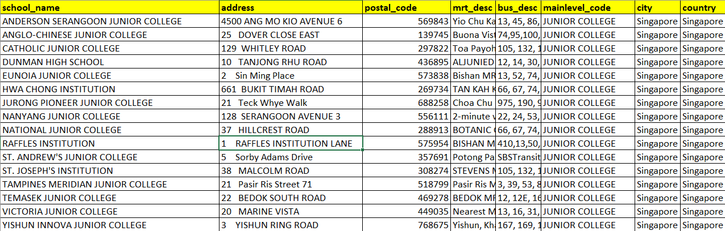

1. Duplicate the file and change the following schools:
   1. Anderson Serangoon → Anderson
   2. Jurong Pioneer → Pioneer
   3. Tampines Meridian → Meridian
   4. Yishun Innova → Yishun
   5. Add Serangoon Junior College → 1033 Upper Serangoon Road
   6. Add Jurong Junior College → 800 Corporation Road
   7. Add Tampines Junior College → 2 Tampines Avenue 9
   8. Add Innova Junior College → 21 Champions Way
2. Save this file in the Data folder and name it ***JC_Before_Mergers***.

## 6.2 Geocoding

1. Open **MMQGIS → Geocode → Geocode CSV with Web Service**



1. Navigate to the *JC_before_mergers.csv* by clicking the button at the end of the bar under **Input CSV File (UTF-8 )**

* For **Address**, select address from the dropdown list
* For **City**, select City
* For **Country**, select Country
* For **Web Service**, select OpenStreetMap / Nominatim
* Save it in your geocoded file

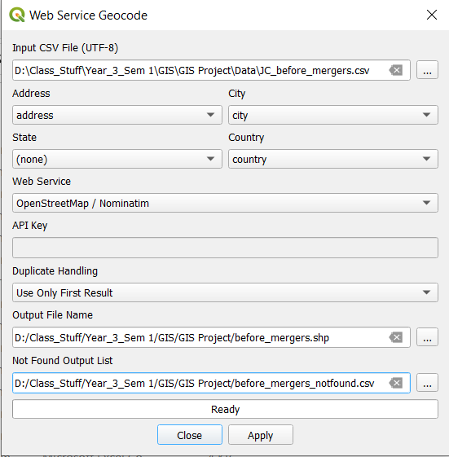

1. Now you may notice a layer called *geocoded* appears. Let us rename it to ‘JC_before_merger’
2. Navigate to the *notfound* file in your geocode folder. There are some schools that are not geocoded properly, and we need to manually find them on the map.

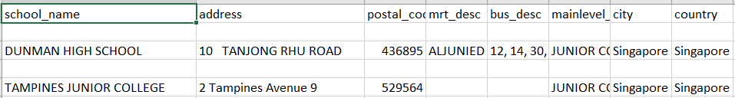

1. Now click Browser -> double click OpenStreetMap



1. For example, Dunman High School is not geocoded properly. We can manually find it by using the OpenStreetMap by using its address.

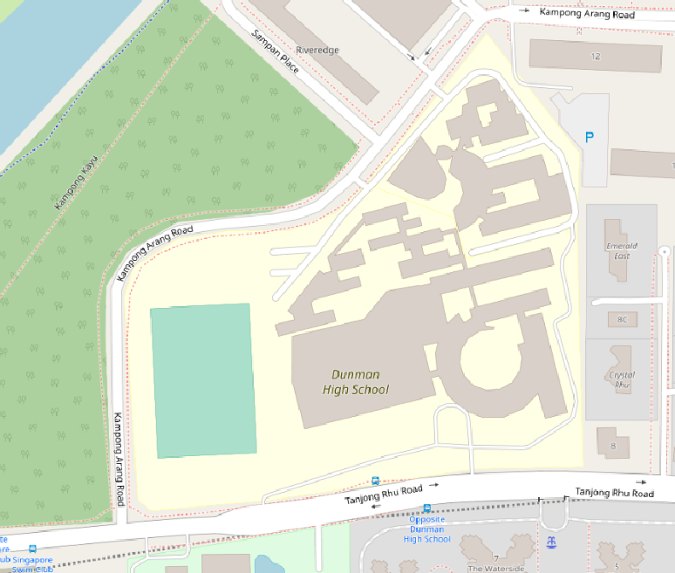

1. After you find Dunman High School on Open Map, active and tick the JC_before_merger layer, right click and select **Toggle Editing**.

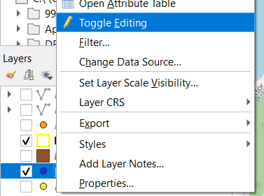

1. Click the **Add Point Feature** icon that is circled in red



1. Fill in the necessary information according to your *notfound.csv* file

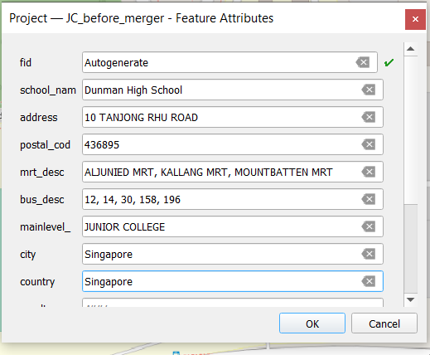

1. Repeat the steps for the other schools in the *notfound.csv* file, now open the attribute table, there should be 20 features, now save it into the Geopackage database

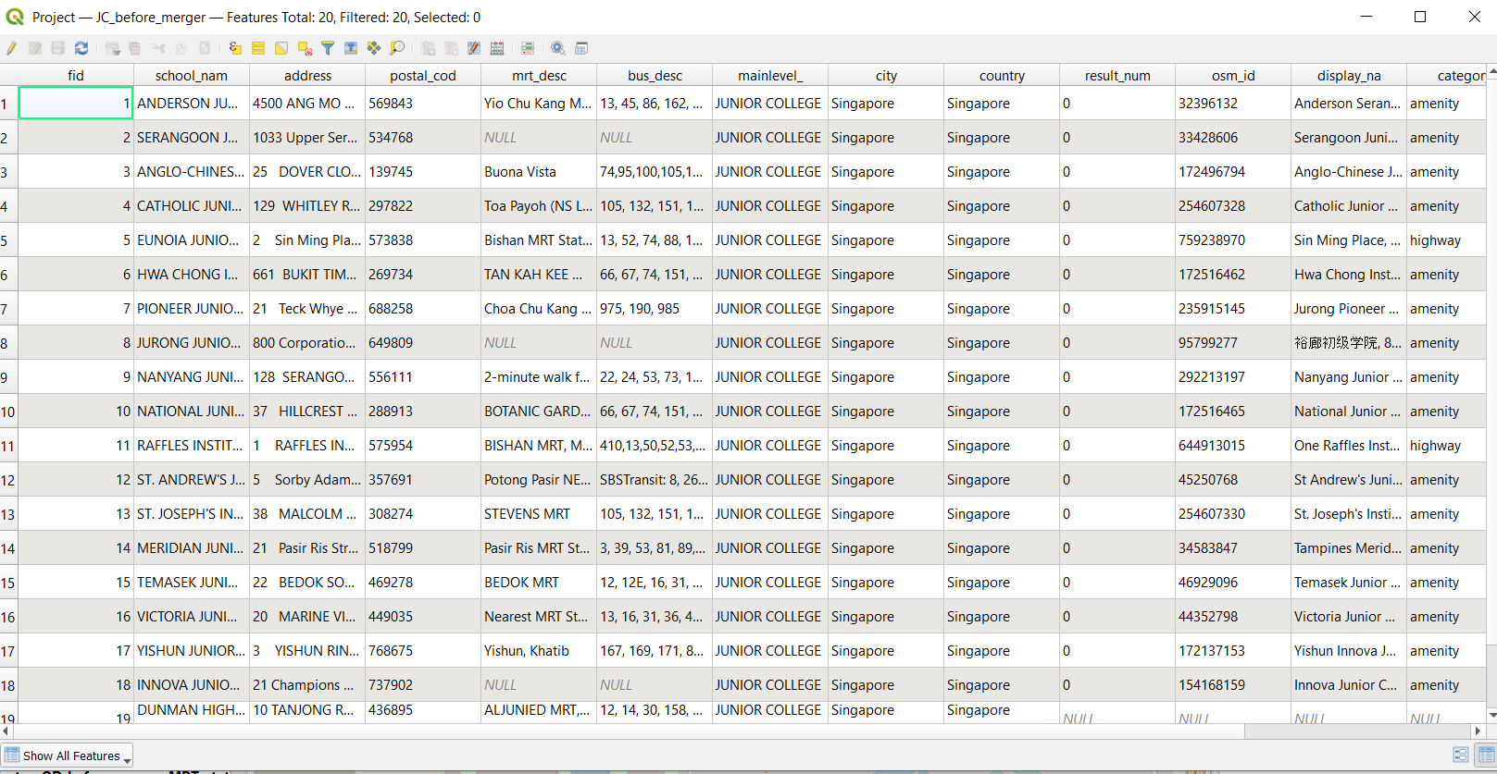

1. Repeat the steps for *JC_after_merger* as well. You should end up with 16 features.

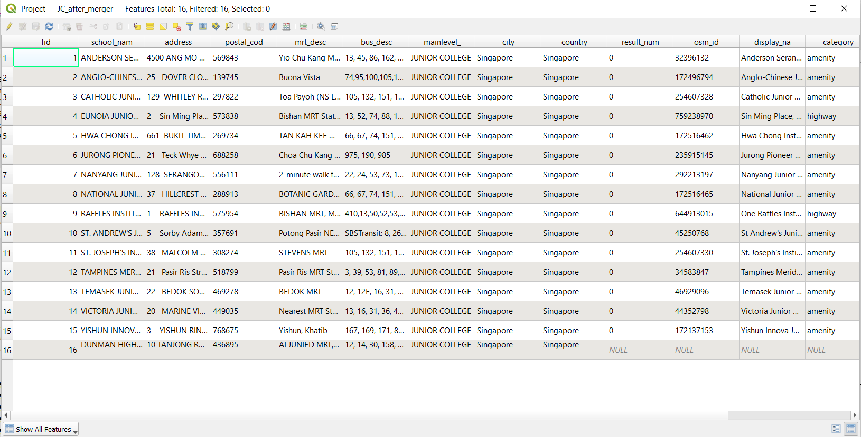

## 6.3 MRT accessibility network

### 6.3.1 Data Preparation

1. Load the [MRTLRTStnPt](https://datamall.lta.gov.sg/content/datamall/en/static-data.html) data from LTA data mall. Save it into GeoPackage as MRTstations_after_merger.
2. Load a second MRTLRTStnPtt layer. Open its attribute table and remove the following stations which were not open at the time of the mergers
   1. Woodlands North
   2. Woodlands South
   3. Springleaf
   4. Lentor
   5. Mayflower
   6. Bright Hill
   7. Upper Thompson
   8. Caldecott (On the Thompson East Coast Line side)
3. Save it into GeoPackage as MRTstations_before_merger

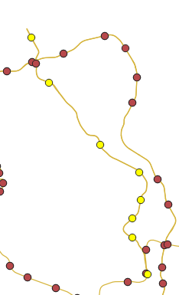

1. Load in the gis_osm_railways from Geofabrik. Select all the MRT, LRT tracks using "fclass" in ( 'light_rail' , 'monorail' , 'rail' , 'subway' )

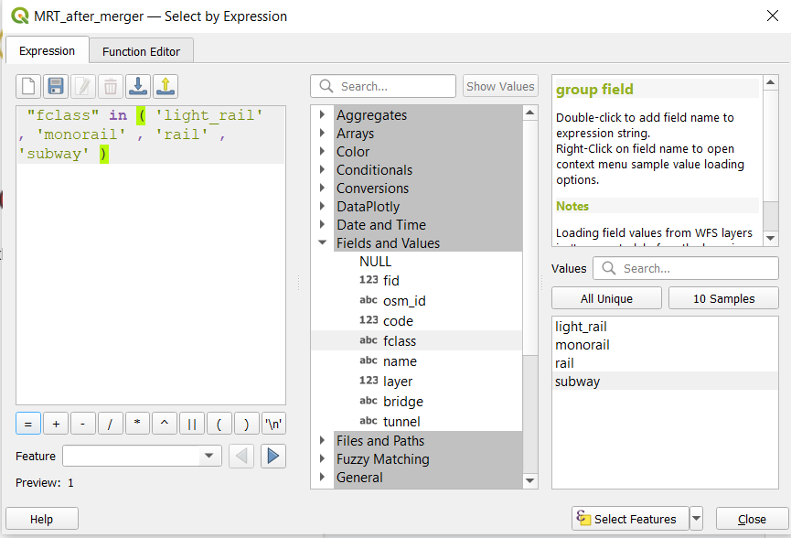

1. Save the selected features as MRT_after_merger
2. Create a duplicate of MRT_after_merger and call it MRT_before_merger. Delete the TEL from the layer (Highlighted in bright yellow)

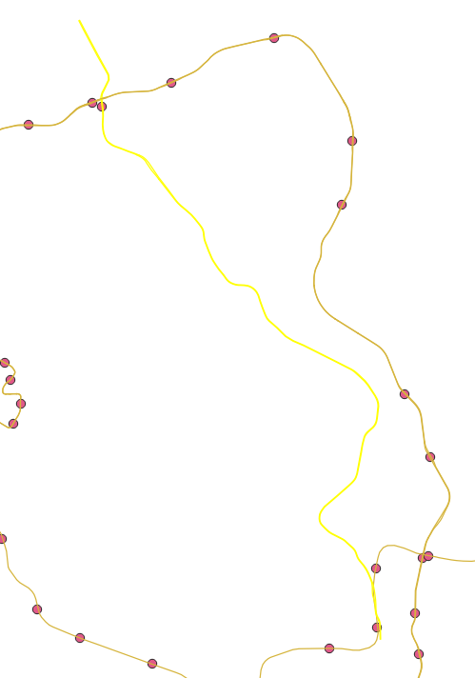

### 6.3.2 Extracting Shortest Distance from Hexagon Centroid to School via MRT

### 6.3.2.1 OD Matrix for hex centroid to MRT stations

Perform the same steps as in section 3.2.2, but with the following parameters changed:

* For Network Layer, select pedestrian_roads from the drop-down list.
* For From-Point Layer, select hex_centroids from the drop-down list.
* For Unique Point ID Field, select fid from the drop-down list.
* For To-Point Layer, select MRTstations_before_merger from the drop-down list.
* For Unique Point ID Field, select fid from the drop-down list.

Save this in GeoPackage as OD_JC_before_merger_MRT_walk

Repeat the steps with MRTstations_after_merger to get OD_JC_after_merger_MRT_walk

6.3.2.2 OD Matrix for MRT station to MRT station

Perform the same steps as in section 3.2.2, but with the following parameters changed:

* For Network Layer, select MRT_before_merger from the drop-down list.
* For From-Point Layer, select MRTstations_before_merger from the drop-down list.
* For Unique Point ID Field, select fid from the drop-down list.
* For To-Point Layer, select MRTstations_before_merger from the drop-down list.
* For Unique Point ID Field, select fid from the drop-down list.

Save this in GeoPackage as OD_before_merger_MRT_travel

Repeat the steps with MRT_after_merger and MRTstations_after_merger to get OD_after_merger_MRT_travel

6.3.2.3 OD Matrix for MRT station to JC

Perform the same steps as in section 3.2.2, but with the following parameters changed:

* For Network Layer, select pedestrian_roads from the drop-down list.
* For From-Point Layer, select JC_before_merger from the drop-down list.
* For Unique Point ID Field, select fid from the drop-down list.
* For To-Point Layer, select MRTstations_before_merger from the drop-down list.
* For Unique Point ID Field, select fid from the drop-down list.

Save this in GeoPackage as OD_before_merger_MRT-school

Repeat the steps with JC_after_merger and MRTstations_after_merger to get OD_after_merger_MRT-school

6.3.2.4 SQL to get accessibility

Repeat steps 3.2.2.3 but with the following parameters changed:

1. For **Additional input datasources**, select OD_before_merger_MRT-school as input1 and OD_before_merger_MRT_travel
2. Enter the following as the SQL query:
   1. select min(input1.total_cost) as shortest_distance, input2.total_cost, input2.origin_id, input2.destination_id, input1.origin_id as school from input1, input2 where input1.destination_id = input2.destination_id group by input1.origin_id, input2.origin_id
3. Save the output as before_merger_sql
4. Open execute SQL again
5. For **Additional input datasources**, select OD_JC_before_merger_MRT_walk as input1 and before_merger_sql as input2
6. Enter the following SQL query:
   1. select input1.origin_id as origin_id, input1.destination_id as origin_MRT,

input2.destination_id as destination_MRT, input2.school as destination_id,

min(input1.total_cost) as dist1, min(input2.total_cost) as dist2,

input2.shortest_distance as dist3 from input1, input2 where

input1.destination_id = input2.origin_id and input1.total_cost < 1000

group by input1.origin_id

1. Save the output as acc_JC_before_merger_MRT

Repeat the above steps with the after merger OD matrices.

## 6.4 Network Accessibility Choropleth Maps (Driving, Walking and MRT)

The logic for preparing maps including creating the hexagon layer and Network Accessibility Analysis are the same as demonstrated in a previous section. Follow the instructions from section 3.2 with JC before and after merger layers to get walking and driving accessibility maps.

Repeat section 4.4.2 using JC before and after merger data to get the accessibility map for MRT travel.

* The thresholds used for driving are 0 - 5 km, 5 - 8 km and more than 8 km.
* The thresholds used for walking is the same as Primary and Secondary School (0 - 1 km, 1 - 2 km, more than 2km).
* The thresholds used for MRT are 0 - 5 km, 5 - 10 km, more than 10 km.

# 

# 7. Results and Discussion

### 7.1 Main Mode of Transport for Students

According to the Department of Statistics Singapore, the main mode of transport for students differs across levels. For primary school students, they mainly walk to school. For secondary school students, the main mode of transport is public buses. However, as conducting accessibility analysis by bus network is out of scope for the timeframe of our project, we have chosen to focus on walking, MRT and driving accessibility. For post-secondary students such as Junior College, we have chosen to focus on walking, MRT and driving accessibility as well. This is considering that secondary school and JC students may be more willing to travel a further distance to their preferred school.

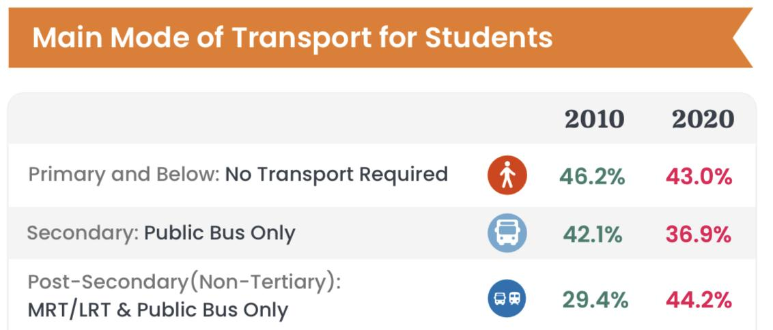

Main Mode of Transport for Students (Source: [Department of Statistics Singapore](https://www.singstat.gov.sg/-/media/files/visualising_data/infographics/c2020/c2020-geographical-distribution-transport.ashx))

## 7.2 Distribution of Youth Population

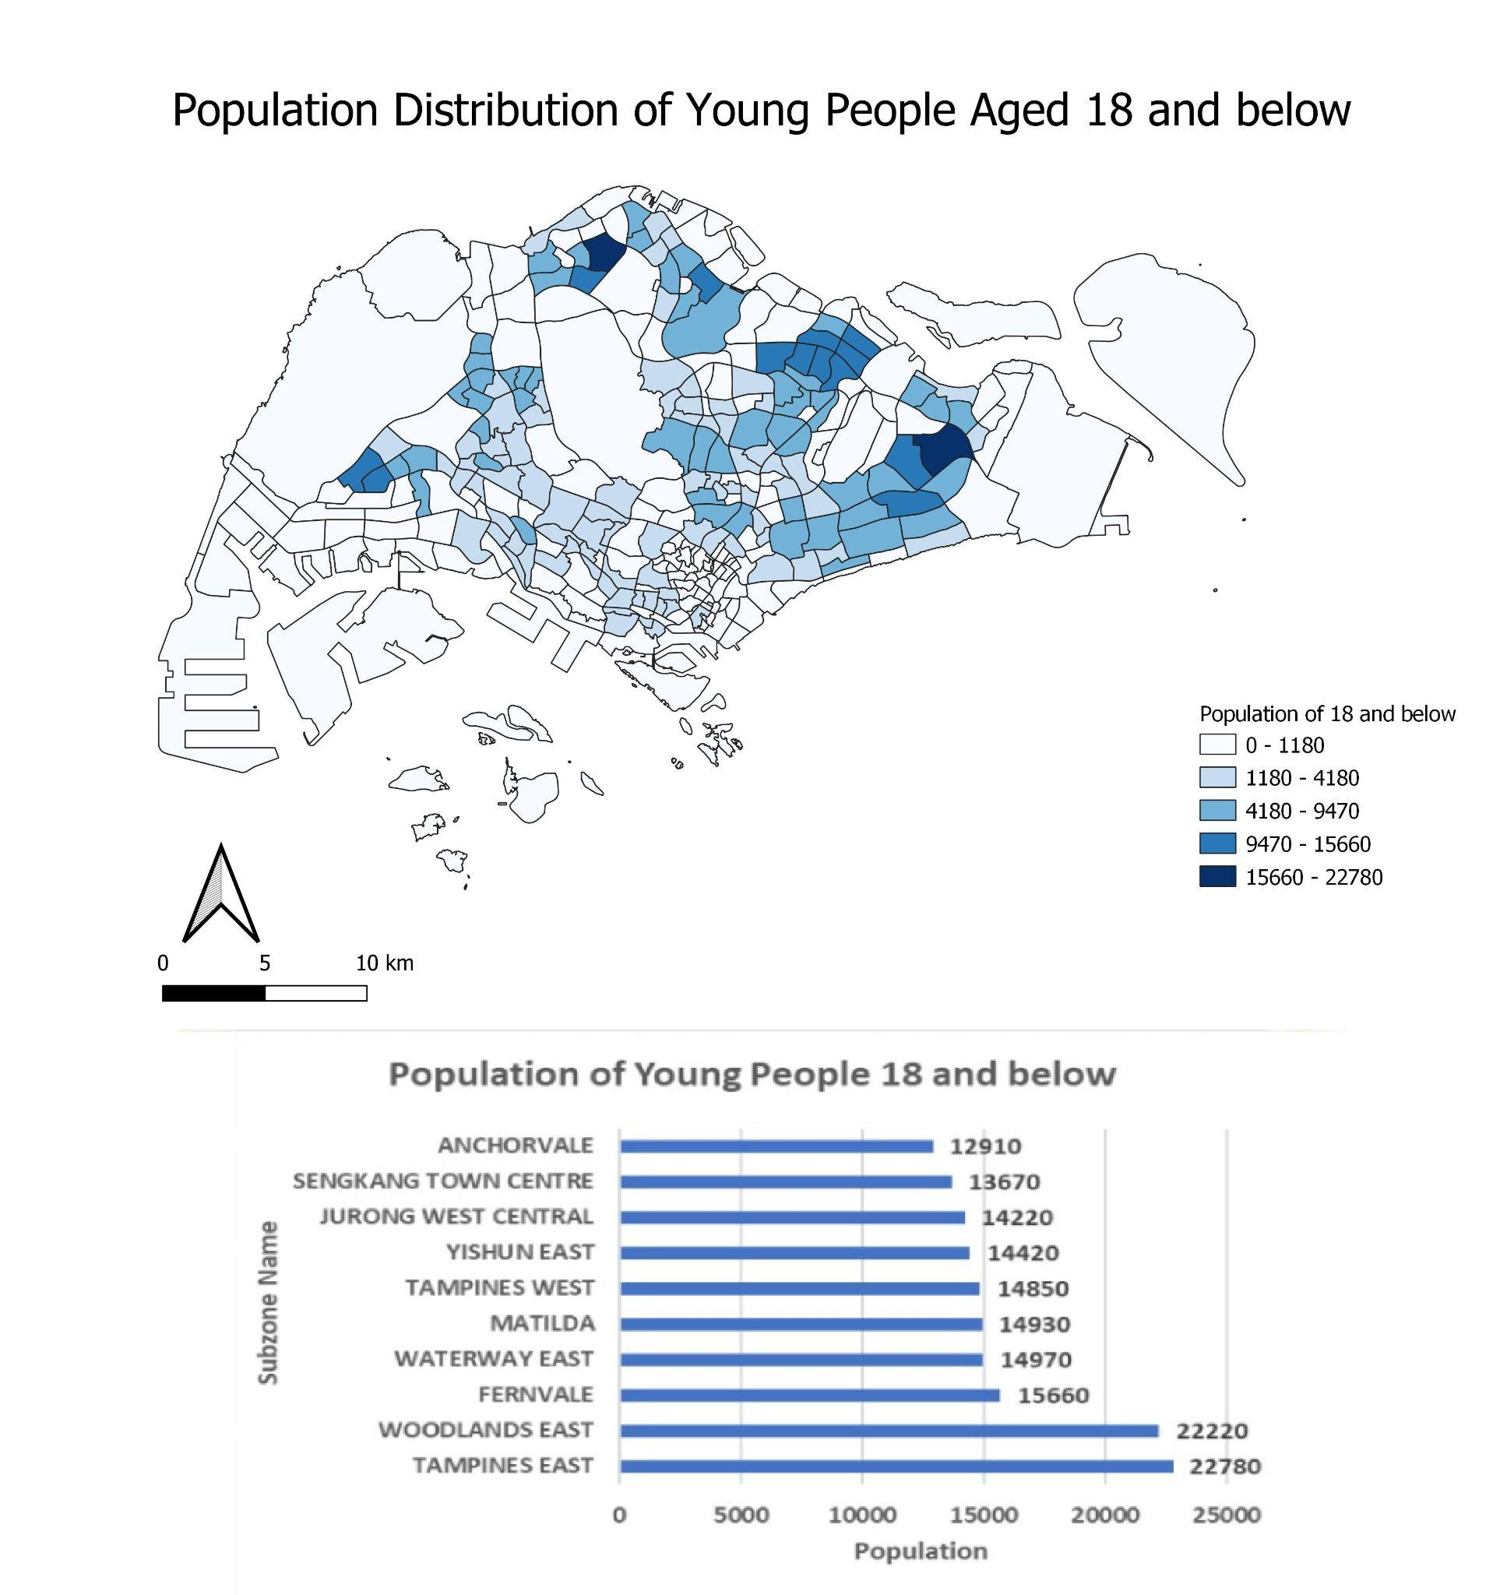

The map above shows the distribution of the youth population (18 and below) across Singapore. There is a high concentration of youth living in two main areas. Firstly, the Northeast of Singapore where Punggol, Sengkang, and Fernvale are located. Secondly, the Eastern part of Singapore where Tampines is located. The top three subzones with the highest population of youth are Tampines East, Woodlands East and Fernvale.

Analysing the distribution of the youth population is important in determining the demand of schools, as schools should be located near to residents’ homes, particularly primary schools. Subzones with a higher youth population should have a higher number of schools located within the vicinity to serve the residents.

These schools should be easily accessible to residents living in the different subzones either by car, public transport or foot. Should there be an area with high youth population but low accessibility to schools, efforts should be taken to increase accessibility to schools.

## 

## 7.3 Accessibility Analysis to Primary Schools

### 7.3.1 Walking Accessibility Analysis

### 7.3.1.1 Before Merger

# 

In Singapore, most of the roads are walkable except for the main roads and expressways.

Hence, we should take into consideration all types of roads except the major roads,

expressways, links to these roads, unclassified roads and bridleway that are path for

horses. All other types of roads except for the aforementioned will be the network layer in

determining the accessibility of hexagon centroids to primary schools.

There are 191 primary schools in Singapore before the 2019 merger. Most of the primary schools are concentrated in the housing estate areas and are well accessible to the children and parents living in the area. This is evident from the map as locations with primary schools are generally highly accessible by walking due to the extensive footpath and pedestrian walkway available for people to walk from different locations to the primary schools.

However, it can be observed that there is a hexagon centroid in the western area of Singapore that is quite inaccessible to Pioneer Primary School by walking. The shortest distance from the hexagon centroid to the nearest primary school via the walking path is 2.216km. Most of the walking paths around the primary schools are service roads which are for access to buildings, parking lots, etc, making it difficult to access by foot from the hexagon centroid. Although there are also some footway paths around the primary school, these paths are not well connected to each other, making it tough to walk to the school. For this reason, parents who send their children to Pioneer Primary School may prefer to drive or take public transport as it is more convenient. Residents living in this area may also experience lower priority for admission to primary schools.

### 7.3.1.2 Walking Accessibility Analysis After Merger

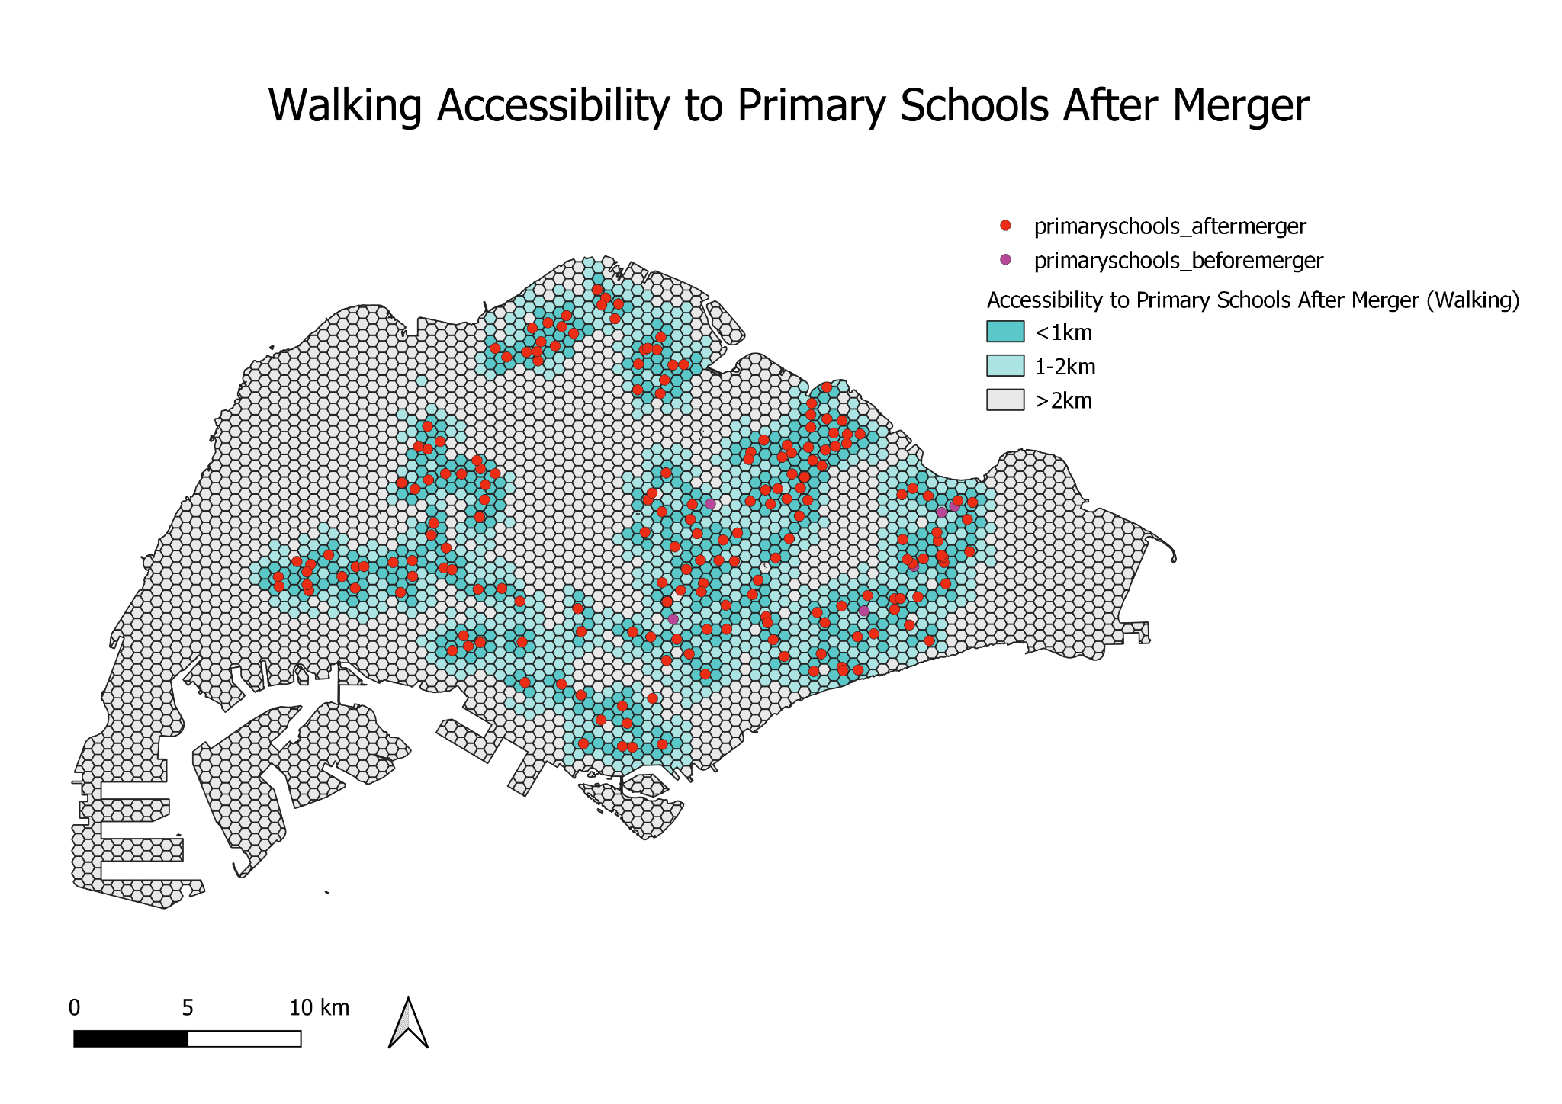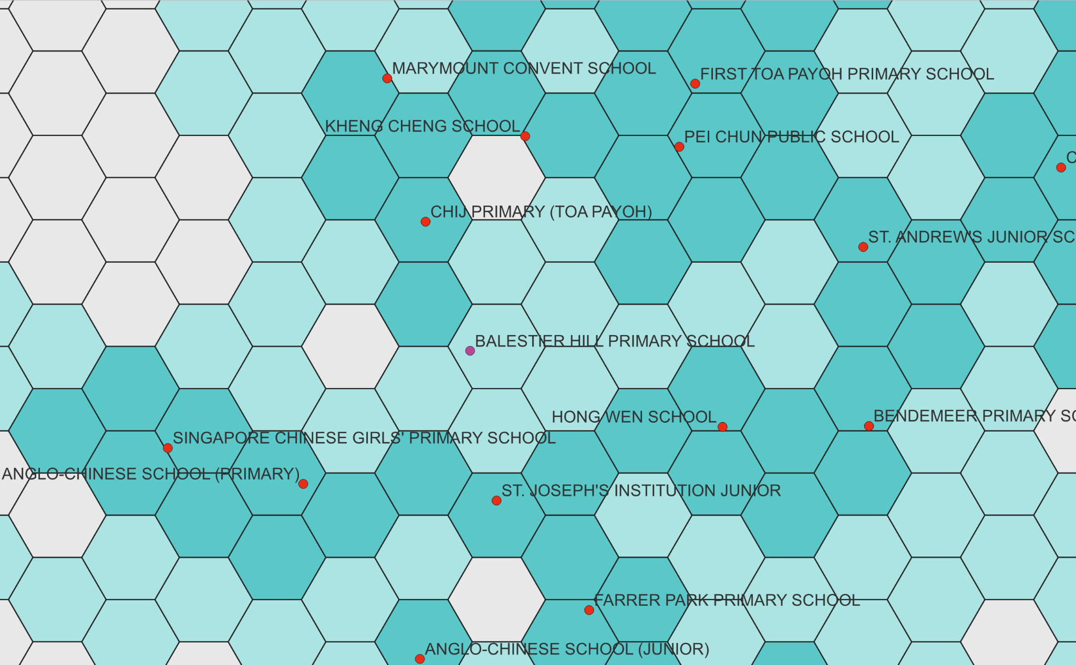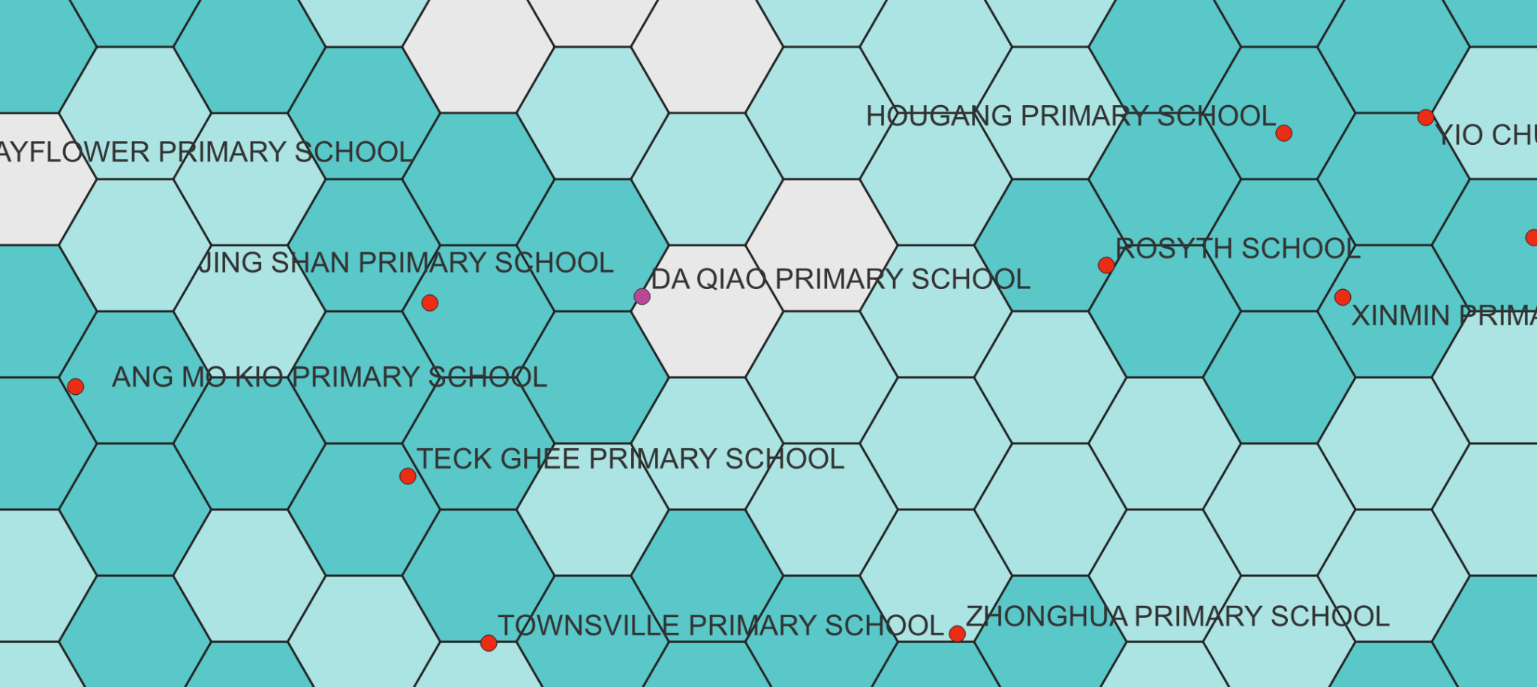

As seen from the figure above, school closures such as Balestier Hill Primary School and Da Qiao Primary School have resulted in a lower accessibility. This will be elaborated further in the next section.

### 

### 7.3.1.3 Before and After Merger (Bivariate Map)

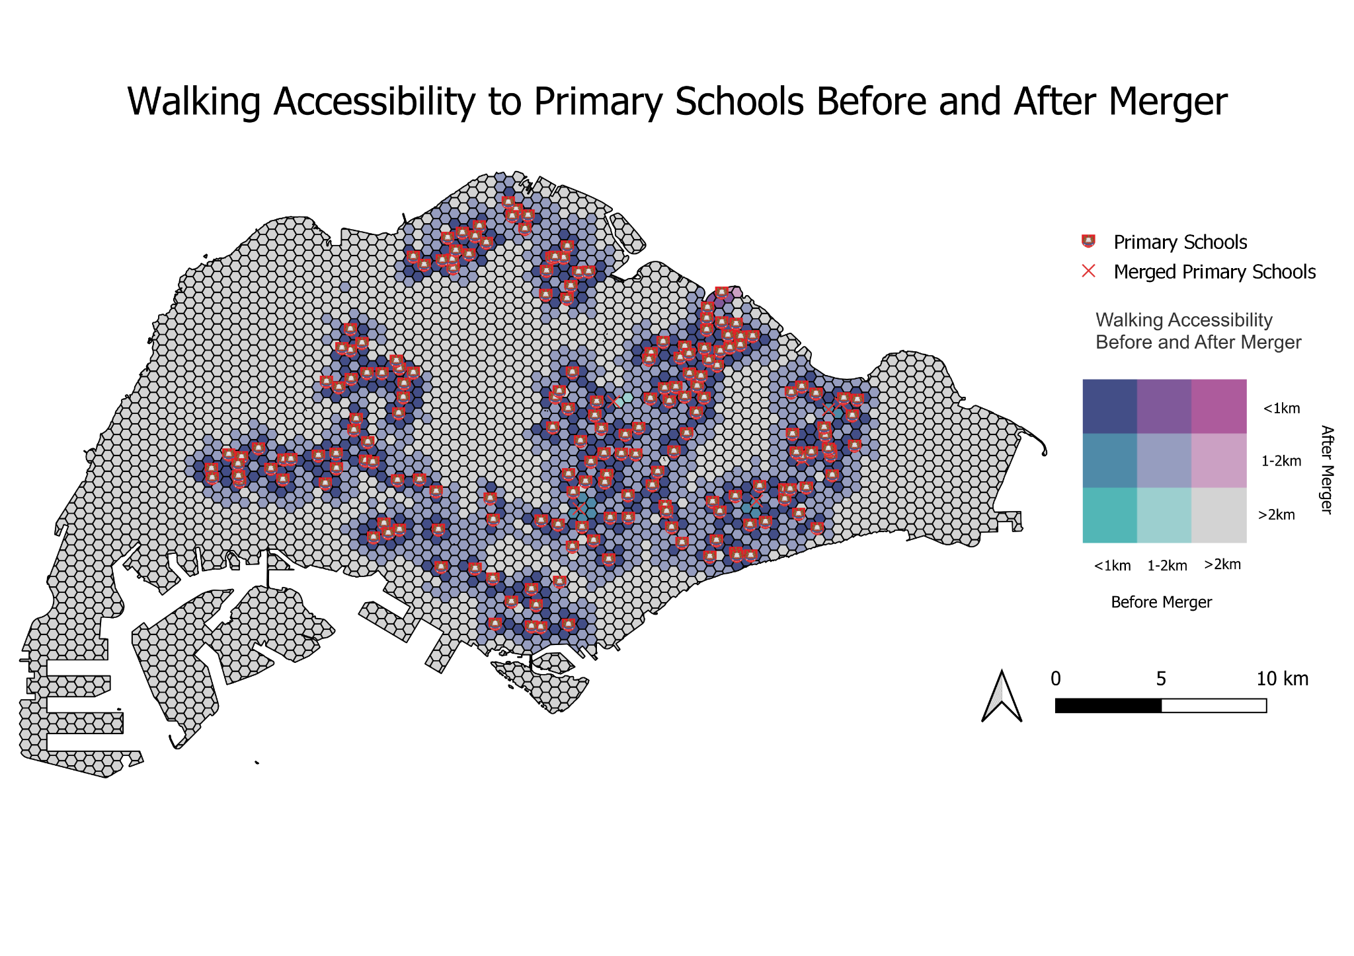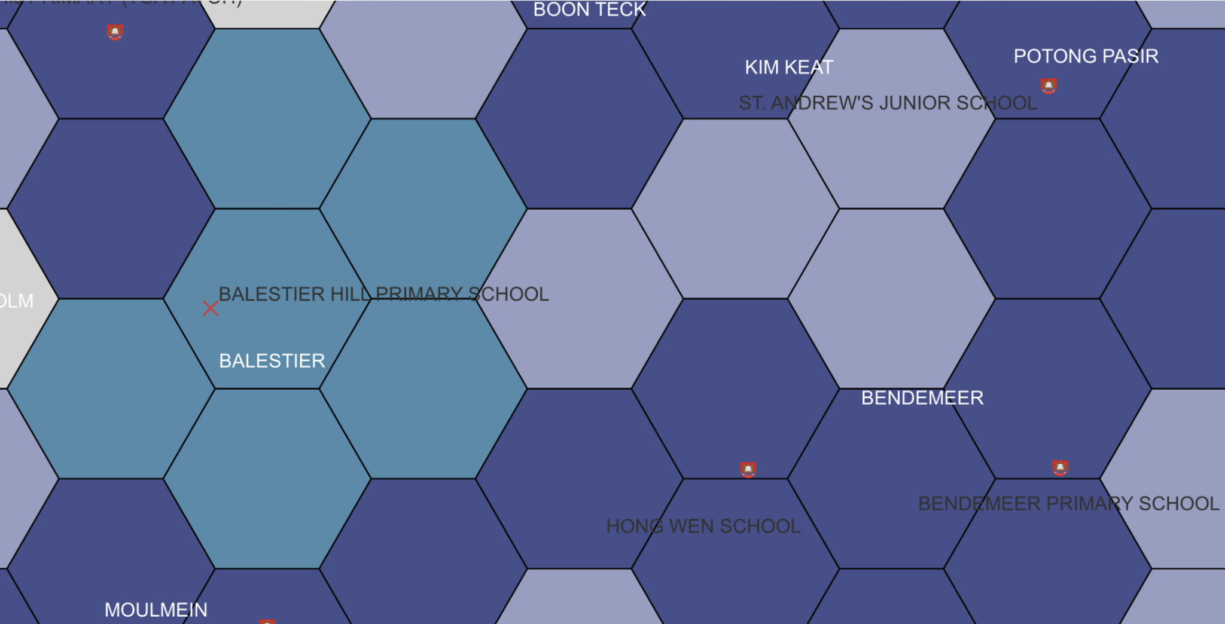

Due to the large number and dense network of primary schools, general accessibility has not been impacted significantly. Areas with a high population of youth, such as Tampines East and Woodlands East are also not affected. However, there are three main areas that have experienced lower accessibility.

Firstly, the merger of Da Qiao Primary School and Jing Shan Primary School has resulted in a lower accessibility for Cheng San subzone, with the nearest primary school being more than 2 km away after the merger, whereas the nearest primary school was 1-2 km before the merger. This would result in residents in Cheng San having to walk a long distance to a nearby primary school, and they would also face lower priority for admission to nearby primary schools.

Secondly, the merger of Balestier Hill Primary School and Bendemeer Primary School has resulted in a lower accessibility for the Balestier subzone, with the nearest primary school now being 1-2 km away instead of within 1km previously. This is despite having several schools nearby, such as Hong Wen School and St. Andrew’s Junior School. Residents in Balestier now also face lower priority when balloting for a primary school.

Thirdly, the merger of East Coast Primary School and Damai Primary School has resulted in a lower accessibility for the Kembangan area, with the nearest primary school being 1-2 km away, instead of within 1km previously. Similarly, residents now have lower priority for admission to nearby primary schools.

Residents in these areas all face lower priority to primary schools, representing spatial inequalities. If they are unable to relocate, they may face difficulties obtaining the primary school of their choice.

### 7.3.2 Driving Accessibility Before and After Merger (Bivariate Map)

### ,

While walking is the main mode of transport for primary school students, there are still parents who would prefer to drive their children to school. As such, we have also analysed the change in driving accessibility before and after merger.

Overall, there is not much change in driving accessibility before and after merger. There are only two main areas that experienced a decrease in accessibility. Firstly, the Balestier subzone has experienced a decrease in accessibility due to the merger of Balestier Hill Primary School and Bendemeer Primary School. Several areas which previously had a primary school within 1 km of their area now have to walk 1-2 km to the nearest primary school. However, there are still several primary schools nearby, such as CHIJ Primary (Toa Payoh), Singapore Chinese Girls’ Primary School and St Andrew’s Junior School.

Secondly, with the merger of East Coast Primary School and Damai Primary School, an area in Kembangan now experiences lower accessibility, with the nearest primary school being 1-2 km, compared to within 1 km before the merger. However, it is only one small area that is affected, as there are other nearby schools such as Telok Kurau Primary School and Damai Primary School.

### 

### 7.3.3 Accessibility Analysis to Primary Schools from Tengah

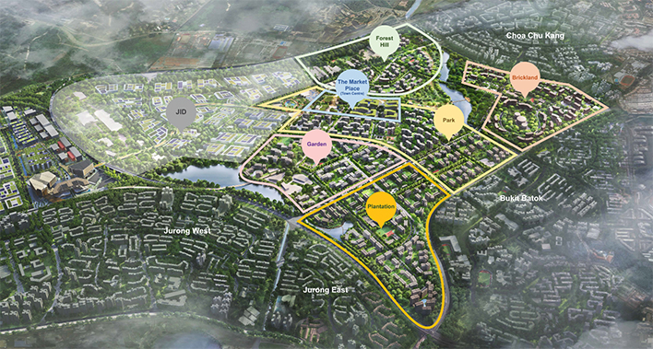

Aerial view of Tengah (Source: [Housing Development Board](https://www.hdb.gov.sg/about-us/history/hdb-towns-your-home/tengah/tengah-districts))

Tengah is a new upcoming housing estate that will comprise 42,000 homes. Tengah will also hold Singapore’s first car-free town centre, where walking and cycling are encouraged. Referring to the figure above, there will be five main districts in Tengah: Plantation, Garden, Park, Brickland and Forest Hill. As many Build-to-Order flats will be built in Tengah, the population would mostly comprise young couples and families, making it extremely important for good accessibility to schools.

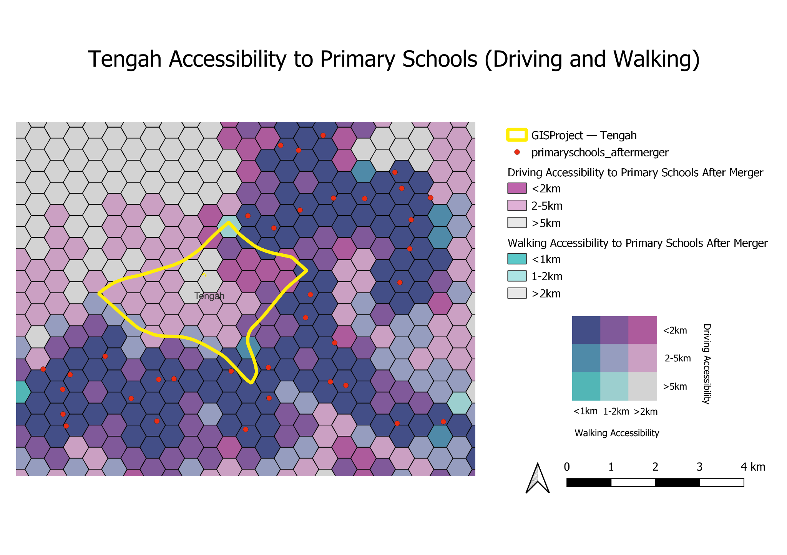

Referring to the figure above, there are currently no primary schools located in Tengah. The walking accessibility to primary schools is extremely poor in Tengah, with most primary schools being more than 2 km away. The only exception would be the most southern area of Tengah, which has good walking and driving accessibility to Jurong Primary School.

Driving accessibility is slightly higher, with some areas in the western and southern region in Tengah being 2-5 km away from primary schools, and areas in the northeast region (Brickland District) being less than 2 km away. There are still areas with very poor walking and driving accessibility in the northern/central region of Tengah coloured in grey.

More primary schools would have to be built in Tengah to increase the accessibility to residents. If no primary schools are built, residents with cars may wish to stay in Brickland District (northeast), as they would have to drive less than 2km to reach the nearest primary school. For those who prefer to walk, they wish to stay in the southern region of Tengah (Plantation District), that is less than 1 km, or 1-2 km away from the nearest primary school by foot.

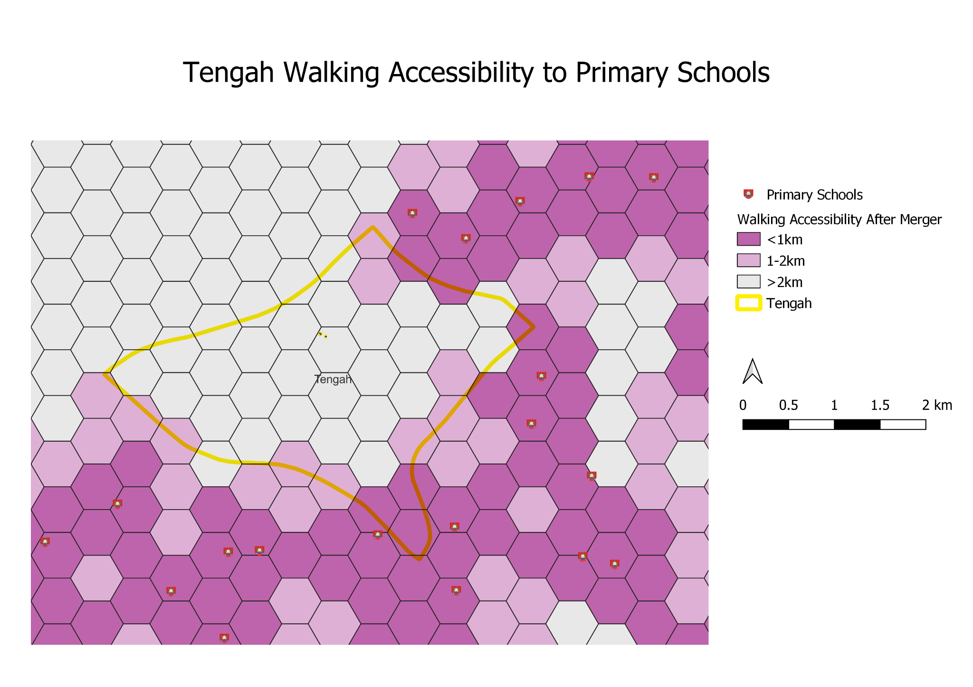

Referring to the figure above, there are currently no primary schools located in Tengah. The walking accessibility to primary schools is extremely poor in Tengah, with most primary schools being more than 2 km away. The only exception would be the most southern area of Tengah, which has good walking accessibility to Jurong Primary School (highlighted in red) and Princess Elizabeth Primary School (highlighted in blue).

More primary schools would have to be built in Tengah to increase the accessibility to residents. For young couples wanting to start a family, it would be best for them to stay in the most southern region of Tengah (Plantation District), that is less than 1 km, or 1-2 km away from the nearest primary school by foot.

## 

## 7.4 Accessibility Analysis to Secondary Schools

From the maps we could observe that the geographic distribution of secondary schools is relatively dense. In 2019, there are only 3 pairs of secondary schools merged, those are East View Secondary & East Spring Secondary, Hong Kah Secondary & Jurongville Secondary, Shuqun Secondary & Yuhua Secondary.

### 7.4.1 Driving Accessibility

### 7.4.1.1 Before Merger

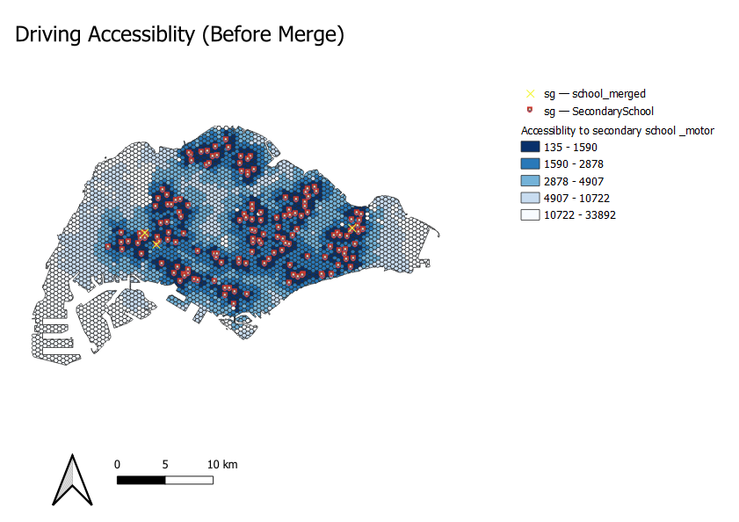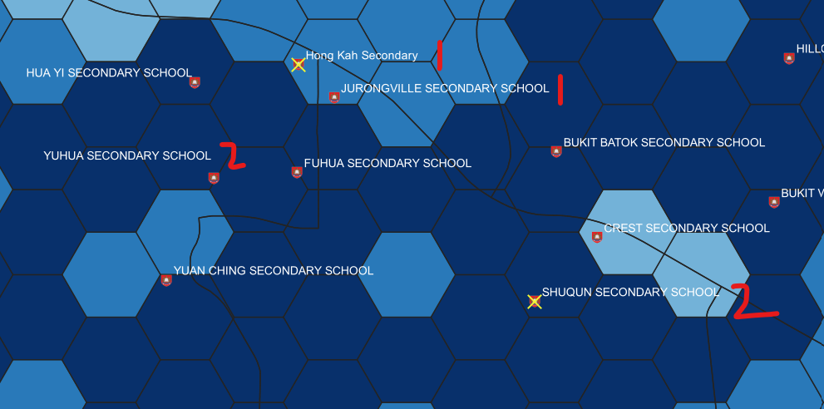

### 7.4.1.2 After Merger

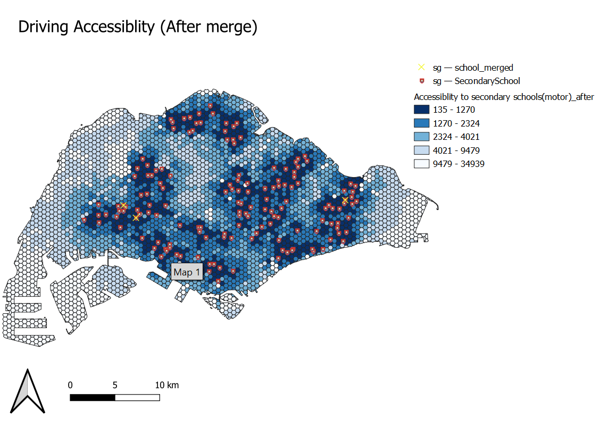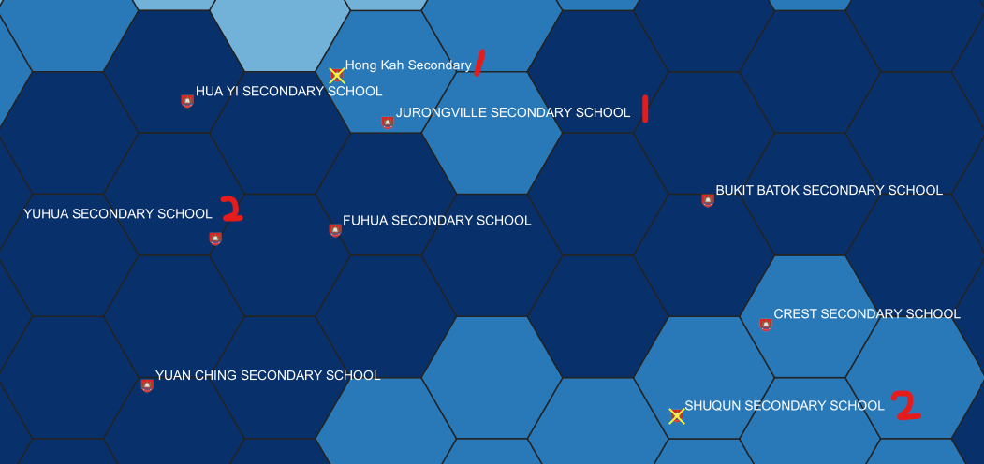

Among the three pairs of school mergers, two of them are located in the Jurong area. The first pair would be the schools labelled 1 on the image above - Hong Kah Secondary School and Jurongville Secondary School. The two schools are in very close proximity to each other (within 1 hexagon (250m)), hence the merger of the two schools does not have significant impact on the accessibility.

The second would be the merger of the secondary schools labelled 2, ShuQun Secondary School and Yuhua Secondary School, where ShuQun Secondary School (located in Jurong East) has merged to Yuhua Secondary (located in Jurong West). The accessibility for residents in the Jurong East area has been slightly impacted. After the merger, the residents staying in the north part (within the red box) have to travel further to other secondary schools with the closure of the ShuQun.

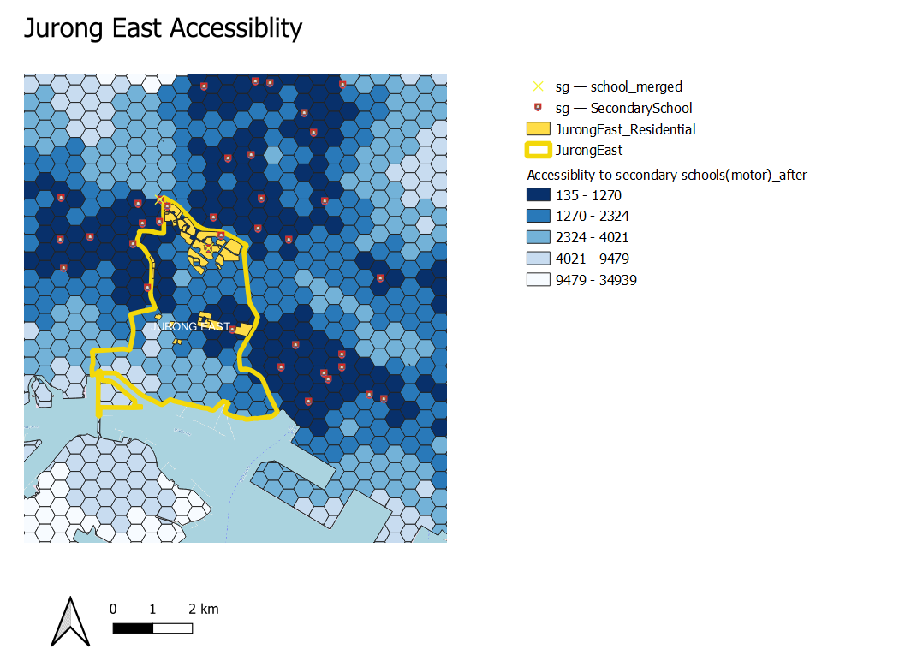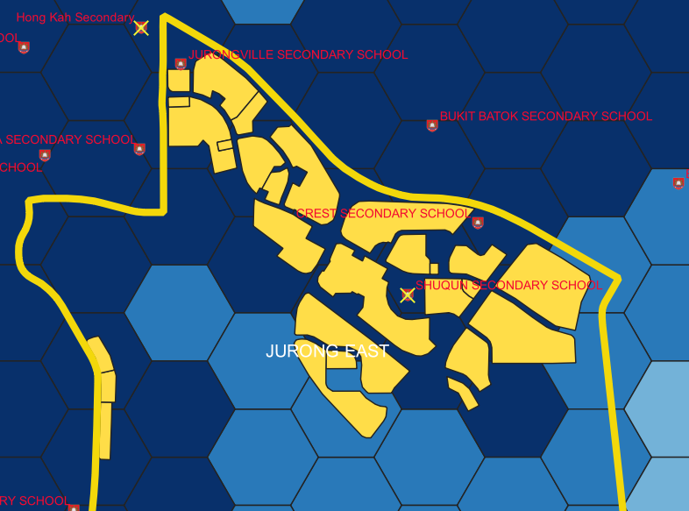

Jurong East Accessibility After Merger

### 7.4.2 Walking and MRT Accessibility

### 7.4.2.1 Before Merger

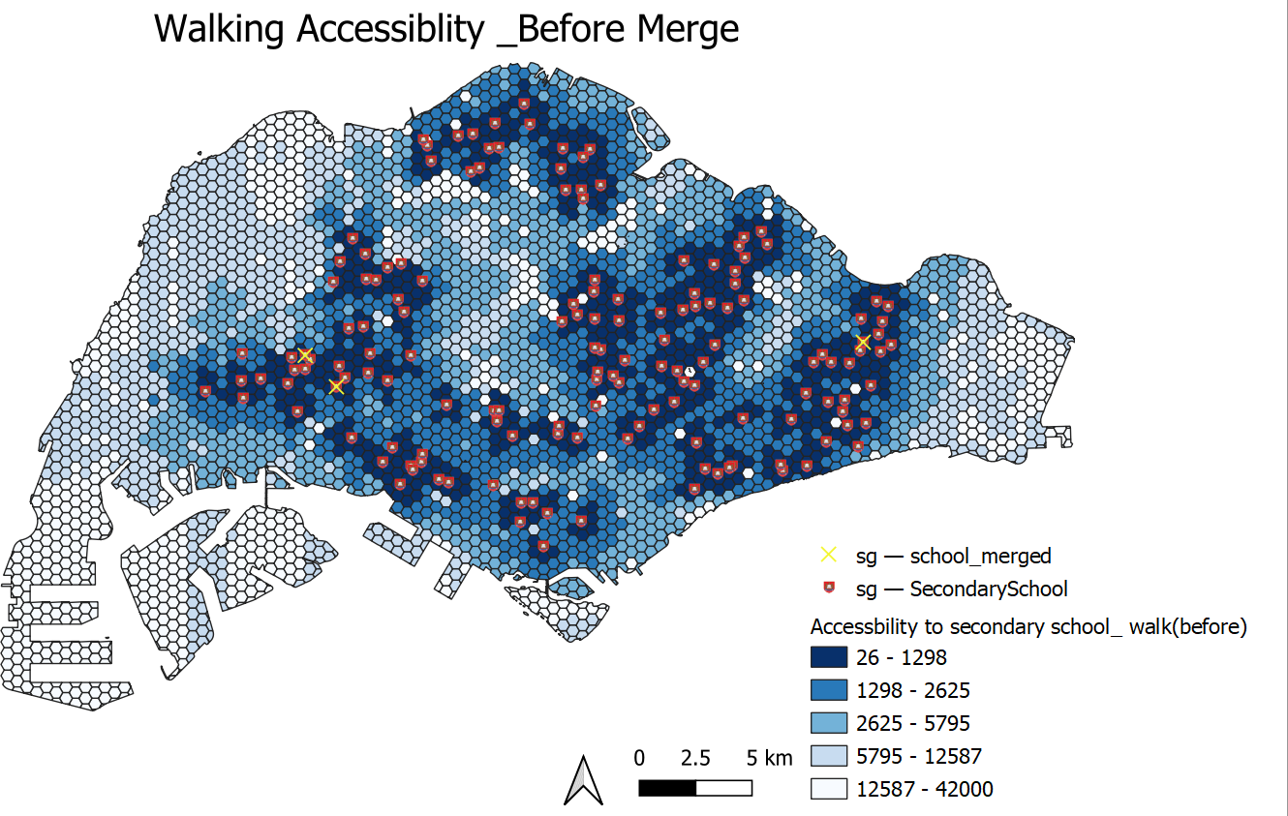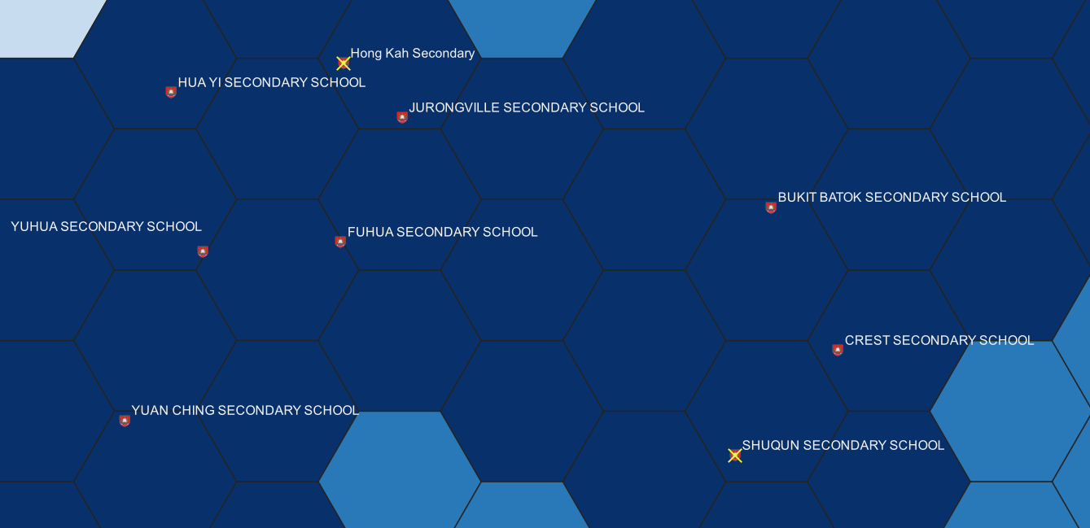



### 7.4.2.2 After Merger

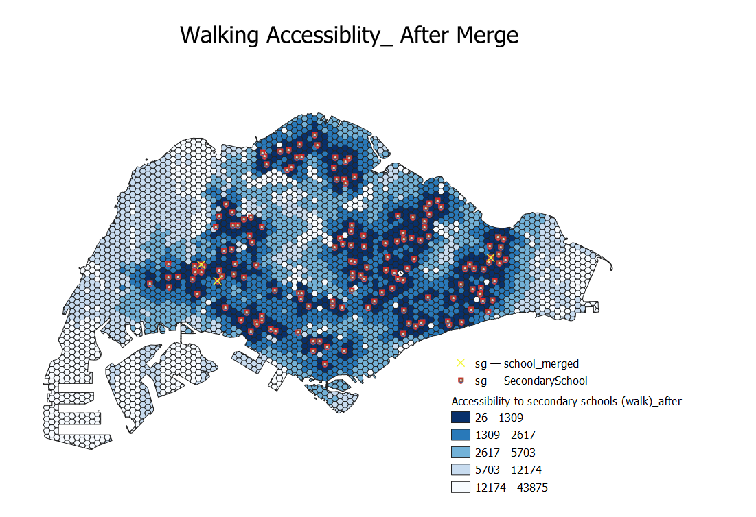

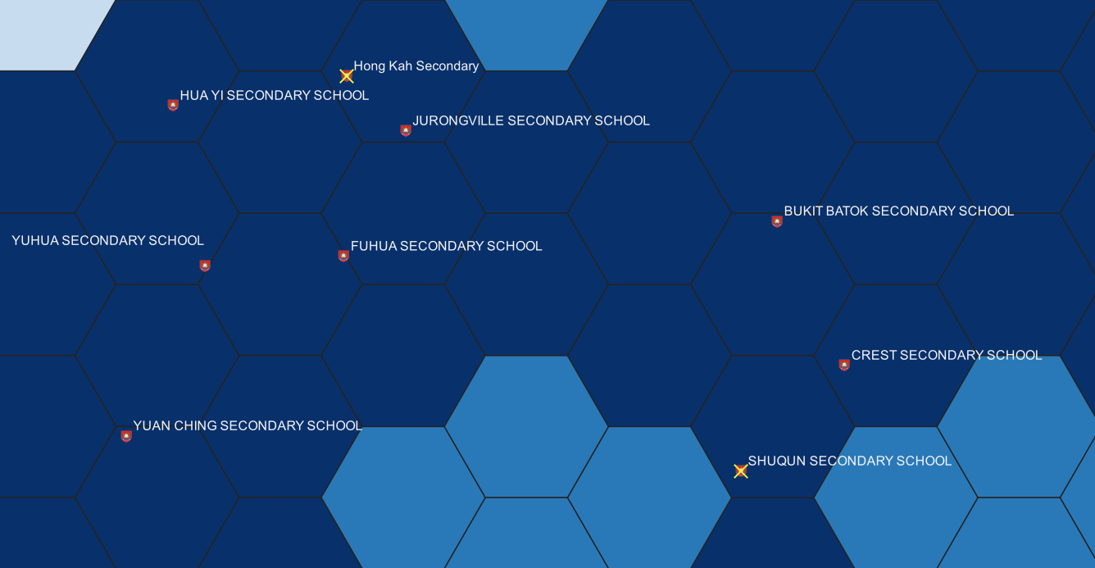

Similar to the driving accessibility, the walking accessibility for secondary school has not been impacted too much for residents near Hong Kah Secondary and ShuQun Secondary school. This is because for the merger of secondary schools, only the pairs of schools which are geographically close to each other have been selected. In addition, even with the school mergers, there are a huge number of secondary schools in Singapore. As such, there are many other secondary schools in each region where parents and secondary school students could choose from. The same conclusion also applies to the impact of accessibility to MRT due to the wide distribution of secondary schools and small number of mergers.

## 7.5 Accessibility Analysis to Junior Colleges

## 7.5.1 Walking and MRT Accessibility

### 7.5.1.1 Before Merger

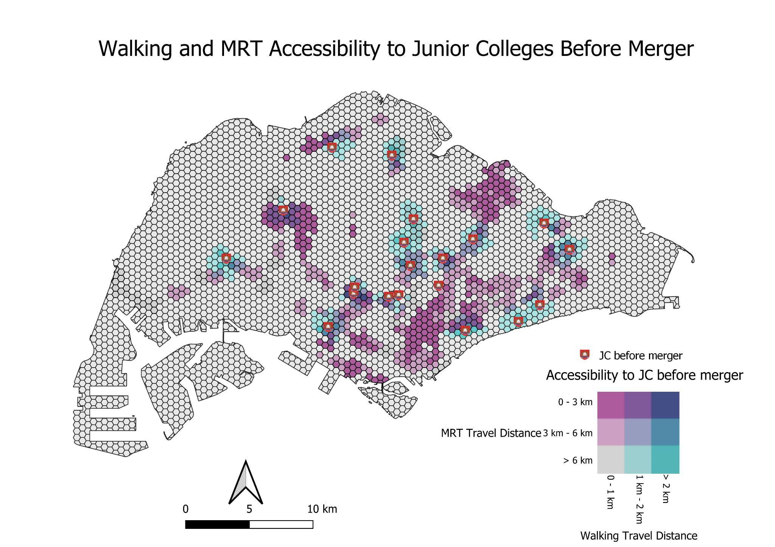

### 7.5.1.2 After Merger

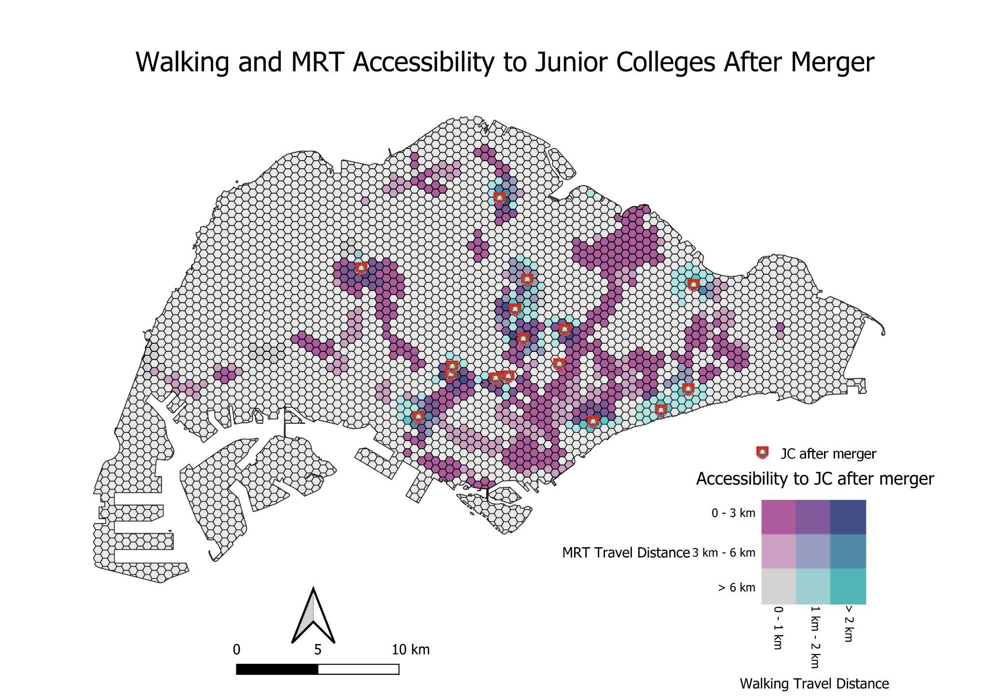

For JCs, we used longer distance thresholds since there are fewer JCs in Singapore with older students that are willing and able to travel for longer distances to school. We kept the same 0 - 1 km, 1 - 2 km and more than 2 km thresholds for walking since most people will not want to walk longer than that if possible. We use a 0 - 3 km, 3 - 6 km and more than 6 km threshold for the MRT, which takes into account the distance of the whole trip from home to station to school. In this particular comparison, there is not much difference in accessibility before and after merger for JCs via walking or MRT. There is an obvious fall in accessibility for walking at the areas where JCs have merged, such as around Jurong Junior College in the west and Innova Junior College in the North as circled in red in the above images.

However, there is also an increase in accessibility around the country as new MRT stations open with time. Circled in green above are the Thompson East Coast line stations opened till now (Phase 1 and 2). There is a clear increase in accessibility to JCs in these areas as more train lines open up.

## 

## 7.4.2 Driving Accessibility Before and After Merger (Bivariate Map)

In terms of driving however, there is a large and obvious difference in accessibility when compared to walking and MRT distances. We use a 0 - 5 km, 5 - 8 km and more than 8 km threshold for this map.

Our first area of interest is around the Northern area of Singapore, where Innova Junior College was merged into Yishun Junior College. There is quite a large drop in accessibility in the area via driving as can be seen in the image below, where the dark green areas represent where shortest distance to a school has decreases from less than 5 km to 5 - 8 km, while the light green areas represent where shortest distance to a school has decreased from less than 5 km to more than 8 km. Woodlands East is affected quite a bit by this drop in accessibility, especially when it is the region with the second highest population of young people which would be attending these schools in the future. It seems that merging Innova Junior College to Yishun Junior College was a poor idea, especially when the northern side already has so few Junior Colleges around.

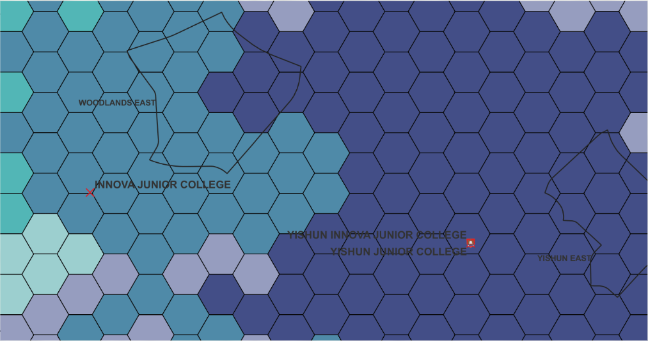

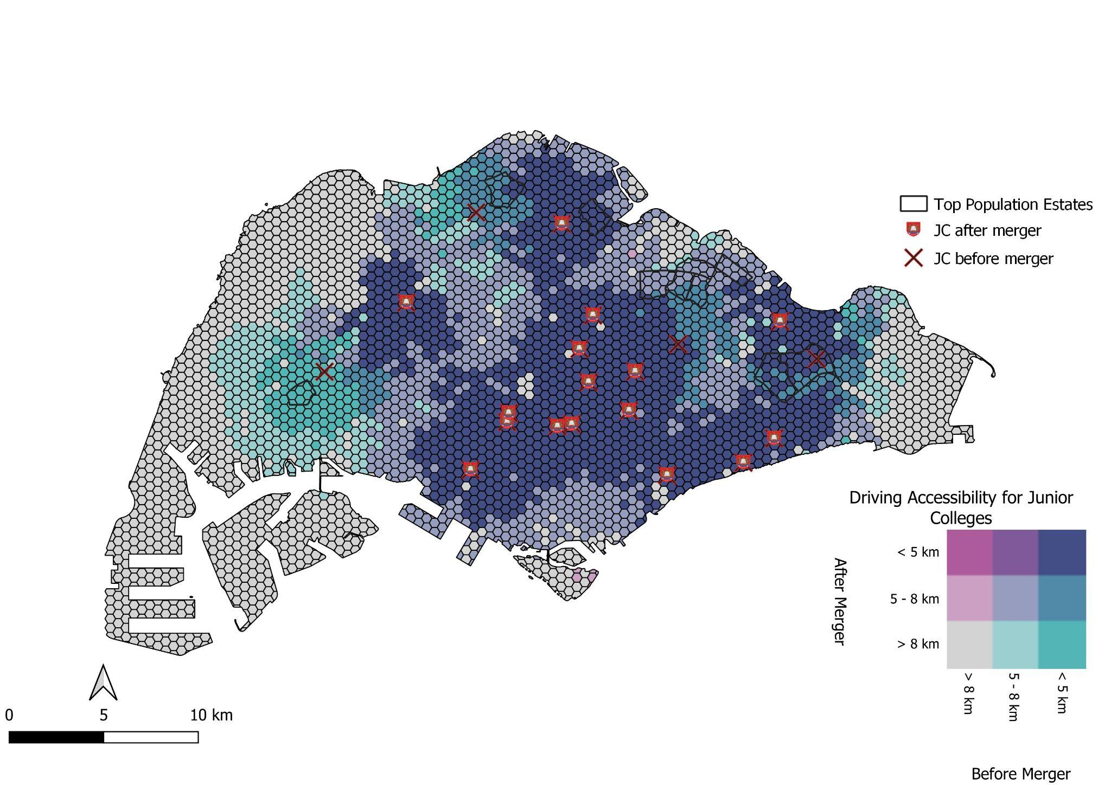

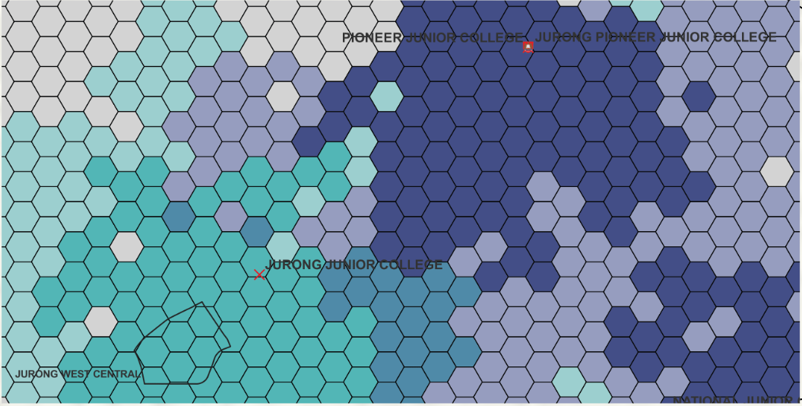

The second area of interest is around the Western region of Singapore, where Jurong Junior College was merged into Pioneer Junior College. The loss in accessibility here is even more drastic than what happened in the North, with a much larger area’s shortest distance to a JC increasing from less than 5 km to more than 8 km. In particular, Jurong West Central, one of the areas with a higher population of young people which will attend these schools in the future, is very heavily affected by the change. As such, it may not have been the best choice to merge Jurong Junior College into Pioneer Junior College, which are not in close proximity to each other, leading to such a large loss in accessibility within the Jurong area.

There are other areas on the map with losses in accessibility due to the merger of Serangoon and Tampines Junior College, but the effect on the accessibility to their surroundings is not as drastic compared to the first two JCs. This is because they are relatively close to another JC via the road network, making the impact of the mergers minimal. Jurong and Innova JC are not in close proximity to the JCs they were merged to, Pioneer and Yishun JC. This made the impact of their mergers bigger. We can conclude from this analysis that the decision to merge these schools purely based on lower student intake levels was not a good idea, as they are further reducing accessibility to nearby regions in Singapore.

# 

# 8. Future Work

## 8.1 Extending Public Transport Accessibility Analysis to include Bus Networks

For our project, we focused on walking accessibility for primary school students, as well as MRT and driving accessibility for secondary school and JC students. However, there is still a significant proportion of students who take public buses to school. Some students may also use a combination of MRT and bus to travel to school. Hence, a future extension of our work could include using bus networks to conduct network accessibility analysis. This would allow us to gain a more comprehensive analysis of accessibility to schools by public transport.

## 8.2 In-depth Accessibility Analysis on Lower and Middle Income Areas

Equity of access to education is an important aspect of our project. To conduct more in-depth analysis, future work would include obtaining data of the average income for the different subzones and housing estates in Singapore, which would help us identify which areas house the lower and middle income population. Accessibility to schools in these areas would be even more crucial, as residents are more likely to be reliant on transportation modes such as walking and public transport. It would also be interesting to compare the accessibility to primary schools within 1km in areas with high income and areas with lower/middle income, as this allows residents to have priority admission when balloting. We would be able to gain meaningful insights with regards to whether higher income residents are in closer proximity to primary schools, resulting in inequity of access to education.

## 8.3 Accessibility Analysis on New Public Housing Estates

Another important area of future work would be accessibility analysis on new and upcoming public housing estates, such as Tengah and the Greater Southern Waterfront. While we conducted a brief driving and walking accessibility analysis for Tengah, we could extend the analysis to include other upcoming housing estates as well. The government has been launching many new Build-to-Order (BTO) Housing Development Board flats, aimed at young couples to buy their first home. Conducting accessibility analysis to schools in these areas would help potential home buyers assess the suitability of the different housing estates according to their needs. For example, most young couples would stay in their new BTO flat for at least five years, and would be looking at potential primary schools in the area. In the long term, they would be looking at secondary schools and JCs as well. Accessibility to education would be an important factor in home buyers’ decisions, influencing the attractiveness of the housing estate.

# 9. Lessons Learned

Through the GIS project experience in analysing the impact of mergers of education institutions on equity of access, our group gained a better understanding of the challenges of urban planning and the role of GIS in aiding the urban planning process.

Changing demographics and declining enrolment have led to insufficient class sizes in Singapore educational institutions. Mergers of schools have become necessary to ensure that students across Singapore continue to benefit from vibrant educational experiences. The decision of school mergers involves both **technical analysis and political thinking**, which requires consideration of several factors, including the demographic change, geographical proximity of the schools to be merged and suitability of the merger (MENA,2021). However, the merger of schools will inevitably lead to geographical inequality in accessing educational institutions for certain areas. For example, in our analysis, we discovered that with the merger of Jurong Junior College and Pioneer Junior College, accessibility to Junior Colleges in the Western region of Singapore experienced a drastic decrease. In particular, Jurong West Central, one of the areas with a high population of youth that form the demand for schools, was significantly impacted by the merger. While these two schools may have faced lower enrolment rates, it is crucial to consider other factors when deciding on mergers, such as the demographics of the population and the density of the school network. As such, the use of GIS concepts and tools learned from class has allowed us to utilize spatial thinking to visualize and analyze such impacts and geographical inequality, leading to actionable insights moving forward.

Another important factor in analyzing the impact of merger of schools on accessibility is the transportation mode. Based on the literature review conducted, we discovered that the choice of transportation has a high correlation to geographic accessibility, since the selection of optimal paths and transportation mode is one of the critical issues for parents who send their children to school (Meena et al., 2022). Transportation cost is another concern for lower and middle-income group parents, which makes it even more important to have schools in close proximity to housing estates, especially via walking and public transport. Therefore, we have learnt that the analysis of accessibility requires an understanding of transportation patterns. In addition, parents and students tend to have different preferences when choosing the transportation mode for different types of schools. For example, walking is the primary mode of transport for primary school students, compared to public transport for secondary school and JC students. Thus, the common transportation mode for different types of schools - primary, secondary and JC, should be considered for conducting accurate and in-depth analysis. This is an important analysis strategy that directed us in the project, leading us to focus on the main mode of transportation for the accessibility analysis of each type of school.

Moreover, in deciding to merge schools, we learned that a critical consideration is being responsive to **changing demographics and future community demands** (MENA,2021)**.** For example, some areas have upcoming school demands, such as Tengah. As a new upcoming housing estate comprising 42,000 homes with affordable prices, Tengah attracts young couples and families to move in. In the years to come, demand for schools would undoubtedly increase, making accessibility to schools increasingly important for residents in the area. However, there are currently no schools in Tengah, making accessibility to schools, both walking and driving, extremely poor. To increase the attractiveness of Tengah and attract home buyers, the government may wish to consider building schools in Tengah. By analysing accessibility of schools to residents in Tengah, we gained better insights into conducting GIS analysis from a long-term and future perspective, which is important for urban planning.

# 

# 10. References

*Geographical Distribution & Transport.* SingStat. (2021, June).Retrieved November 10, 2022, from *https://www.singstat.gov.sg/-/media/files/visualising_data/infographics/c2020/c2020-geographical-distribution-transport.pdf*

*How distance affects priority admission for P1 registration*. Ministry of Education . (n.d.). Retrieved October 26, 2022, from https://www.moe.gov.sg/primary/p1-registration/distance#:~:text=Priority%20admission%20is%20given%20in,outside%202km%20of%20the%20school

Meena, D.K., Tripathi, R. & Agrawal, S. An evaluation of primary schools and its accessibility using GIS techniques: a case study of Prayagraj district, India. GeoJournal (2022). <https://doi.org/10.1007/s10708-022-10715-3>

Names of Primary and Secondary Schools Merging in 2019. (2017, December 29). *Ministry of Education*. Retrieved October 27, 2022, from https://www.moe.gov.sg/news/press-releases/20171229-names-of-primary-and-secondary-schools-merging-in-2019.

Singapore : School Mergers. (2021, Apr 09). MENA Report <http://libproxy.smu.edu.sg/login?url=https://www.proquest.com/wire-feeds/singapore-school-mergers/docview/2510495881/se-2>

*Tengah Districts*. HDB. (n.d.). Retrieved November 3, 2022, from https://www.hdb.gov.sg/cs/infoweb/about-us/history/hdb-towns-your-home/tengah/tengah-districts

*Tengah's Park District to feature Singapore's first 'car-free' town centre, flats to be launched in August*. CNA. (2020, August 10). Retrieved November 3, 2022, from https://www.channelnewsasia.com/singapore/hdb-tengah-park-district-flats-car-free-town-centre-615171

Wong, J. (2022, November 17). *November 2022 HDB BTO Review – Tengah*. 99.co property website singapore. Retrieved November 3, 2022, from https://www.99.co/singapore/insider/november-2022-hdb-bto-review-tengah/